The 1960’s (History of Belmont Athletics)
The 196o’s saw the continued evolution of Belmont’s athletic programs and the emergence of new sports and traditions. Boys’ basketball was generally recognized as the highest profile sport for most of the decade and track and field retained a prominent role. Other sports such as volleyball, soccer and cross country also continued to develop, and by the end of the decade, many Belmont teams were able to compete with those from the more established city and Island schools.
In 1962-63, Elizabeth Fisher Junior High School opened its doors in the building which is now Belmont’s north wing. This triggered a grade reconfiguration in the inner zone, as Belmont switched to a grade 11-12 senior high, and Elizabeth Fisher became grade 8-10. The grade 7 students were now relegated to the elementary level. Although the fact two buildings were extremely close to one another geographically, a small two foot fence was erected between them to act as a barrier and the students were strictly instructed to remain on their own side. In 1965, the two schools assumed their own distinct identities and established separate athletic programs. Elizabeth Fisher also created its own yearbook known as “Driftwood.” In the 1964 editorial of the Belmont “Kee-Yu” yearbook, Principal Stephenson described the coming change. “Neither cell is like its orginal. Belmont is older and smaller than its parent, Elizabeth Fisher younger, larger and more complex.”
The new junior high school adopted black and gold as its colours and many of the sports teams chose names with an indigenous Central American theme. Most of the grade 9-10 boys’ teams became known as the Sun Devils, while the junior boys were the Aztecs. The names of the girls’ teams varied, but many were called the Mayas. The Sun Devil, Aztec and Maya names would continue to be used for the junior teams, even after Belmont and Fisher re-united in 1974-75, and would not be phased out until 1985 when the grades 8-10 students were dispersed to Spencer and Dunsmuir and Belmont became a grade 11-12 school.
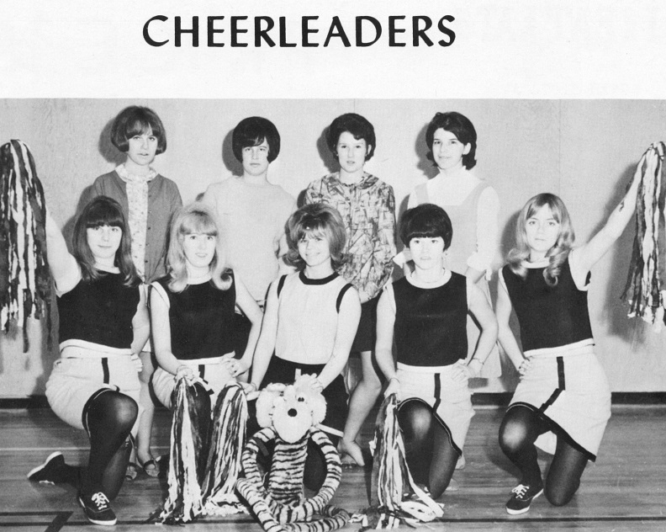
The 1967 Elizabeth Fisher cheerleading squad supported many of the school’s athletic events.
It took a number of years for Elizabeth Fisher to establish its own athletic traditions, but mention should be made of a powerhouse grade 9 boys’ basketball team that dominated most of its competition during the 1965-66 season.
The squad was led by Doug Little, and also featured a strong supporting cast that included Rick Allen, Glen Kilduff and Bill Plumb. Little was an American import who was born in Victoria, but had lived most of his life in California. He was an outstanding basketball player in grade 9 and scored an incredible 92 points in one game against Mt Newton! (Kilduff, Recollections of Belmont Athletics in the 1960's 2014). Unfortunately for the Belmont basketball program, Doug’s family moved back to Santa Barbara the following year, where Doug continued his stellar play. He earned a scholarship to play for the Oregon Ducks and was drafted by the NBA Buffalo Braves in 1973, but failed to make the team’s final roster.
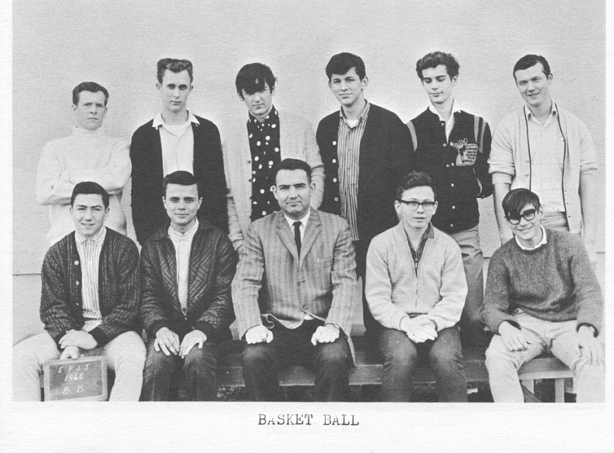
The 1965-66 Elizabeth Fisher boys basketball team.
There were many strong performances by Belmont male athletes during the 1960’s, both in both individual and team sports. Peter Parker became the first Belmont athlete to capture a provincial title, as he won swimming gold at the 1960’s B.C. championship meet. The Braves consistently attained strong results in basketball. The powerful 1962-63 squad that featured John Allen, Gary Smith, Ricky Powell, and the Drummond twins, Paul and David, came within one victory of becoming the first Belmont team to advance to a provincial championship.
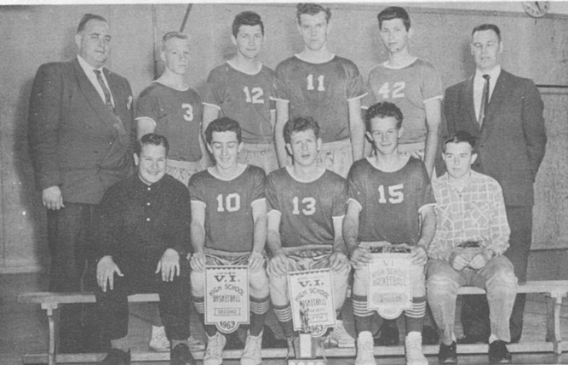
1962-63 Braves: Back row: Mr. Powell , Robin Allan, Paul Drummond, Ricky Powell, Dave Drummond, Mr. Parrot
Front row: Jim Wilson (manager), Lloyd Powell, John Allen, Gary Smith, Norm Arden (manager)

The senior boys’ volleyball team, coached by Randy Smith, enjoyed increasing success throughout the decade and captured their first Lower Island title in 1969.
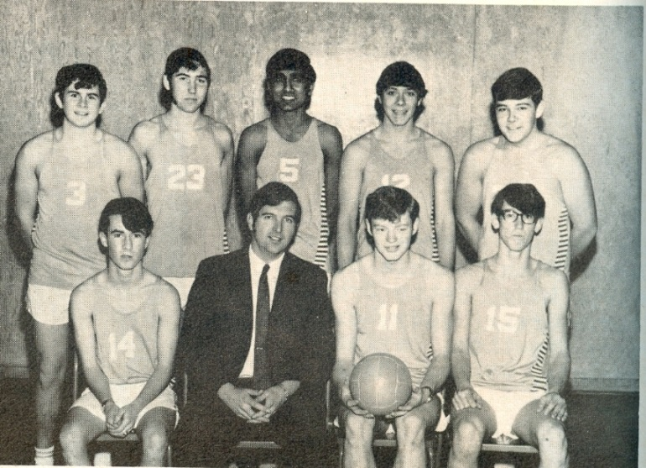
Top Row: Wayne Hendry, Tim Weckend, Assa Manhas, Mike McKenzie
Bottom Row: Guy Shields, Mr. Smith, Gene Longson, Barry Alexander

Although golf wasn’t a high school sport at that time, several Belmont students played at the nearby Royal Colwood course, and Gary Smith was crowned BC junior champion. A number of Belmont grads also made their mark in the Western Lacrosse Association. Bill Spotswood, Mel Spotswood, and Murray Muralt suited up for the Shamrocks, and Rod Kilduff and John Allen both starred for the Coquitlam Adanacs, with John later being inducted into the Canadian Lacrosse Hall of Fame
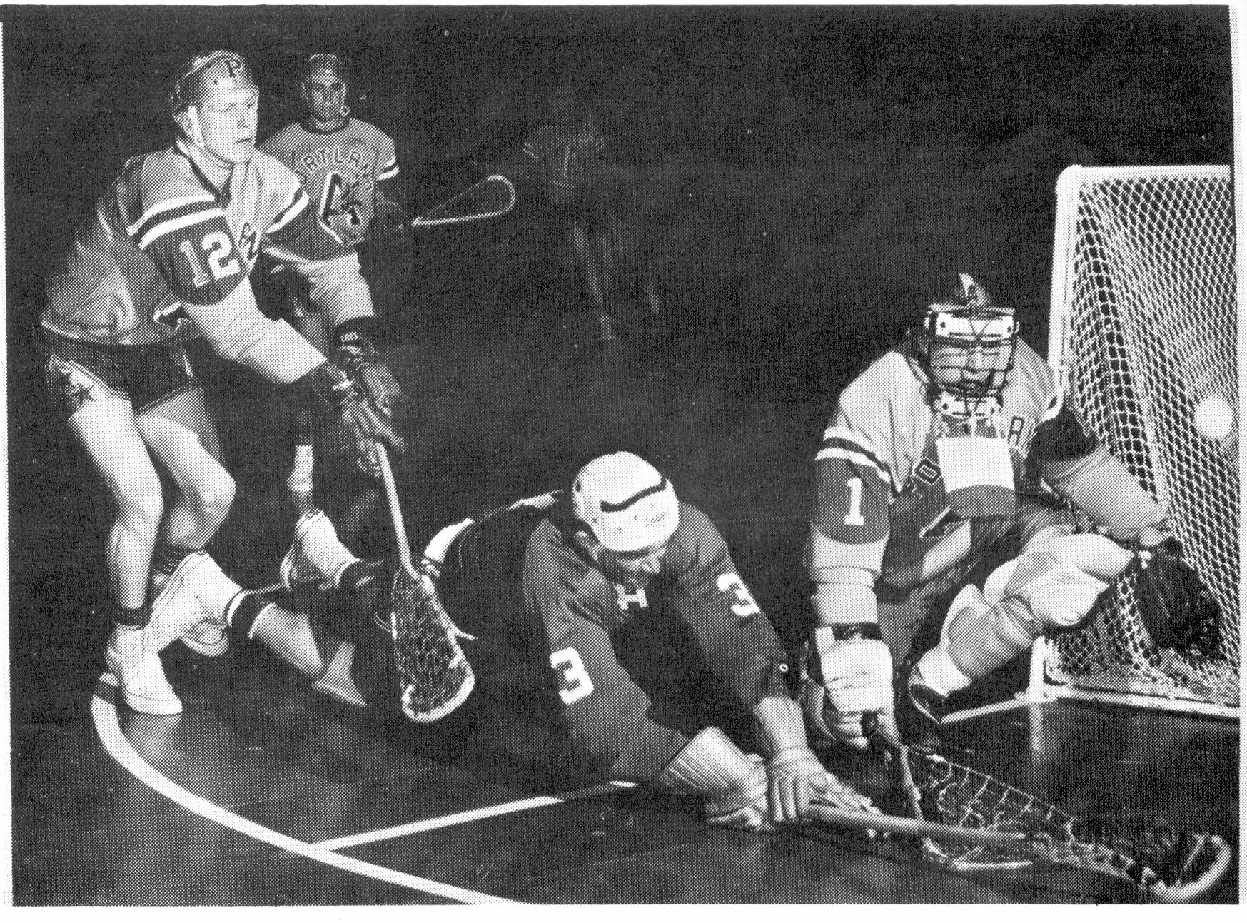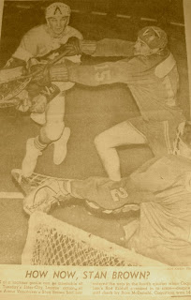
Rod Kilduff Coquitlam Adanacs photo
John Allen (#12) Coquitlam Adanacs photo

The girls’ athletic program was not quite as intense as that of the boys during this decade; however, Belmont offered teams in a number of sports including basketball, volleyball, soccer, track and field. A few of the prominent female athletes included Carol Newcomb, one of the leaders of the girls’ softball and basketball teams in the early 1960’s, Mt Doug transfer Gail Drysdale, and all-rounder Ann Caffrey, Belmont’s top female athlete of 1968, who would later compete for Canada’s national rowing team.
Belmont developed a strong cross country program in the 1960’s and all students were expected to engage in regular training runs. The Belmont teachers created a course around Glen Lake that the PE classes ran on a regular basis. The route started and ended in front of the main entrance on Jacklin Road, and the runners raced down to Jenkins Road, turned onto Glen Lake Road, and returned to the school via Sooke Road to Jacklin. Paul Drummond, a grad from 1963, recalls that this was not a very popular activity amongst many of his classmates. Some of the boys regularly took short cuts and delighted in outwitting their PE teachers who would drive around the course in their vehicles to monitor the runners. On one occasion, an unfortunate youngster spotted his teacher’s car approaching and dove into the bushes, right into a barbed wire fence! The Glen Lake run also served as the route for Belmont’s annual cross country championship. Glen Willing dominated this race during its early times, capturing the winning trophy an impressive five out of the six years he was at the school. Later the event was modified to include a swim across the lake, the equivalent to today’s biathalon.
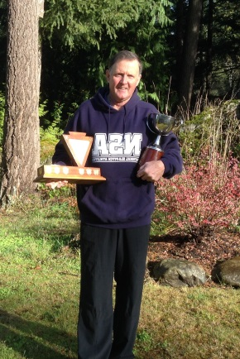
Glen Willing in 2014 holding the Glen Lake Run trophy
By the 1960’s, there were several distinct outdoor sporting facilities at Belmont. The gravel baseball diamond was located on the upper field and there was an asphalt area for outdoor basketball. There was also a track, which was surfaced with cinders taken from the school furnace. As Paul Drummond pointed out, you definitely didn’t want to fall on the Belmont track as it would likely cost you a few layers of skin. There was one grass field, on the lower portion of the property, which was generally reserved for soccer. The soccer facilities were rather primitive, as Robert Vallance noted in the 1969 yearbook: “Our practice field was a cow pasture out in the backwoods.” Vallance clearly had a good sense of humour as evidenced by his wry assessment of the soccer team’s performance that season: “Our standing was firmly grounded – basement floor, and nobody seriously challenged it.” The girls’ grass hockey team shared similar sentiments about the Belmont field as the 1970 yearbook writeup stated: “Our worst enemy (next to Oak Bay) was our lack of proper playing facilities.” Although the girls also lost every game that season and played a number of their matches in tough muddy conditions, they developed a post-game ritual to revive their spirits: “A wake was held after most games at Bob’s Burgers, where we drowned our sorrows in hot coffee or gorgeous multiflavored milkshakes.”
Intramural or house competitions continued to be very popular throughout the 1960’s, as teams competed against one another for bragging rights and to earn points for their houses. Teachers Ernie Teagle, Stan Powell and Randy Smith coordinated the noon-hour activities that were popular spectator events and often drew many enthusiastic student supporters. Broomball was a particularly competitive game for the boys. The sport was played with similar rules to floor hockey, but players used old corn-straw curling brooms instead of sticks. Although one might think it would be difficult to get a decent shot away with a broom, apparently many of the boys could fire the ball with both velocity and accuracy. Later on in the 1960’s, broomball was replaced by floor hockey. The boys cut the blades off old wooden sticks and taped up the ends so as not to damage the gym floor. Instead of a hockey puck, they used a circular felt ring with a hole in the middle. The players were able to stickhandle with ease and could lean into their stick and snap powerful shots, but sometimes they just used brute force to push the ring into the goal. There was also a lot of physical contact, with body-checking a permissible and highly-anticipated part of the game. The boys were delighted whenever Ernie Teagle, the extremely popular Belmont teacher and coach, came out to play with them. Mr. Teagle was a spirited, intense competitor and the boys relished the opportunity to test their skills against such a worthy opponent.
Another popular intramural activity was mat ball, a variation of European handball. It was played with a volleyball and players were permitted three bounces of the ball before they had to pass. Two mats were situated at opposite ends of the gymnasium and goals were scored by getting the ball to hit anywhere on your opponent’s mat. Other house sporting activities included softball, soccer and basketball.
High schools usually relied on their partner junior high programs to help develop their incoming athletes, but Belmont in the 1960’s also had a unique training facility: a comprehensive athletic complex located on the half acre back lot of the Kilduff family home.
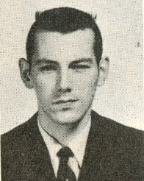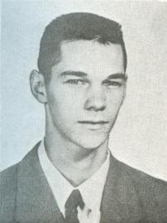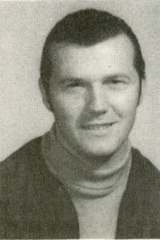
The three Kilduff brothers: Cliff, Rod and Glen
Eldest son Cliff, with the help of younger brothers Rod and Glen and an assortment of neighborhood friends, had constructed a multi-sport field on the grass field that was soon worn down to a hard clay surface by the constant pounding of young athletes. There was a basketball hoop set up for half-court games, equipped with spotlights so the games could continue into the evening hours. There was also a softball diamond, with the outfield extending into a seldom-used motorbike track that bordered the Kilduff property. Cliff had constructed a pitching area, with a regulation-size mound and an old carpet situated at home plate distance, complete with the strike zone painted on so that boys could aim for precision with their pitches. Not to be outdone, Rod built a lacrosse goal that adjoined a shed in the back yard and some of the Shamrocks wold drop by regularly for some extra practice. On a side note, the Kilduff parents originally had intended the shed to be a quiet refuge for the kids to study and do their homework, but the addition of a ping pong table transformed it into yet another lively sporting venue. Perhaps the most unlikely of sporting facilities was a high jump pit that was later expanded to serve as a pole vault pit! Cliff cut several strong, slender saplings, whittled one end down to a sharp point, and daring boys would launch themselves into the air. It’s no wonder that the Kilduff back yard became a favorite hangout and the place that a number of Belmont’s top athletes from the 50’s and 60’s honed their skills and developed lifelong friendships.
By the end of the 1960’s, Belmont’s athletic program had evolved to the point where the school’s athletes were poised to become regular contenders for city and Island championships, and set the stage for the 1970’s, when several teams broke through as serious challengers for provincial titles.
Compiled by Cindy Cullen - 2015

Bibliography
Caffrey, Anne, interview by Miranda Llewellyn and Frelen Gorst. Belmont Sports Memories (November 4, 2014).
Drummond, Paul, interview by Cindy Cullen. Belmont memories of the early 1960's (September 3, 2014).
Holt, John. "Principal's Message." Legacy, 1976.
Kilduff, Glen, interview by Miranda Llewellyn and Frelen Gorst. Belmont Sports Memories (October 2014).
Kilduff, Glen, interview by Cindy Cullen. Recollections of Belmont Athletics in the 1960's (August 13, 2014).
Mansfield, Earl. A Brief History of Belmont Senior Secondary School. Victoria: Belmont School, 1994.
Muralt, Murray, interview by Cassy Allen. (October 2014).
Stephenson, Archie. "Editorial." In Kee-Yu, by Yearbook staff. Victoria: Belmont School, 1964.
Vance, Robert. "Soccer." Kee-Yu, 1969.
Varcoe, Carol (Booth / Spotswood), interview by Cindy Cullen. Belmont memories (August 19, 2014).
Willing, Glen, interview by Cassy Allen. Belmont sports memories (October 2014).
Willing, Glen, interview by Cindy Cullen. Recollections of Belmont Athletics in the 1960's (June 2014).
Yearbook staff 1967. Kee-Yu. Victoria: Belmont School, 1967.
Yearbook staff. "Grass Hockey." Kee-Yu, 1970.

