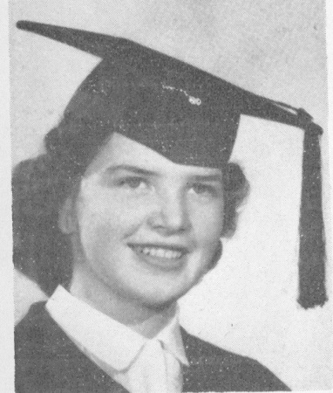
Shirley (Moseley) Smith: 1947-1953
Shirley attended Belmont from 1946 through 1953. She graduated before the new Belmont building had been constructed so attended her classes in the old army huts. She has vivid memories of clearing the playing field and recalls many hours outside with her classmates with rakes and wheelbarrows picking up rocks. During her time at Belmont, Shirley was recognized as a talented and hardworking athlete. She had the honor of being captain for many of the teams she played on, such as softball, and volleyball. She won the Student’s Cup in grade 10 and was captain of “B” House girls for three consecutive years.
After high school, sports continued to play a huge role in Shirley’s life. She continued to excel at softball, and was shared MVP honours in the Victoria women’s league with her sister Marilyn in 1953 and 1954. She continued to play softball for many decades, competing first at Hyacinth Park and later at the masters’ level. Golf was Shirley’s second outstanding sport, and she was crowned Ladies’ club champion at Prospect Lake on four separate occasions. She continued to be active into her senior years and competed in two World Masters’ Games: in 2002 in Melbourne, Australia where she took home silver medals in both softball and golf, and 2005 in Edmonton, where she earned a gold, silver, and bronze medal, all in golf competitions. As well, she won a silver medal at the 2006 BC Senior Games in Abbotsford.
Athletics also were a central component of Shirley’s family life. In fact Shirley met her husband through sports, and on their first date they went to a wrestling match! Her children and grandchildren have led active lives participating in hockey, lacrosse, softball, golf and javelin. Her sister Marilyn, and daughters Della and Kristy, were all selected to Belmont’s Hall of Fame for their accomplishments in softball, soccer, and track and field.
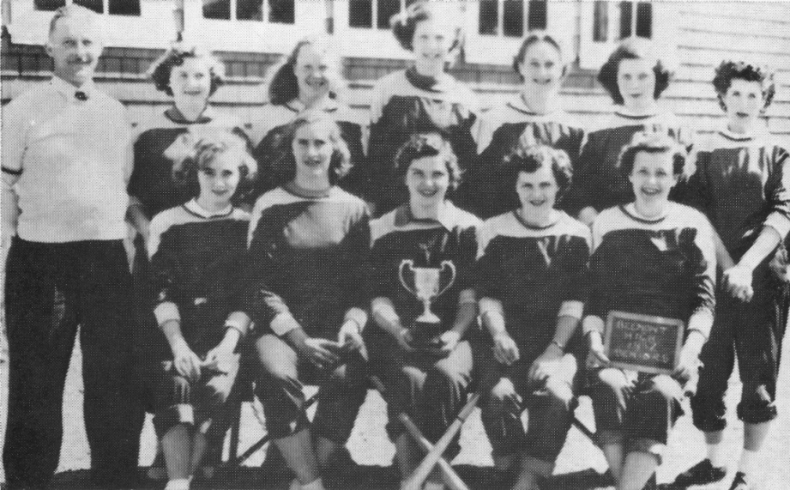
Shirley Moseley with her 1951-52 Belmont softball team-mates. Shirley is sitting in the front row holding the trophy.

