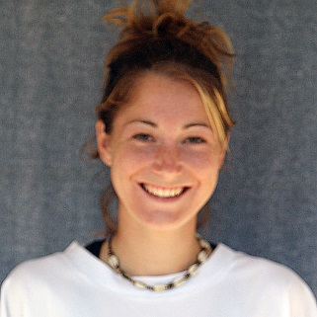
Rachelle Armstrong – 2001-2004
Rachelle was a multi-sport athlete who was a key contributor to Belmont’s cross country, basketball, soccer and track teams during her high school experience. She had always been active as a youngster, starting T ball at the age of 5. Three years later, her parents signed her up for soccer and she soon realized this was the sport she was most passionate about, a conviction that never wavered as she got older.
At Belmont, Rachelle, nicknamed “Rocket,” stood out for her high fitness level and competitive drive. She was a striker in soccer: a natural goal scorer who used her speed and finesse to elude defenders and create scoring chances. Coach Lloyd Powell remembers the Bulldogs team that included Rachelle and fellow Hall of Famer Moira Hood as one of the strongest girls’ teams in the school’s history. Besides her soccer accomplishments, Rachelle excelled at several other sports at Belmont. She was one of the top cross country runners in the city, and consistently recorded top ten finishes. In track, she competed in a variety of events, with the 200m and 800m being her best races. And in basketball, she was a speedy guard who played tenacious defence and scored numerous fast break layups. Rachelle’s best high school sporting memory is of the basketball team’s ten day trip to Hawaii her senior year.
After high school graduation, Rachelle accepted a soccer scholarship to Trinity Western University and made an immediate impact, scoring a team-leading 13 goals her rookie season and helping the squad capture the CIS national title. She later returned to Uvic and finished her collegiate career with the Vikes.
Rachelle credits her parents as being her most important influences on her athletic career: “they attended all my sporting events and were incredibly encouraging.” She also says most of her coaches were also very supportive, especially Patti O’Neill, Cindy Cullen and Troy Harris.
Rachelle’s advice for current Belmont athletes is “to enjoy your school sports and always remember to have fun!”
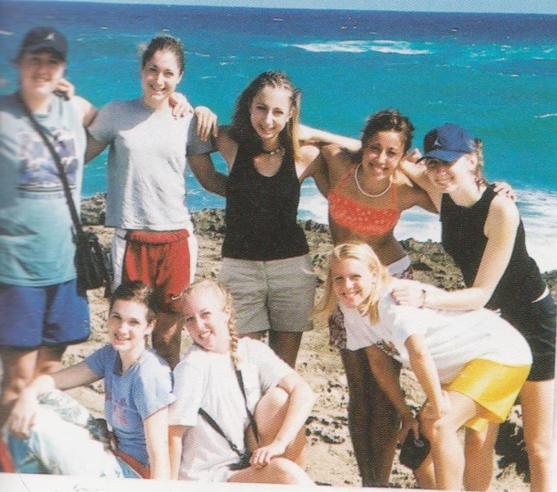
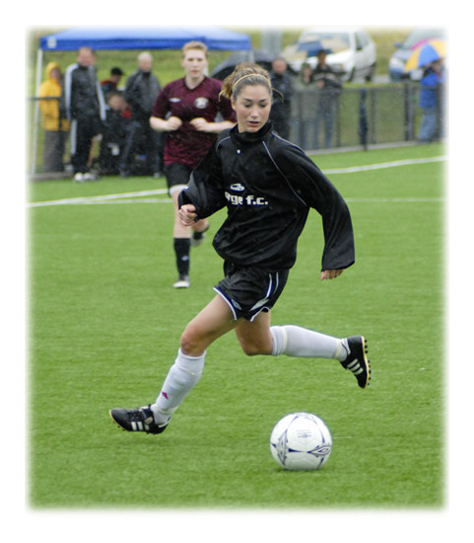
Rachelle (standing 2nd from the left) with her Belmont basketball team-mates in Hawaii

