Pam Henson Harknett 1972-2001
Pam (Henson) Harknett was a prominent Belmont coach in the 1970’s and 80’s, who was the head coach of the senior girls’ basketball team and assisted with the volleyball, field hockey and track programs. She guided the Tomahawks basketball team to several Greater Victoria league titles, Island Championship tournaments, and a berth in the B.C.’s
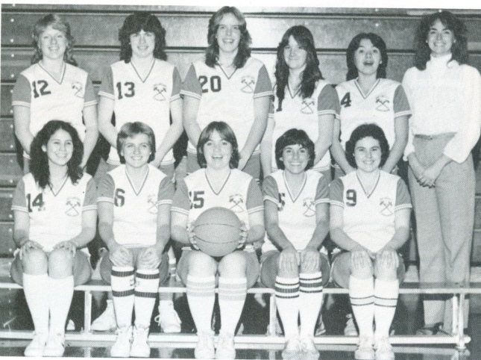
Pam is standing in the back row on the far left with her 1972-73 Belmont Tomahawks team
Athletics have always played a significant role in Pam’s life. As a youngster, she grew up on Portage Inlet and attended Craigflower Elementary, Colquitz Junior Secondary and Esquimalt Senior Secondary schools. She participated in all sports available at school, including field hockey, volleyball, basketball and track and field, and while in high school, she also played basketball in the community with First United, one of the organizations that consistently produced elite female players in the 1970’s.
Pam enrolled at Uvic to pursue a teaching degree and majored in secondary physical education and counselling. During her freshman and sophomore years at UVic, she continued to play basketball for the First United junior women’s team that won a BC Junior championship title and took third place in the Canadians. From 1969-72, she suited up with the UVic Vikettes, first coached by Howard Tooby, and later led by her former First United coach Mike Gallo.
The following September, Pam was hired to teach PE 11 at Belmont. Although teaching P.E. and coaching field hockey, volleyball, basketball and track and field were all time-consuming ventures, Pam still continued to play basketball herself for many more years at the Senior “A”, Senior “B” and Masters levels before hanging up her high tops to begin coaching her two sons’ night league teams.
Some of Pam’s best coaching memories from her Belmont years revolve around the relationships she built with the female athletes she got to know so well. She recalls that “in that era there were lots of road trips that really challenged our basketball expertise and showed that we could play tough competitions with anyone. There were long van rides and weekend tournaments to Courtenay, Campbell River, Nanaimo, Vancouver and who could forget the flights and travel experiences to the 24 team basketball tournaments at Victoria Composite High School in Edmonton.” Pam is held in high esteem by her former players, who remember her as a knowledgeable coach who pushed the athletes to improve their skills but always provided a positive and fun atmosphere. The fact that several of Pam’s teams still hold periodic reunions that include their coach several decades after high school graduation is evidence of the bonds that were created through their shared sporting experiences. Pam says that she’s always thrilled to have the chance to get together with former players to reminisce about the past and share updates on their current lives.
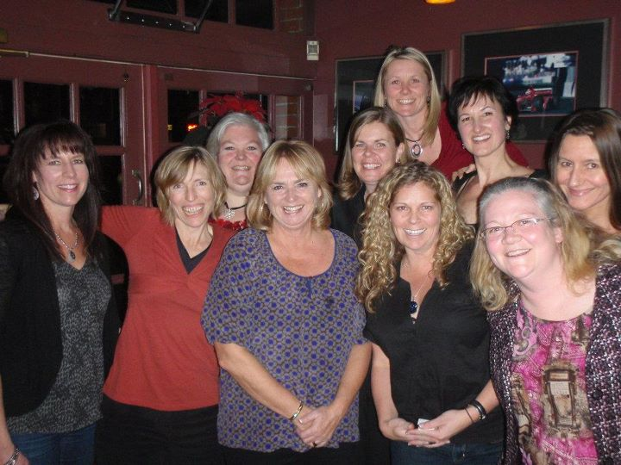
Reunion photo (2011) of the 1982-83 Belmont Tomahawks Senior Girls basketball team that won the Lower Island title that season
Since 1972, Pam spent her entire teaching career at Belmont. In 1995, and again in 2002, she was seconded by the BC Ministry of Education to help develop External Credential process and assisting policies. She was responsible for the Grade 11 and 12 External Credit initiative that granted high school credits for athletes who participated on provincial and national sports teams or played in BC, Canadian or other major games. She also worked on the Physical Education IRP’s, and was part of a group that examined educational opportunities connected to the 2010 Winter Olympics in Vancouver.

