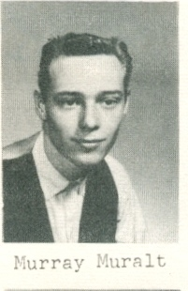
Murray Muralt: 1962-67
Murray Muralt, an all round athlete, was one of Belmont’s top basketball players in the mid-to-late 1960’s. He first got involved with sport with a neighborhood team and continued to play through his high school years. Murray enjoyed his time at Belmont and has fond memories of his favorite teacher Mr. Teagle, who used to participate in rugged floor hockey games with the older boys.
Although Murray was a skilled basketball player, lacrosse was his number one sport. He played on youth teams in the community and won an impressive seven provincial championships. He moved up the ranks to play for the Victoria Junior Shamrocks for the 1967 and 67 seasons before graduating to the senior Shamrocks for several more years. An interesting trivia fact is that one of Murray’s team-mates on the Shamrocks was Muzz Bryant, the longtime Belmont PE teacher and boys’ basketball coach.
Today Murray lives in the Western Communities and still keeps in touch with a few of his old Belmont sporting friends.

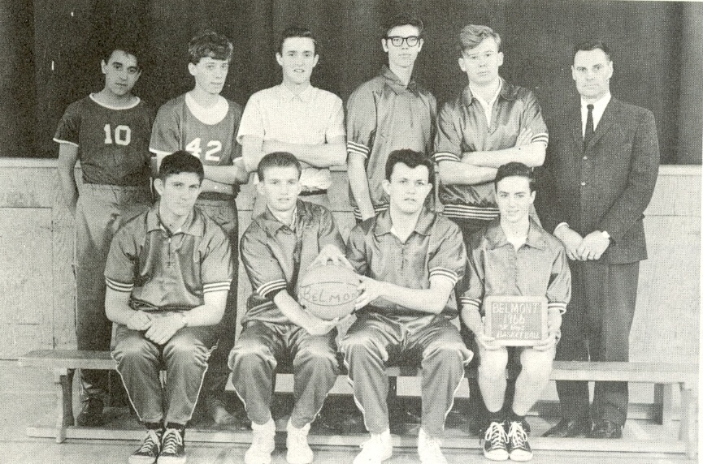
Belmont’s 1966 Boys’ Basketball Team.

