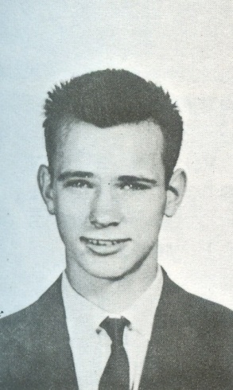
Mel Spotswood: 1955-1961
Mel Spotswood, Belmont’s top athlete from 1961, has been highly active in sports his entire life. He and his two siblings grew up on their grandfather’s farm at the bottom of Lagoon Road and regular chores such as milking the cows, collecting eggs from the chickens, mowing the lawns, and harvesting the hay fields, were part of the children’s regular routine. Mel also worked part-time after school on a mink farm in high school and would run the few miles home to the farm after completing his duties. All that outdoor physical activity made him fit and strong from a young age.
Mel attended Belmont for grades 7-12 and was a valuable contributor to a variety of teams. In grade 9, he was a member of the 1957-58 Belmont track and field team that captured the school’s first Lower Island title. Mel placed 3rd in the junior boys’ 880 yard race in the championship meet. He would continue to shine at distance running events and won the annual Glen Lake run in his graduating year. Mel also excelled in soccer and basketball. One of his best Belmont sporting memories was from grade 11 when he scored the winning free throws in the dying seconds of the Braves’ thrilling one point victory against Vic High in front of an enthusiastic home crowd. Vic High would become BC champions that year, and the Belmont defeat would be their only loss of the entire season.
Although his Belmont achievements were impressive, Mel feels that lacrosse was his best sport. He played in the community for many years, working his way up through the bantam, juvenile, and junior ranks. He played the rover position, which allowed him to take advantage of his speed and tenacity. Mel was selected MVP for his Juvenile A team and was a member of the Victoria Junior Shamrocks when they won the Minto Cup to become national champions. He also played for the senior Shamrocks, but couldn’t continue on a long-term basis due to his commitments with the navy.
After graduation, Mel entered the Navy College for grade 13, where he was won the institution’s top sports award. He then graduated to Royal Roads military college and continued to impress with his athletic ability. He was selected as the college’s top athlete in his second year and won the boxing competition (in the middleweight or light heavyweight divisions) all three years he was at the college. At Royal Roads, he was also introduced to the life sport of tennis, which he played for many years as an adult.
Mel feels that sport has tremendous physical and social benefits and believes that all youngsters should participate in a variety of athletic pursuits. He has retired from the navy and now lives in Nanaimo with his wife Caroline.
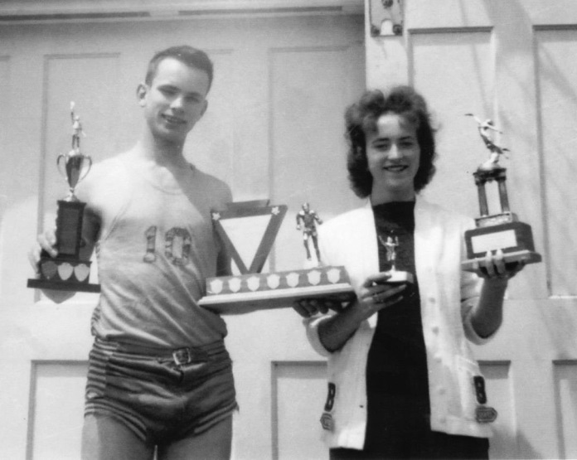

Mel is holding the trophies for Belmont’s top male athlete and the Glen Lake Run. His grade 10 sister Sandi was named the school’s top female athlete that same year.

