**Massimo Segato: 1988-1990** 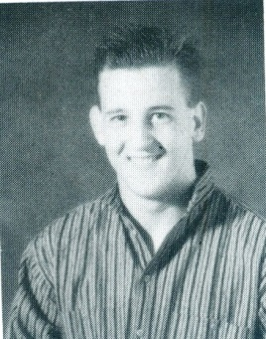

Massimo Segato, Belmont’s top grade 11 athlete of 1989 and top senior athlete of 1990, was a key contributor to a number of sports teams during his two years in high school, including basketball, volleyball and track. Soccer was the sport that he first played in the community as a youngster, and he didn’t start playing organized basketball until grade 8 at Spencer. It didn’t take him long to become skilled at the game, and by the time he reached Belmont, he had developed into one of the most talented players in the province who excelled at both the offensive and defensive ends of the court. He was a natural scorer who had two 40 points game as a senior and one incredible 55 point performance! He was a Times- Colonist first team All Star for two consecutive seasons, and in grade 12 he was selected as a first team Vancouver Island All Star and played in the B.C. high school All Star game.

Many years later, the “team” accomplishments and relationships are far more memorable to Massiomo than the individual accolades. He looks back fondly on the many moments he shared with his teammates while pursuing a common goal of team excellence. He feels fortunate to have been part of a group of players who were able to achieve a high level of success on the court. Massimo credits his former Spencer coaches Peter Songhurst and Gary Mols for contributing to his basketball development and says that both men were positive role models in his life.

Lessons learned through sports have carried over to Massimo’s professional life. As he explains, “*It takes a lot of hard work and perseverance to achieve goals, as well as the ability to work well with others.”* After high school graduation, athletics continued to play a significant role in his life. He played basketball at Camosun College, but Massimo says that he is probably most proud of competing in triathlons. Previously, he always was involved in team sports so he really enjoyed the challenge of competing in a new environment.

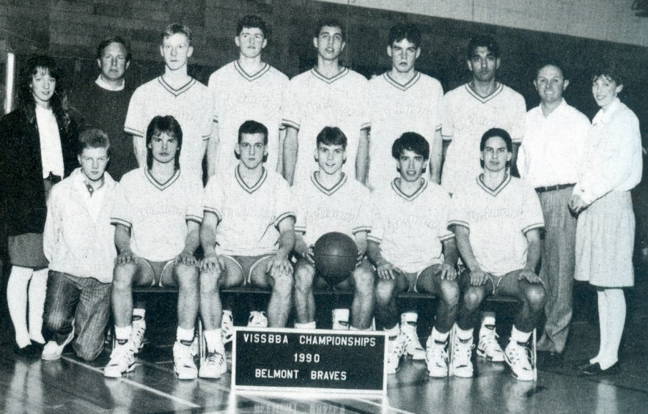Massimo’s advice to current Belmont athletes is to “*Enjoy yourself; this is a great time in your life.”*

*Massimo is seated third from the left with Belmont’s 1989-90 basketball team.*