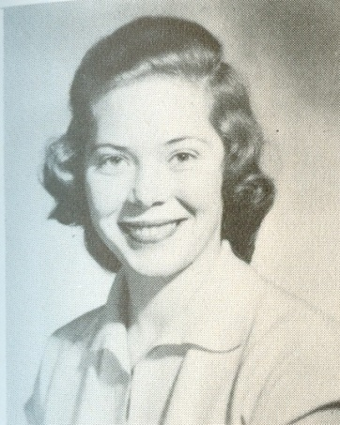**Marilyn Moseley Hepworth 1950-56**

Marilyn Moseley, or Babe as she was more commonly known to her friends and family, was a terrific Belmont athlete and a major asset to the school. Her favorite sport was softball, which she played both at school and in the community, and apparently she could throw a ball farther than most of the boys. She also loved basketball and was selected team captain in her grade 12 year. She was also the sports editor of the “Kee-Yu” annual her senior year and sang in the school choir. Babe was at Belmont when the army huts were replaced by a brand new school building that featured a large gymnasium: a huge improvement over the rough outdoor basketball court.

Babe recalls some of her favorite memories at Belmont as the Staff vs. Student softball games where she was surprised that Principal “*Mr. Stephenson could run like a deer….as we thought he was a bit on the older side*.” Babe also enjoyed the social side of high school life and added “*us gals loved to watch the BOYS play ball as well.. there were some real aces, like Herk and brother Des, Eric, John, Gary...to name a few.”*

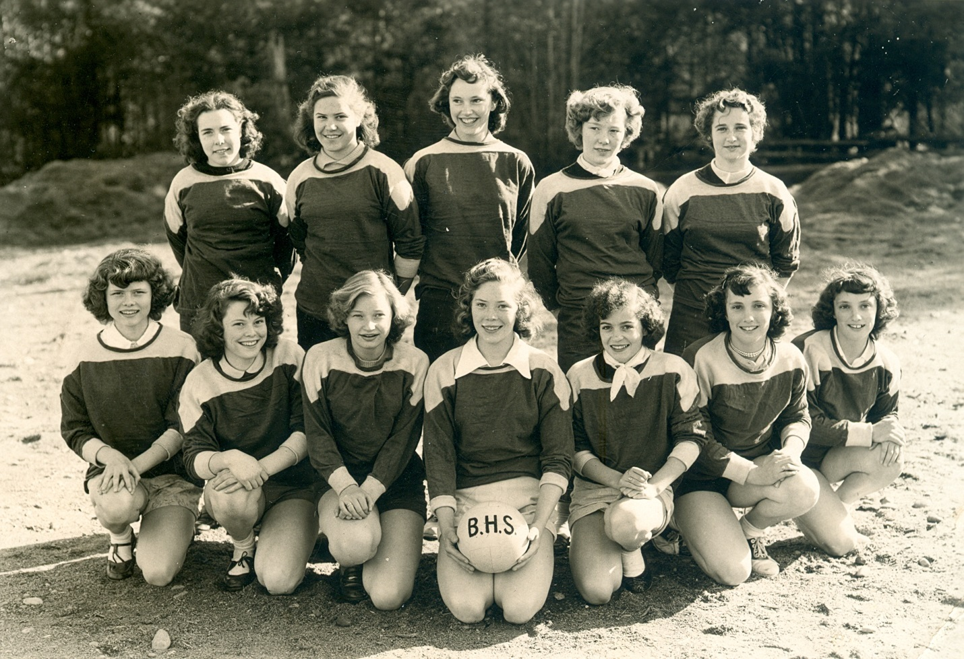

*Marilyn (Babe) is sitting in the front row holding the volleyball.*