Lloyd Powell: 1994- 2014
When Lloyd Powell announced his retirement after 20 years as senior girls’ soccer coach at Belmont Secondary School, it marked the end of an amazing career and an association with the school that has spanned an incredible 55 years, as a student, parent and coach. Lloyd has quite possible donated more volunteer hours to Belmont than any other individual in the school’s history and has left a lasting legacy.
Lloyd first entered Belmont as a grade 7 student in 1958. He was a good athlete and played on a variety of the school’s sports teams, including the very strong 1962-63 Braves’ basketball team that came within one win of advancing to the BC Championship tournament. He also played volleyball, but recalls basketball as the most organized and competitive sport offered at Belmont during that time period. Ironically, he didn’t play school soccer except informally with his friends during the lunch break.
The Powell family have a long history of strong Belmont connections. Besides Lloyd’s role as student and coach, his wife Lynda worked as a secretary at Belmont for ten years, and their son Todd (now a teacher at Edward Milne Community School) attended the school from 1996-98. Todd followed in his father’s footsteps and was also a member of the Braves basketball team.
Lloyd became involved in coaching youth soccer in the community in 1984 with the Juan de Fuca Association, and in 1994, Muzz Bryant asked him if he would be willing to also coach the Belmont girls’ team. The two seasons didn’t conflict at that time, as JDF had a fall / winter season and the high schools played in the spring, so he accepted the position. He also pointed out that it wouldn’t have been possible for him to coach at Belmont if he hadn’t had such an understanding employer. The first three years he coached on his own and was later joined by a young Belmont teacher, Troy Harris. Lloyd and Troy would work together for eight seasons, and both found the partnership very rewarding. In the years after Troy stepped away, Lloyd had other coaching partners, including Brian Hobson, Nicole Mann, and most recently, Bud Livingstone, whose two daughters played on the team.
Players and coaches alike seem to have the same profound admiration and respect for Lloyd as a coach and a man. He is described by many as a “gentleman” who treats others with kindness and respect. Muzz Bryant describes him as an “honest and caring” individual who always acted in the best interest of the girls. Muzz also noted that Lloyd always was extremely supportive of the school as a whole, and regularly attended band concerts, Pace musicals, and other events in which his soccer players were involved.
When talking to Lloyd, it becomes apparent why he is held in such high regard. He explained that his first priority each year was to try and ensure every player on the team had a positive experience and learned new skills, and that wins and losses were secondary. He cannot recall a single season that he didn’t enjoy, and his most treasured memories are of the relationships he built with the girls and the fun they had a team. When asked if any particular team stood out for its results, he mentioned the 2004 group with future university stars Moira Hood and Rachelle Armstrong, as well as the most recent teams from 2012-2014 that featured Kristen and Marisa Livingstone, Kathy Forbes, Lindsay Hargreaves, and Claire Joyce. Ironically, although the 2012 and 2014 teams both qualified for the provincial tournament, Lloyd believes that the 2013 squad might have been Belmont’s best-ever team. Although that group went undefeated the entire season, a 1-1 draw in one of the round-robin games of the Island tournament was enough to eliminate them from having a chance to play in the title game and prevented any chance of qualifying for the BC’s.
If his thousands of volunteer coaching hours weren’t impressive enough, Lloyd has fulfilled another vital position for Belmont athletics the past 25 years: as president of the school’s Athletic and Extracurricular Society. Basically, Lloyd has been responsible for heading up a group that monitors and distributes the funds that come into the school for fine arts, athletics and other activities that are not part of the regular curriculum. Other Society members are usually parents who commit to help as long as they have children in the system, but Lloyd is the one constant who comes back year after year. He can’t remember exactly how he first became involved with the society, but suspects that Muzz Byrant and Bill Spotswood used their persuasive powers to convince him to take on the role. Lloyd admits that it can be fairly time-consuming, but says that it has been a huge advantage that he lived close to the school so could pop in quickly to sign a cheque or complete other paperwork. He also says that the fact he has no children in the school means that he has no conflict of interest and can be seen to be impartial.
In 2006, Belmont coaches created a new athletic award, to be presented each year to the student who had demonstrated the most valuable volunteer service to the school’s athletic program. It was an easy choice to name the new trophy the “Lloyd Powell Service Award,” in honour of one of the most dedicated volunteers in the school’s history.

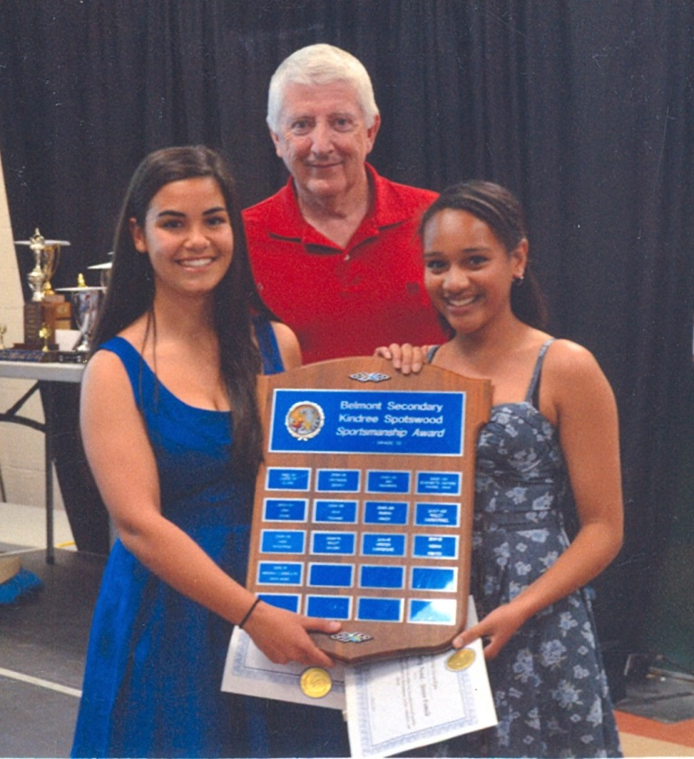
Lloyd presenting Belmont’s junior girls’ sportsmanship plaque to Julia Muniz and Miranda Llewellyn, two girls that he coached in 2013.

