Lisa Koop: 1990-1992
Lisa Koop, was an outstanding athlete who is generally acknowledged to be the best female basketball player ever to play at Belmont. She was part of a very strong night league team coached by Bill Spotswood that included Bill’s daughter Kindree. Most of the girls attended Dunsmuir Junior High School, and in their grade 10 year, won the provincial junior tournament, under the guidance of coach Kevin Harrington. Lisa was the point guard on the team and earned tournament MVP honours for her tremendous passing, ball handling, scoring and leadership abilities.
She continued her stellar play in high school, and led the Tomahawks to a 4th place finish in the province her grade 11 year. By this time, she was attracting significant attention from many university coaches, and Uvic legend Kathy Shields regularly attended Belmont games in her attempt to recruit Lisa to the Vikes. In grade 12, the Vancouver Province named Lisa the senior high school player of the year, and she and standout post Denise Rehman guided the Tomahawks to city and Island titles, with Lisa winning MVP honours at the Island tournament. At the BC’s, the girls were ranked #4, but pulled off a huge upset by defeating the top ranked Salmon Arm Jewels 83-58, with Lisa recording an astonishing 30 point, 16 assist and 20 rebound performance. In the final game, with Lisa in major foul trouble the entire game, the Tomahawks came up a little short again the Richmond Hyacks and had to settle for the silver medals.
After graduation, Lisa moved onto Uvic where she made an immediate impact and became a crowd favorite with her exciting and dynamic style. By her third year, she had become one of the top players in the country and was named Canada West Player of the Year and a CIS All Canadian for three consecutive seasons, from 1996-1998. In 1997-98 she helped lead the Vikes to a national championship title. By the time she completed her five years at Uvic, she had become the team’s all-time leader for both points and assists, and still holds the Vikes record for career points. She also spent some time with Canada’s national team and played professionally in Spain.
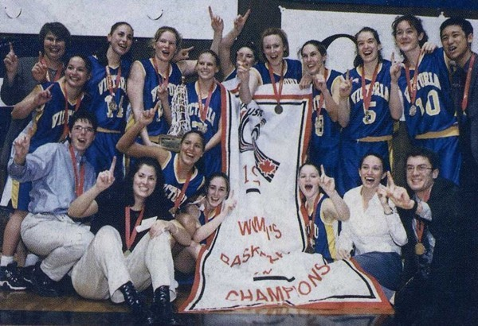
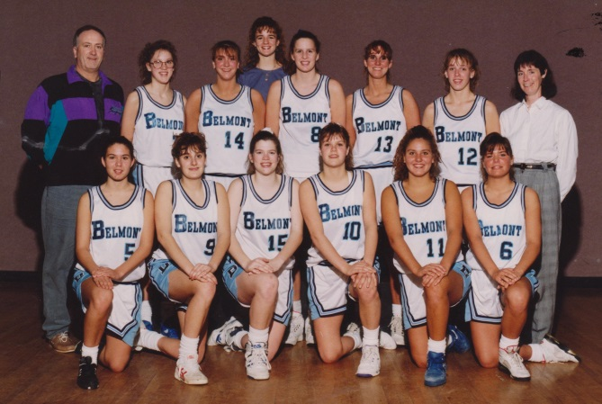
Lisa (kneeling 3rd from left) with Uvic’s 1997-98 national championship team
Lisa (#11) with the 1991-92 Belmont team that finished 2nd in the province

