Liam Girard: 2000-2002

Liam Girard was one of the top soccer players ever to play at Belmont. He was a strong all round athlete who participated in a variety of sports as a youngster, including track and field, volleyball, and basketball, but soccer became his main focus by high school as he had developed into one of the top young players in the country.

While still at Belmont, Liam, affectionately known as Mutt to some of his team-mates, was selected to Canada’s Under 17 national soccer team. Although making the team was an extremely impressive accomplishment in itself, Liam added to his resume by being selected team captain and by scoring a goal against Costa Rica in a tournament in San Jose, Costa Rica in 2002. Liam was a key member of a talented Bulldogs school team that included close friend and future national team star Josh Simpson, but he considers his best Belmont sports memory to be watching friends such as Shawn Loglisci, Zack Stewart and Curtis Payne play basketball and volleyball in the packed Spotswood Gym. He says it was always fun going to the basketball and volleyball games.

After high school graduation, Liam earned a Division 1 athletic scholarship to the University of Denver. It didn’t take him long to make his mark both on and off the pitch. Once again, his leadership qualities impressed others and he was a team captain for his final three years with the Pioneers. He also earned numerous awards and accolades, including being named an NCAA Regional All American in 2004 and 2005 and three times as an All-MPSF selection. After his final university season, Liam was drafted in the 6th round of the MLS by the Colorado Rapids and played one season of professional ball. He later returned to Victoria and continued to play at a high level for Gorge FC, with whom he earned MVP honours at the 2010 BC Men’s Soccer Championship tournament.

Liam says that there were many people who helped him develop as an athlete, but makes special mention of his Dad – Mark and his mom-Jo Ann and says he will never be able to repay them for all the time and financial commitment they provided. He is also grateful for the opportunities that soccer provided: “Soccer has shaped my life and given me opportunities that I would have never dreamed of. Soccer allowed me to get a free University education, to travel the world, meet amazing friends and give me challenges that I still look back on today. I still play soccer, albeit on a less competitive basis. I still watch and follow soccer as closely as I ever have.”
When asked if he has any advice for aspiring Belmont athletes today, Liam replied: “Belmont has a history of producing elite athletes. The one thing in common with all those athletes is that they put in the extra work behind the scenes. Just going to practice isn’t enough. The work you do on your own honing your craft, away from your peers, is the work that will set you apart.”
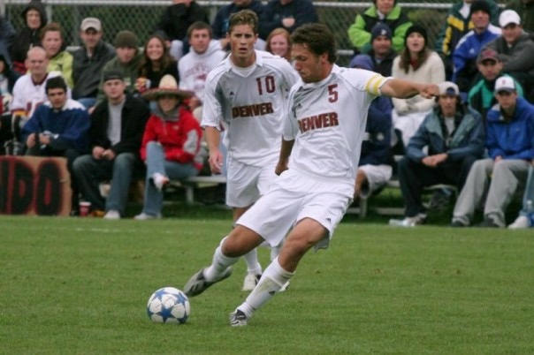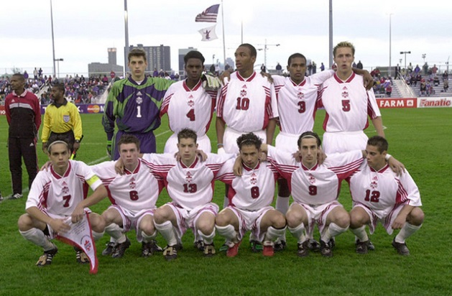
Liam (#5) with his U-17 Team Canada team-mates
Liam preparing to strike the ball

