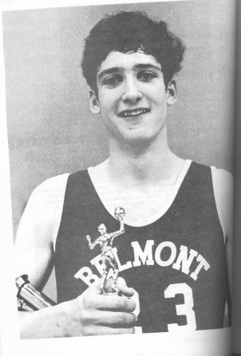
Lee Edmondson: 1970-1972
Lee Edmondson is perhaps the most outstanding Belmont male basketball player in the school’s 67 year history, earning numerous individual accolades while leading the Braves to a third place finish in the provincial championship.
Growing up on a farm in Alberta, Lee was active as a youngster and participated in a variety of sports, including baseball, football and hockey. Although he continued with hockey until grade 9, he started to become serious about basketball as a Dunsmuir grade 10 student when Elizabeth Fisher principal and basketball coach Wally Russell, watched him play against the Sun Devils and encouraged him to develop his talent. Wally had accepted the principal position at Belmont the following year and was excited to have the opportunity to coach Lee instead of play against him.
In his two years at Belmont, Lee amassed an impressive athletic resume. Some of his top individual accomplishments include winning the most valuable player award at the Vancouver Island High School Basketball Championship and earning first team provincial all star recognition. Even more important to Lee than individual honours, were the outstanding achievements of the team. The Braves became the first senior boys’ Belmont basketball team to defeat Oak Bay and to win the Lower Island title. They were also the first team to win the Island championship and advance to the provincial tournament. Forty –five years later, their third place result in 1972 is still tied for the best Belmont finish ever at the boys’ basketball high school tourney. Lee’s inspirational account of the Braves’ big league win in the Oak Bay gym is cited in the 1970’s article located in the history section of the website.
After high school graduation, Lee accepted a full Division 1 NCAA scholarship to Montana University. He later returned to Victoria and starred for the Uvic Vikings, and helped the team rise to national prominence. It was also at Uvic that he met his wife, Ronni Hind Edmondson, who played for the powerhouse Vikettes’ basketball team. The relationships that Lee developed through basketball have been important to him throughout his life. “Many of my best friends are players I played with or against and therefore much of who I am I owe to the lessons I have learned through sport.” He also found sport a way to bond with his own three children, as he coached his sons in basketball and hockey and shared an active lifestyle with his daughter. “Candidly what I think I have most enjoyed is being a part of my kids’ lives as they succeeded in sports endeavours and careers more so than my own. Sports participation adds to character development in ways that are uniquely individual however strengthen family, community and teamwork.”

There were a number of people who helped Lee achieve his athletic goals. His mother and grandmother attended all of his high school and college games and offered non-judgmental support no matter what the results. He also feels that indirectly, Dunsmuir principal Harold Parrott helped him immensely as he went out of his way to create an environment where the boys could have a basketball team and get a sponsor, despite the fact Dunsmuir didn’t offer organized sports teams at that time. He took a group of 7 or 8 “misfits” who didn’t even have uniforms and made it possible for them to have a team and develop their skills. Five of those boys went on to play at Belmont. Lee also credits Braves coach Wally Russell and Uvic coach Ken Shields as two people who really have had positive influences on my athletic accomplishments and world views of sports and life in general.”
Lee believes that “sport is universal and irrespective of the decade it starts with fun and passion for the game and yourself. I truly believe that although we talk a lot about team I’m not sure I completely agree that there is no ‘I’ in team because their most assuredly is. The secret is to strive diligently to embrace your personal ego to accomplish and succeed melding it together with strengths and attributes of your coaches and teammates to collectively build something stronger than yourself. My advice is to embrace your challenges and individual accomplishments and cherish the moments that collectively everyone in your midst succeeds. This will stand you well for any endeavor you choose on your life path.”

