Kristy Smith Evans (1972-1977)

Kristy was an all-round athlete who played on a variety of teams at Elizabeth Fisher and Belmont, including field hockey, volleyball, basketball and track and field. She also participated in softball in elementary school and played on community teams through the Langford organization, but there was no high school girls’ softball league at that time, so that wasn’t an option at Belmont.

Kristy was a valuable contributor to all the teams she played on and displayed determination and toughness, as evidenced by the fact she once broke her foot in a volleyball match but continued to play the rest of the game before going to the hospital for an x ray and discovering the extent of the injury! It was in track and field that she rose to national prominence. Her strong arm developed through many years of softball made her a natural for the throwing events of javelin, discus and shotput. She won the Vancouver Island championship in grade 12 which qualified her for provincials. This was an extra impressive accomplishment considering there wasn’t enough interest that year to field a track team. PE teacher Patti O’Neill stepped up and volunteered to be a teacher sponsor so that Kristy could compete at the BC’s as Belmont’s sole representative.

After high school, Kristy played in the Victoria-Saanich Women’s Fastball league from 1979-1983, and earned a “Golden Glove” for her defensive expertise at third base in 1980. She later competed at the Masters level and won the provincial and Western Canadian championship, an extra special win since she shared it with her two sisters Della and Jennifer. She also competed in the 1998 World Masters Games in Portland Oregon.

Three or four years after high school graduation, Kristy decided to join the Victoria Track Club to give javelin another try and she made remarkable progress, first doing well at provincials and then qualifying for the national championships. She was informed by the national team coaches that she was too short to be very good at the sport, but she proved them wrong by winning the Canadian women’s title in 1986! That same year, she toured Europe and Eastern Europe with the national team, and capped off the five week trip by competing for Canada at the Commonwealth Games in Edinburgh, Scotland. After falling only a few centimeters short of qualifying for the 1988 Olympics, she decided to call it a career.

Kristy had a number of people who supported her throughout her athletic career, including her husband Ian, mom Shirley, dad Vern, and sisters Della and Jennifer. She also appreciated her Belmont coaches, particularly Marty Adams and Patti O’Neill, who managed to maintain a great balance between competing and having fun.

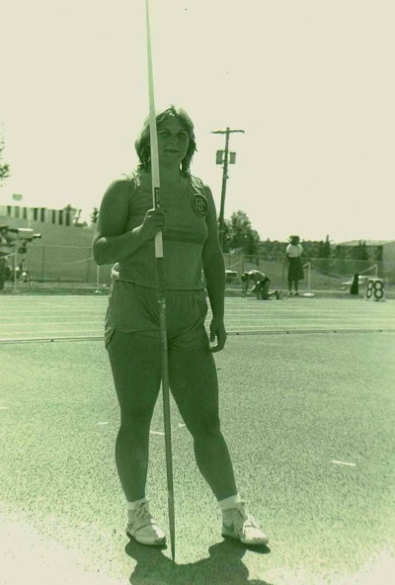
Kristy passed away from cancer in 1999. Three years later, her sisters Della and Jennifer competed in the softball tournament at the World Masters Games in Melbourne, Australia. In memory of Kristy, Shirley stepped up to the plate to represent her daughter, and later was awarded a silver medal with the rest of the team. Kristy’s love of sport lives on today through her two children Roger and Stefanie.
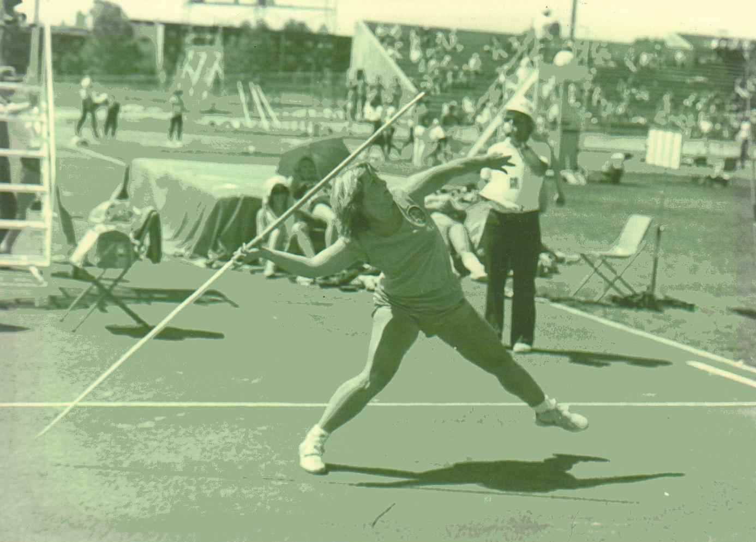

Kristy winding up to propel the javelin

