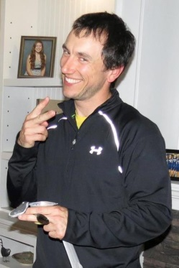
Kristopher Walushka: 1998-2001
Kristopher Walushka attended Belmont from 1998-2001. During his years at Belmont he was on the basketball and track teams all three years and in grade 12 also played on the volleyball and tennis teams. Since Kris was little though he knew he wanted to play baseball; however because his birthday was in December he wasn’t old enough to play so signed up for Langford Fastball instead. From then on his two main competitive sports were ten pin bowling and fastball.
At Belmont Kris’s top sporting accomplishment was being named Athlete of the Year in grade 12, in recognition of his many contributions to Belmont’s athletic program. He was popular with both his team-mates and coaches, and by the end of high school he had picked up the nickname “Wally”, the same name that his dad was called when he played hockey. Other nicknames depending on the team he played on include “LOU”, “Louie”, “Walls,” “Hammy,” and “Dubs.”
Kris’s sporting life didn’t end after high school. Throughout college he stayed in shape by playing intramural basketball, volleyball, soccer and Slo Pitch, as well as coaching many teams. Today he continues to coach basketball, volleyball and fastball, both in the schools and community. Kristopher also played Fastball at a high level and has represented BC in many national championship tournaments. He was the top hitter at both the International Softball Championships and Canadian National Fastpitch championships while playing for the Sooke Loggers.
He recently became a member of Team Canada, representing the country in a Pan-American Games qualifier in Parana, Argentina in October, 2014. The team finished 3rd behind Venezuela and Argentina. Kris has an interesting batting routine that he started at age 15 because his gloves weren’t sticky enough. In between pitches, he would spit on his gloves, rub them together and clap twice: a habit he continues to this day.
Over the years, Kris has had numerous dedicated coaches, but one who particularly stands out for him is one Alan Naylor, who always pushed him to do better.
When asked what advice he could offer to Belmont student athletes today, Kris replied, “Work Hard, Don’t Hardly Work”.
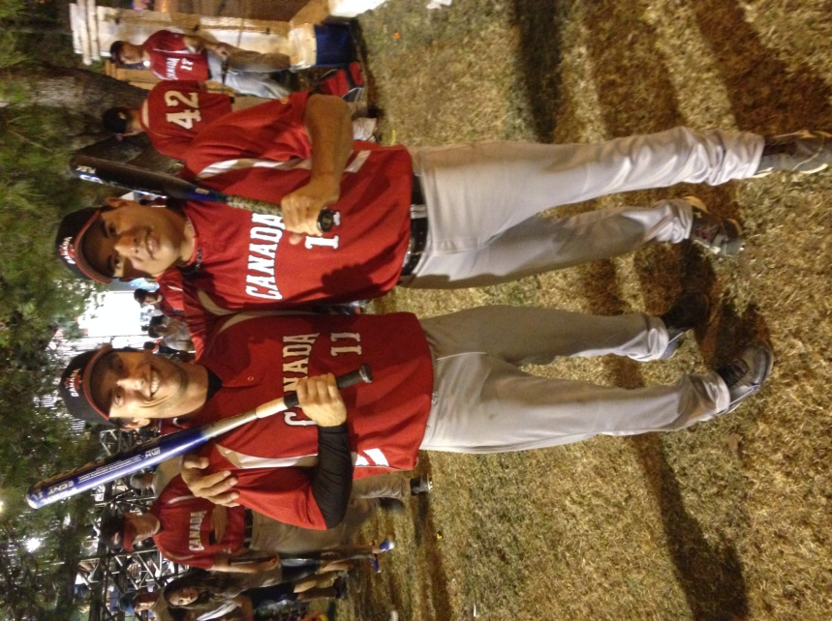
Kris, coach of Belmont’s senior girls’ basketball team, shows off his crazy side with player Claire Church
Kris is standing on the left in his Team Canada uniform.

