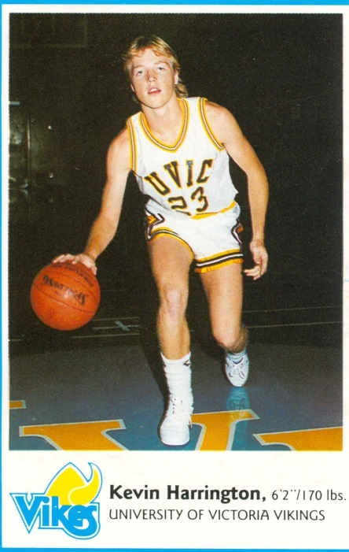
Kevin Harrington: 1986-1988
Kevin Harrington first became active in competitive sports at the age of six when he began playing community soccer. He then began playing community football at the age of 11. During his time at Belmont, Harrington played basketball, volleyball and ran track. He was MVP of the Braves Basketball team both of his years at Belmont; leading the team in scoring, steals and blocked shots. He was also the All Star at almost every tournament he played in with the team. His sporting career in high school included highlights such as going to Islands for volleyball and having his Basketball team achieve a mid-season ranking of #5 in the province. Above all else, his most memorable moments in high school sports are the friendships he made; travelling and hanging out with the team were times he wouldn’t trade for anything.
After Belmont, Harrington continued his athletic career as he played basketball with the UVIC Vikes and went on to win the Western Canadian finals, giving him the opportunity to play in a National championship tournament. He also played Quarterback and Free Safety for the Victoria Payless Junior Football team. To this day, athletics and Belmont continue to play an immense part in Harrington’s life. He now teaches at Belmont, and coaches the Belmont Bulldogs football team, a program which he himself started and continues to dedicate his time and energy toward. He hopes to one day win a BC championship while coaching the Belmont football team.
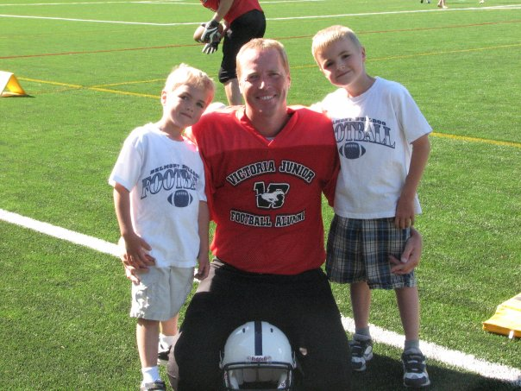
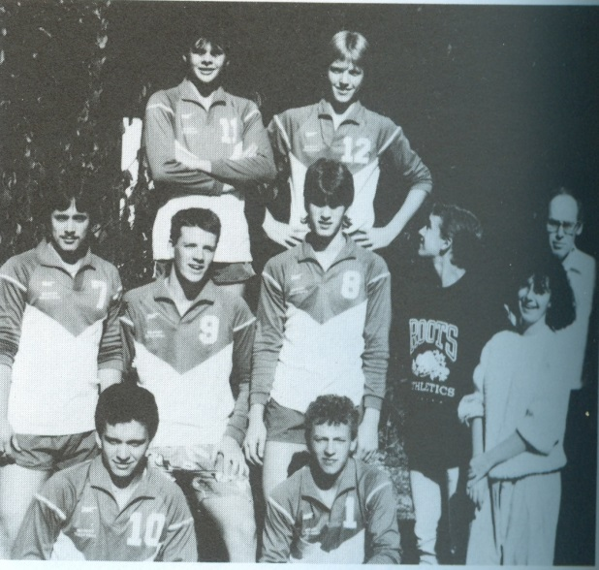
While Harrington is well-known for his athletic accomplishments as a player and a coach, he is also recognised for his selfless character. A memorable example of this (from an article in the Times Colonist) is when the Bulldogs won their first Vancouver Island High School Championship. In winning tradition, Harrington’s players had drenched him in water from their big cooler. It was a chilly day, and after the game when the audience had left for their warm homes, Harrington stayed behind. “Soaking wet, the coach was going through the stands picking up garbage.” His generosity and passion for the well-being of others have made a difference in the school and in the community.
Kevin with his two sons Q and Jaxon
Kevin (#12 in the back row) with his Belmont volleyball team-mates

