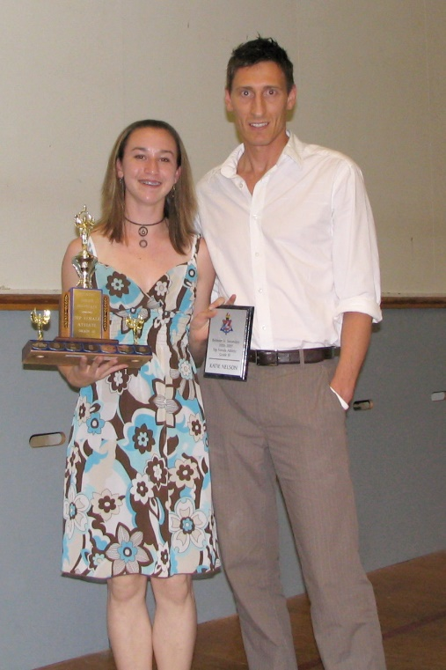
Katie Nelson: 2009
Katie was a standout track athlete for Belmont, and earned top female athlete awards for two consecutive years. In 2007, she won the gold medal in the 400 meter even at the Canadian junior track and field championship, and that same year won the provincial title in the 400 meter race at the BC High School championship meet. One year later, she earned silver in both the 200 and 400 meter events at provincials.

Katie with her track coach Dean Baldwin at the Belmont athletic awards ceremony
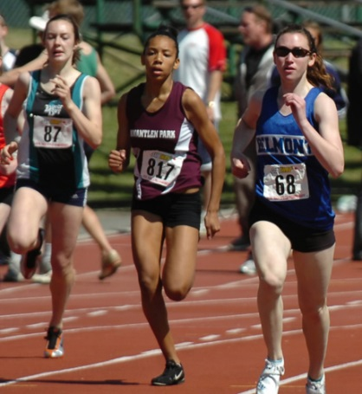
Katie (#68) competing for Belmont at provincials.

