Kathy Anderson: 1999- 2002
Kathy was a member of the powerful Belmont girls’ volleyball team that captured the gold medal at the 2001-02 AAAA Provincial Championships in North Vancouver. She was named a first team all star at that tournament.
Kathy first started playing competitive volleyball in her grade 8 year at Spencer, though she only tried out for the team because her twin sister Elaine was playing and she didn’t want to be left out. Ken Lowe, coach of the Belmont junior girls’ squad, was short of players that year so he brought up a few of the Spencer girls to fill out his roster. Kathy was one of them. Although new to the sport, she was a natural athlete and picked up her volleyball skills quickly. She also acquired the nickname “Stretch.”
By grade 11, she had developed into a dominant right side attacker and was a key contributor to the 2000-01 Belmont team that made it all the way to the final game of the BC’s, before having to settle for the silver medals. The team earned redemption the following season when they became the first Belmont girls’ team ever to capture gold at a provincial tournament. Kathy describes that group of girls as a “super, cohesive and awesome team,” and relished the fact she could share the experience with her twin.
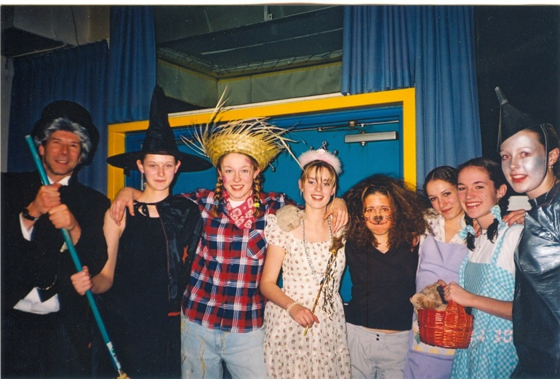
Although Kathy considers the provincial title her top sporting accomplishment at Belmont, her best sports memories revolve around the road trips. Some of her more vivid memories include “speeding up island with Toakley in the team van (and getting ticketed), taking over any visible Subway with the whole team, and dressing up as The Wizard of Oz cast for B.C.’s team dinner.” (Kathy is the wicked witch second from the left in the photo.)
Coach Toakley reminisces “Kathy was one of hardest hitting players I ever coached and she had an all world line shot from the right side. Also one of the feistiest competitors I’ve known.”
After high school graduation, Kathy attended Malaspina University (now known as Vancouver Island University) in Nanaimo on a partial scholarship. Her team placed 2nd at Nationals two years in a row, which was great but a little bittersweet. It was a similar story in her club volleyball, where as a U-18 player she also grabbed a silver medal at the National Championships in Saskatoon. She now plays recreational volleyball once or twice a week to keep in touch with friends and stay in shape.
There were several people Kathy credits for helping her achieve excellence in the sport of volleyball. Her family was a huge support, and she also had a number of coaches who aided her development. She lists “Ken Lowe who was the first person to pull me up to a more competitive team in Grade 8 and encourage that competitive spirit. Jason Sinclair who was a great encourager of team bonding and big defense. Last, but not least, Mike Toakley who didn't always say the things I wanted to hear, but often the wisdom I needed to. He has always been someone who saw the technical aspect of my play and knew what needed to be corrected.”
Her advice for current Belmont athletes is “Take care of your body. Do your stretching, remember to ice when you get home, do your physio stretches and remember to take a deep breath every once in awhile. And if you do take a long break from your sport, don't be afraid to get back into it when given the opportunity. Sometimes a little time away gives you a new love and a better perspective for a sport.”

