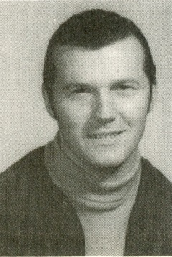
Glen Kilduff: 1963-1968
Glen Kilduff attended Belmont from 1963 to 1968. During his time at Belmont, Glen played many different sports, including basketball, soccer, and baseball. He was an excellent athlete and won the “Boy’s Aggregate Award” his senior year. Growing up, sports had always played a big part in his life. His two older brothers, who are also both Hall of Fame athletes, influenced him greatly, mentoring him in basketball and baseball.
Although baseball was Glen’s main sport, his most memorable sports moment was during a basketball game, when he went in for a layup, made the shot and got fouled in the process. His opponent argued with the referee, and continued arguing, even after being given a warning. The referee gave the opposing player two technicals, and Glen got to take three foul shots. He made all of them, resulting in a five-point play! This was an especially hard feat to accomplish considering he played when basketball didn’t even have a three-point line.
After graduating, sports continued to play a huge role in Glen’s life. He played Senior Men’s League soccer Div. 3, Senior Men’s baseball, Senior A and Senior B fast pitch softball. He also coached his three kids’ basketball, baseball and softball teams who were all active members of Belmont’s sports community and still lead athletic lives, just like their father!
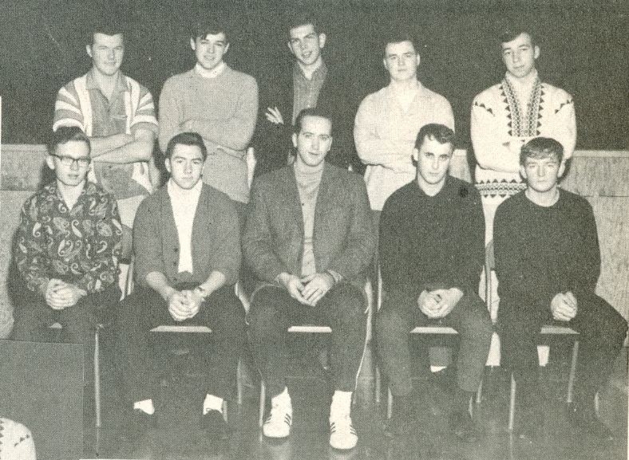
Belmont’s 1968 Boys’ Basketball Team.
Glen is standing in the back row on the far left.

