Gary Smith: 1957-1963

Gary attended Belmont for six years, from grade 7-12, and was one of the school’s outstanding basketball players. He first made the team in 1958 as a 12 year old, and was a key contributor to the Braves. His fondest memories were of the 1962 and 1963 powerhouse teams, where the boys were one of the top teams on the Island and he was the second highest scorer. He has a couple of lasting memories from that time period, including the time their coach Mr. Banks broke his ankle falling off the first step of a ladder, something that Gary found hard to fathom. A more amusing recollection was of his team-mate Dale Keown, who decided to eat a jar of pickled onions before a game to deter his check from guarding too closely. Gary can’t remember the outcome of the basketball game, but does recall Dale not feeling very well during the game.
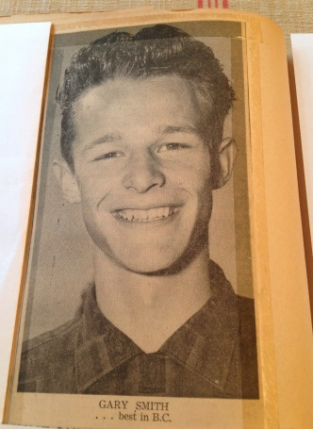
As talented as he was at basketball, golf was the sport that he achieved national status. His parents signed him up at the Colwood Golf Club in 1956. He would later join Uplands Golf Club as well in 1962. It didn’t take long for Gary to make his mark on the links. In 1961, at the age of 15, he won the Victoria Junior Title, a title he would win for the next three years. In 1963, his senior year of high school, Gary had a number of outstanding achievements. Besides winning the city junior championship for the 3rd year in a row, he won the Colwood Mens’ club title, led the Uplands Golf Club to its first victory in interclub matches, was a runner-up in the Vancouver Island Open (that included both amateurs and professionals), was named to the BC provincial team and earned a scholarship to the University of New Mexico. After one successful season at New Mexico, Gary decided to return to Colwood for his final year of junior eligibility. This proved to be a wise decision, as Gary won the 1964 BC Junior Championship and represented the province at the national junior tournament. He then enrolled at UBC and was the # 1 player on their golf team for two years. He earned his Bachelor of Commerce degree and accepted a job with Great West Life. In 1971, he was transferred to California and became regional vice president of the company in 1979. Today he lives in Pasadena with his wife and two daughters. He continues to play golf and is still a single digit handicap.

Athletics have been an integral part in Gary’s life and he believes that sport teaches valuable lessons that apply to all parts of life. First of all, focus and dedication are essential to achieving any goal. Second, sports such as basketball teach that the interaction of the players is critical to the team’s success. Finally, individual sports such as golf require self-motivation, which is also a very important life lesson.

