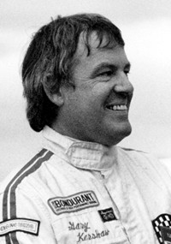
Gary Kershaw
Gary Kershaw attended Belmont in the early 1950’s and played on the boys’ softball team. Those were the days when the field was in its primitive stage and the boys had to regularly go out with rakes and wheelbarrows to clear away rocks and debris from the ball diamond before practices and games. There wasn’t a formal league, but the team played spirited matches against their rivals from Milnes Landing School in Sooke. He also participated in the school band.
Growing up right next to the racetrack at Western Speedway, it was only natural that Gary gravitated to motor sports. He started out racing go-carts and then made the transition to stock cars. According to information listed on the Victoria Sports Hall of Fame website, Gary made an immediate impact with his 1932 Ford car and won Rookie of the Year honours in 1961. He continued to record impressive results for many more seasons, and in 1968, was the stock car champion at Western Speedway. At this point, he moved up to the super stock car events, and continued to build on his earlier success. With the encouragement of his sponsors and crew, he decided to try the NASCAR super stock circuit, and enjoyed five successful seasons. One highlight occurred in 1971, when he became the first Canadian driver to ever capture the Permatex 200 in Riverside, California, an accomplishment that helped him earn Victoria’s Male Athlete of the Year award.
Gary was inducted into the Victoria Auto Racing Hall of Fame in 1984, and in 2010 was named as an entrant to the Victoria Sports Hall of Fame. While Gary is appreciative of the honours, he is quick to note that he didn’t do it alone. He is grateful to all his sponsors, without whom he would not have been able to compete. He says that he also had a wonderful team that included Dave Smith, Harvey Chipper and Joe McMurchie and that they are equally deserving of any credit of recognition that he has received.

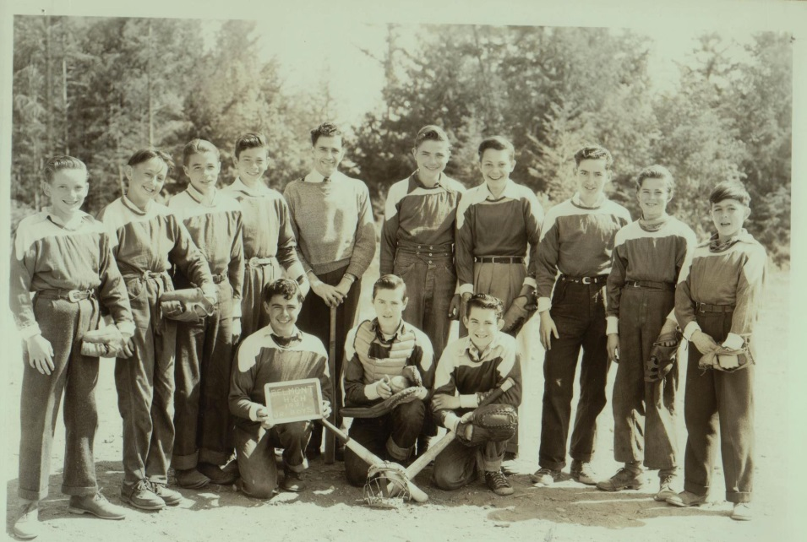
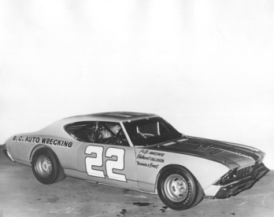
Gary is kneeling in the front row on the far right with Belmont’s 1950-51 junior boys’ softball team.

