Frelen Gorst

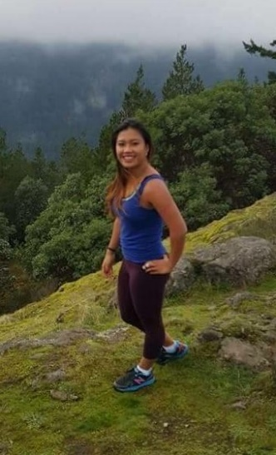
Frelen is a multi-sport athlete who competed in basketball, rugby, cross country and track and field during her three years at Belmont. She is a top scholar and gentle personality outside of athletics, but turns into a fierce competitor once she steps on the court, field or track. In grade 11, she was a key contributor to the Bulldogs rugby team that won the Lower Island title and became the first Belmont rugby squad to ever advance to the BC high school championship tournament. She was selected to the Tsunami Island rugby team last summer and placed first in provincials. She also played for the Castaway Wanderers team that earned a 2nd place result in B.C. In basketball, she was a defensive dynamo who was often asked to guard the star player on the opposing team. Her team-mates voted a co-captain her grade 12 season. She was also selected captain of Belmont’s rugby team for three consecutive years.

In 2013-2014, Frelen won Belmont’s top senior girls’ sportsmanship trophy, in recognition of her positive attitude and supportive nature with team-mates and coaches. Her grade 12 year, she won two major athletic awards as she was named Belmont’s top grade 12 female athlete and was also honoured as the school’s outstanding scholar athlete for maintaining the highest grade point average of any Belmont student who made significant contributions to least two Belmont sports teams.

It’s not surprising that Frelen’s best sporting memories revolve around road trips to tournaments such as the rugby provincials in Vancouver in 2014 and the Totem basketball tournament in Port Alberni her grade 12 year. She feels that “the group dynamic improves so much after spending a weekend together, and you always come back with inside jokes, and unforgettable stories to tell.”

Athletics will always play a major role in Frelen’s life, whether it be competitive or recreational level. She found it rewarding to hear the recollections of many of Belmont’s Hall of Fame athletes: “It's always inspiring talking to people about their passions. So many of the ones I interviewed had such wonderful stories to tell, and I didn't realise just how many amazing athletes had gone to Belmont. It's made me realise that it's very possible to achieve your dreams, and that there are so many different ways to keep having sports be a part of your life.”

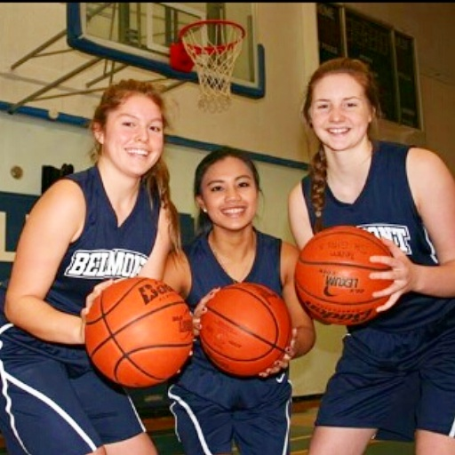
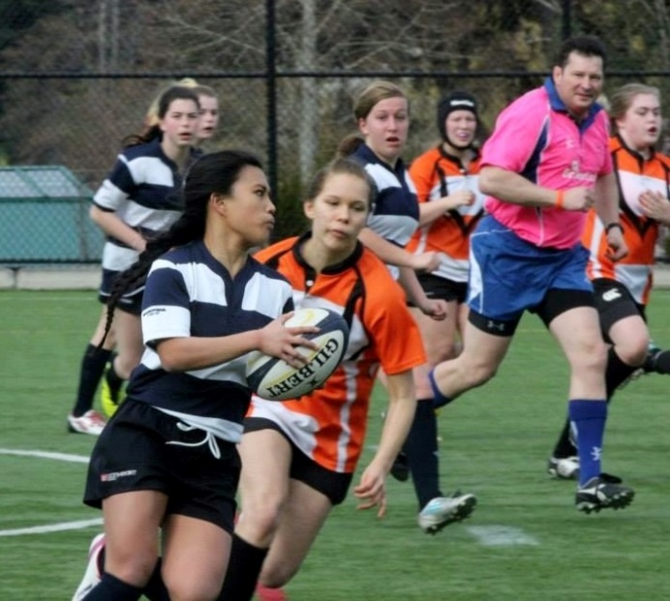
Frelen (centre) with basketball team-mates Isla Swanwick and Claire Church
Frelen eludes the tackle during a rugby match

