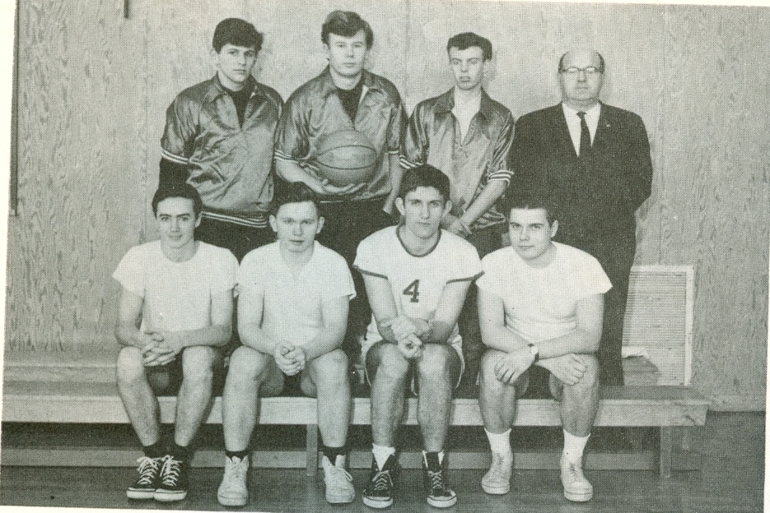
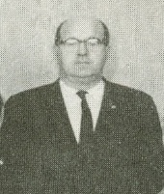
Ernie Teagle
Ernie Teagle made a huge positive impression on many Belmont students in the 1960’s and was remembered as a favorite by many of the school’s top athletes from that era. Mr. Teagle coached multiple sports teams every year, and also helped to organize the intramural floor hockey games that were so popular with many of the boys. Glen Kilduff, Belmont’s top male athlete from 1968 and 1969, composed the following tribute to his mentor that was published in the Goldstream Gazette shortly after Mr. Teagle passed away.
“Recently I notice in the paper the passing of a school friend of mine.
He wasn’t the same age as me, he was 30 years older. No, he hadn’t failed numerous grades, he was a teacher. He was not just any teacher, he was Mr. Ernie Teagle.
Mr. Teagle was not just my friend. He had befriended the whole school of Belmont. Mr. Teagle, or Ernie as some playfully called him, wasn’t even a teacher or coach of mine, yet he impacted my life as a friend. Mr. Teagle was a credit to his profession as a teacher.
Mr. Teagle would come out to the gym at lunchtime and play in our floor hockey games, which included body-checking.
Ernie was a bear of a man. Since I was the biggest kid in most games, I would take a run at him, with bruising results. I soon learned that it would have been easier to run into a wall because it didn’t have elbows and powerful shoulders like Ernie.
He would take the felt-ring puck we used down the floor and jam it with any three of us kids into the net. He would tease us, and we in turn would tease him back. Mr. Teagle didn’t have a mean bone in his body, but if he had to be stern he could do it well.
Mr. Teagle was a world class race-starter in his spare time. When the Pre-Olympic trials were at the University of Victoria in 1968, Ernie started the track events. He started such big USA team members as John Carlos, Tommy Smith, and Jimmy Hines. They went onto win gold medals in Mexico City later that year. They raised their gloved fists in the Black Power salute. So Ernie dusted elbows with famous people.
In closing I would like to say: “A man is a truly measured by the impact he has on other lives.” Sorry, I stole that quote. Mr. Teagle had a huge impact on my life at an impressionable time. I bet if you asked anybody who had him as a teacher they would say the same.
When I go to heaven, I want to see both my parents, followed closely by Mr. Ernie Teagle. God bless you “sir.”
Coach Ernie Teagle with the 1967 Belmont boys’ basketball team.

