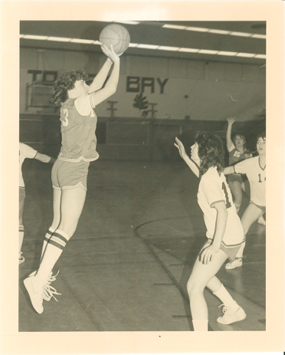
Donna Holmwood: 1982-1984
Donna Holmwood was a terrific all round athlete who was a key contributor to Belmont’s cross country, volleyball, basketball and soccer teams in the early 1980’s. She grew up in an active family, and with four hockey-playing brothers, it was only natural that she spent a lot of time as a youngster at the ice arena. Although Donna loved the idea of playing hockey like her siblings, her parents enrolled her in figure skating instead, and she participated in that sport for seven years before finally being permitted to switch over to hockey. Soccer was her dominant sport, and she first began playing at the age of ten for the Gorge Soccer Club. Although she initially tried to play both soccer and hockey during the same winter season, the experience of playing the first two periods of hockey and then racing out the door to arrive in time for the second half of her soccer game made her realize that she was going to have to choose between the two sports, and at the age of 13, she made the decision to drop hockey to focus on soccer.
At Belmont, Donna was a member of a powerful girls’ cross country team that made it to the provincial championships in both her grade 11 and 12 years. She recalls having to race in the snow in grade 11. In grade 12, her team captured the silver medals at the BC High School championships: at that time, the best result of any Belmont girls’ sports team in the school’s history. Her volleyball, basketball and soccer teams were also competitive. Donna was described by her coaches as a hard-working, dedicated, and very positive athlete who was a delight to coach. This coincides with her own recollections of high school athletics, as she stated she just loved to play, and her favorite part was “the sense of belonging and camaraderie of playing on teams at Belmont. It was things like the team piling into my mom's station wagon to travel to away games that was memorable.”
Athletics continued to play a major role in Donna’s adult life, as she continued to play both soccer and fastball. She began coaching soccer when she was in the 10th grade and has continued to coach soccer and basketball, both in the community and at St. Margaret’s School ever since. Although she gave up fastball a few years ago, she continues to play soccer in the Lower Island Women's Soccer Association for the Castaways. She says that the highlight of her post high school sports career would be playing in the Western Canadian Masters Soccer Championships with the Gorge Women's Soccer team and winning the gold medal.
Donna credits a number of individuals for having been positive influences on her as an athlete, and is grateful to have had so many great role models and mentors. The most prominent were her father, her brothers, and Peter Songhurst, who was an important part of her playing and coaching career from elementary school through to adulthood. Donna’s advice to aspiring young Belmont athletes today is “to always play for the love of your sport, respecting your teammates, opponents and officials of the game.”
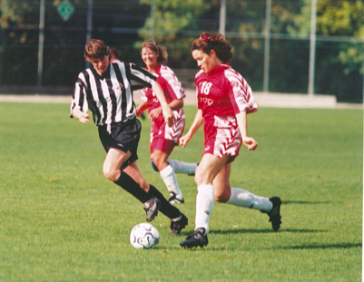
Donna (wearing the black uniform) at the 2002 Western Canadian Championships

