Mr. Harald (Doc) Palsson: 1948-1976
“Doc” Palsson was a dedicated teacher and coach who was instrumental in establishing Belmont’s athletic program in its early days, particularly the girls’ softball teams. According to the 1976 Belmont yearbook, he began his 44 year teaching career in a one-room schoolhouse in Saskatchewan in 1932. When World War 2 broke out, he joined the Air Force, and after the war ended, he moved to Victoria. He was granted a position at Belmont as a mathematics, science and art teacher in September, 1948, the second year of the school’s existence.
Mr. Palsson’s arrival coincided with that of Principal Archie Stephenson, who believed firmly in the value of sport in enriching the education of young people, and athletics became an integral component of the school’s culture. Mr. Palsson volunteered to coach the girls’ softball team and held regular practices at lunch time on the rocky diamond. The players had to rake the infield before practices and games to try to remove at least some of the debris. The equipment was primitive by today’s standards and the uniforms very basic, but the skill level was high and the competitive drive fierce, and Belmont teams earned a reputation as tough opponents. They consistently fielded strong teams and particularly relished the years they were able to defeat their SD 62 rivals from Milne’s Landing School in Sooke. Mr. Palsson’s former players remember him fondly, and say he was a gentleman as well as an excellent coach. He continued to coach girls’ softball for many years, until it was dropped as a high school sport.
His strong administrative abilities led to him being named vice-principal of the new Elizabeth Fisher Junior High School in 1960. After a short stint as president of the BC Teachers’ Federation, Mr. Palsson returned to Belmont and assumed a vice-principal role there as well. He retired in 1978 after 28 years at Belmont!
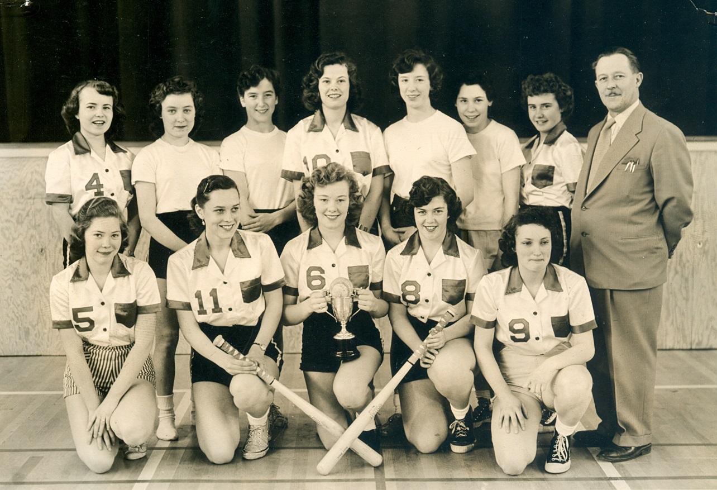
Mr. Palsson poses with the 1956 Belmont senior girls’ softball team.

