Denise Rehman: 1990-1992

Denise was an outstanding basketball player who helped lead the Tomahawks to a second place finish in the province her senior year. She was always active as a youngster, playing T ball and then softball up until grade 10. She became exposed to basketball in grade 5 and it quickly became her favorite sport.

Denise attended Spencer Junior High School for grades 8-10, where her coach Peter Songhurst gave her the nickname “Doc,” which stuck with her for many years. By the time she moved onto Belmont for grade 11, she had developed into one of the top posts in the province, as the combination of her athleticism and 6’3” frame, made her an imposing presence on the court. She teamed up with dynamic point guard Lisa Koop and a strong supporting cast of other players to make Belmont a serious contender for a provincial title. The girls made it all the way to the provincial final, but had to settle for the silver medals, losing to New Westminster in the championship game. Denise was named a tournament first team All Star for her outstanding play.
After high school graduation, Denise attended the University of Fraser Valley on an athletic scholarship. She became a key contributor on the strong team that advanced to the CCAA national tournament all four years that she played and came home with three silver medals. Individually, she was a two time All Canadian and received three All Star awards at the national championship tournaments. After finishing her playing career, she remained with UFV as an assistant coach for the next six years.
Denise credits coaches Peter Songhurst and Bill Spotswood for always encouraging her, and is grateful to her family for always being there to support her and transporting her to practices and games. She says that sport still plays a huge role in her life today. “A day without some sort of sport doesn’t happen too often in my house. I spend the majority of my time driving from one field/court to the next watching my kids play their sports (which I love). My husband coaches basketball at a university level, both my daughters play basketball, soccer, and softball, and I help run a youth basketball club with my husband in the Fraser Valley.”

When asked what advice she would pass on to current Belmont athletes, Denise replied: “If you have the opportunity to play your sport at a post-secondary level, take it! It can be such a great experience which will give you life-long memories while getting a degree!

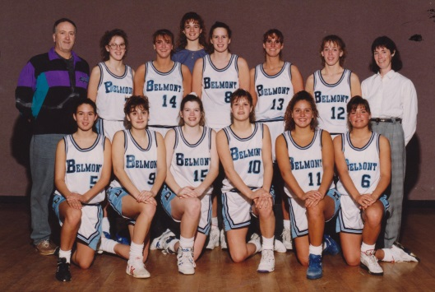
Denise (#8 in the back row) with Belmont’s 1992 basketball team

