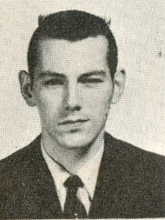
Cliff Kilduff: 1955-1960
Cliff Kilduff attended Belmont from grade seven all the way to grade twelve, graduating in the year of 61. He was well known for his athletic achievements, but was also recognised as a prefect for his academic success.
During his time at Belmont, Cliff played every sport available to play including football, baseball, basketball, soccer and track. He excelled especially in soccer, baseball where he played centre field, and track. Cliff was even a member of the 1957-58 Track and Field City Champions. That year, he had won the Junior Boy’s 880 Yard Run.
After high school, Cliff’s life continued to include sports. He played golf, and tennis. In fact, he even met his wife, Anne, who is also a Hall of Fame Athlete on the tennis court! Cliff became a fifth grade teacher at Happy Valley Elementary School, and coached many different sports teams there for his teaching span of thirty years. He was also involved in running the district wide cross country, track and field, basketball, volleyball, and swimming meets.
Cliff was loved dearly by his students, and although he has now passed away, his memory will live on in the hearts of all who he has taught, coached, and inspired. In fact, when the old Happy Valley School burnt down, and then rebuilt, the new gymnasium was named the “Kilduff Gym” after him, and in front of the gym, there is a plaque with his picture, commemorating him for all that he has done.
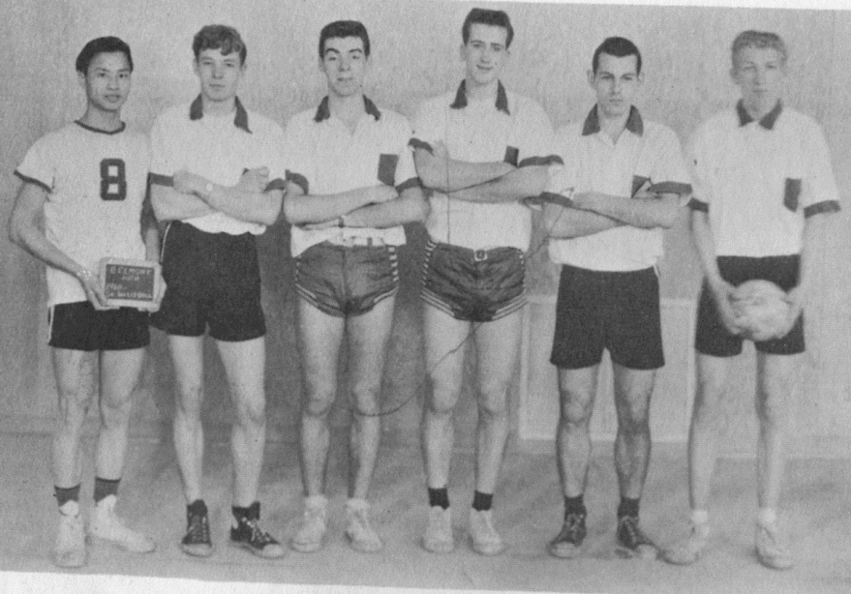
1960 Belmont boys’ volleyball team: Cliff is second from the right.

