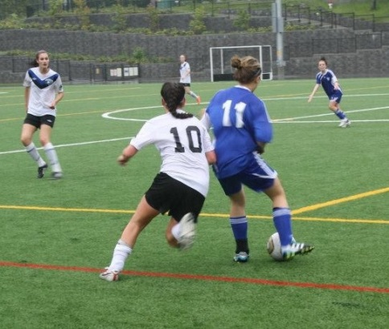
Claire Joyce

Claire has maintained an active lifestyle ever since she was a preschooler. Her parents registered her with the Gorge Soccer Association at the age of four, one year later, her family moved to Australia for a three year exchange. Claire continued playing competitive soccer, and also took up tennis, swimming, and track (she ran her first one kilometer race when she was seven).

Upon her return to Canada, she joined Juan de Fuca soccer, and each year was selected for the highest level possible in her age group. In grade six, she became involved with the HPL summer program and travelled to various tournaments in the States. After playing one season of Metro soccer, she was chosen for the Highlanders Reserves team that would capture a provincial title in 2013. This past year, she played in the Metro Women’s Soccer League and was looking forward to joining the Highlanders senior squad before the team announced that it was folding due to financial difficulties. Although soccer has always been Claire’s favorite sport, she participated in a variety of other activities during her middle and high school years, including cross country, basketball, volleyball and track and field. In grade 7, she completed the Times Colonist 10 K event with an impressive sub 46 minute result, and she ran her first half-marathon in grade 9. She was also a member of Belmont’s junior and senior girls’ basketball teams that finished fourth on the Island her grade 10 and 12 years.

Claire’s best Belmont sporting memories are of her 2013 soccer team that went undefeated in league play and won the Ryan Cup for the first team in the school’s history, and the 2014 team that qualified for the BC championship tournament. She is one of the leaders on this year’s squad that is hoping to contend for an Island and provincial title. She credits a number of people for contributing to her soccer success. Her parents have been incredibly supportive throughout the years, and she’s enjoyed the camaraderie and competitive drive of her close friends and team-mates Lindsay Hargreaves and Jenna Brown. As well, Dunsmuir and Belmont coaches Gord Johnson, Brian Hobson and Troy Harris were also terrific mentors.

Claire is heading off to the University of Lethbridge next season, where she will play varsity soccer and work towards a nursing degree. She’s enjoyed the sports history project and finds it inspirational that so many of Belmont’s Hall of Fame athletes have remained active their entire lives, and that their love of sport has often carried over to their children.

