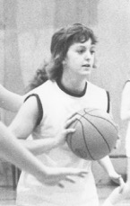
Cathy Auburn: 1969-72
Growing up in Ontario on a military base provided Cathy with many sporting opportunities and helped her develop into a talented multi-sport athlete. She enrolled in competitive gymnastics around the age of 8, and also played on curling and bowling teams, figure skated, and took tap and ballet lessons. Her first memory of really playing basketball and volleyball was in middle school in grade 7.

After moving to the west coast with her family, Cathy attended Elizabeth Fisher for grade 10 and Belmont for grades 11 and 12. She and her younger sister Sandy became mainstays on a number of school teams. Cathy played field hockey, volleyball, basketball, badminton, and track and field. She even recalls filling in on a relay team at an inter-school swim meet and helping her team place second, despite falling off the starting block! Cathy was recognized for her many contributions to the school athletic programs by being selected as the top junior female athlete in 1970 and the top senior athlete in 1972. After grade 12, she also received one of ten $750 Nancy Greene scholarships awarded to B.C. students, which at the time, easily paid for her first year of university.

Although Cathy earned a number of individual accolades, being named a Vancouver Island all star basketball player for two consecutive years, her best high school memories revolve around the times she shared with team-mates. She loved the basketball road trips and has fond memories of travelling to the tournaments with various teams. She also appreciated the chance to play on a Victoria Representative volleyball team in grade 12 with her younger sister Sandy. The girls were two years apart in age, and were the respective Belmont / Elizabeth Fisher reps.
After high school graduation, Cathy played for the powerful Uvic Vikettes basketball team from 1972-1976 and also rowed for Uvic from 1972-1975: two demanding sports to juggle! She rowed internationally for Canada at the European Championships in Moscow in 1973, and twenty-four years later, a racing shell was named the “Spirit of ‘73” in her team’s honour. As an adult in Kelowna, she curled, played basketball, softball and volleyball, and even tried a season or two of flag football and floor hockey. She kept her competitive drive stimulated by participating in several BC Winter Games in basketball and played basketball in the World Master’s Games in Edmonton. She continues to remain active and plays volleyball, badminton and pickle ball, as well as enjoying hiking, biking, kayaking and downhill skiing.
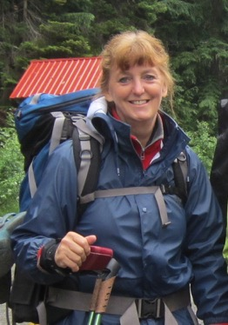
Cathy advises current Belmont athletes to try lots of different sports and activities to give you an activity-based mind set that may allow you to take up any sport later in life. She states that “high school sports are a tiny part of your life but the experiences and relationships will stay with you. I have lost touch with most of the girls from high school and university but if I was to see any of them now, I would view them as friends! From my years of playing Ladies Basketball, I have maintained a core group of wonderful friends. We are there for each other years after the games are just memories.”
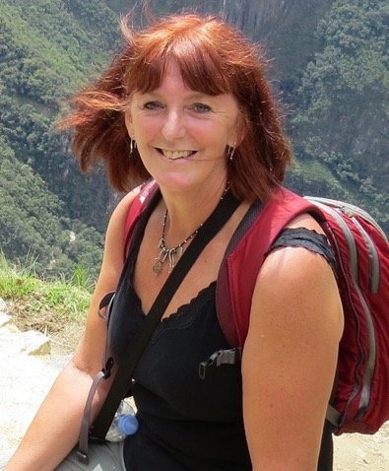
Over four decades after Belmont graduation, Cathy maintains an active lifestyle. The photo on the left shows her at Machu Pichu in 2013, while the right photo was taken in 2012 at Glacier National Park.

