Carol Newcomb: 1955-62
Carol Newcomb attended Belmont from 1955-1962 and was a main contributor to the school’s athletic program, participating in softball, basketball, volleyball, swimming and track and field. She considers her top accomplishment at Belmont to be her selection as the Top Female athlete in her senior year. Carol first started playing softball at school, but joined the Victoria Vikettes in 1960 and continued to play fastball for many years in the community. From 1960 to 1973, she played 2nd base, catcher and out field for the Vikettes. Her team won 12 Sr. B titles, 2 Sr. A titles, 2 Western Canadian titles, and also captured a silver medal in 1973 at the Canada Summer Games. Until 1994 she played on 3 other fastball teams. In 1994 Carol switched to Slo-pitch and has been playing with the Shakers mixed team ever since. In 2007 Carol and a group of women put together a 55+ ladies team to compete in masters’ age group competitions. In 2011 her team won a bronze medal at the B.C. senior games, earned a silver result in 2012. She left the team after that year to just play on the mixed team.
Bowling was Carol’s other long-time sport. From 1964 to 1994 she bowled 10 pin on several teams in several leagues, and won numerous high average, high game, and high series trophies. In 1967 she finished 10th overall in the B division at the World Bowling Championship in Rochester New York, but unfortunately she had to retire from bowling after injuring her shoulder. Carol’s role models were her parents and all of her coaches in school, as well as Walter Yeamans, her Vikettes softball coach.
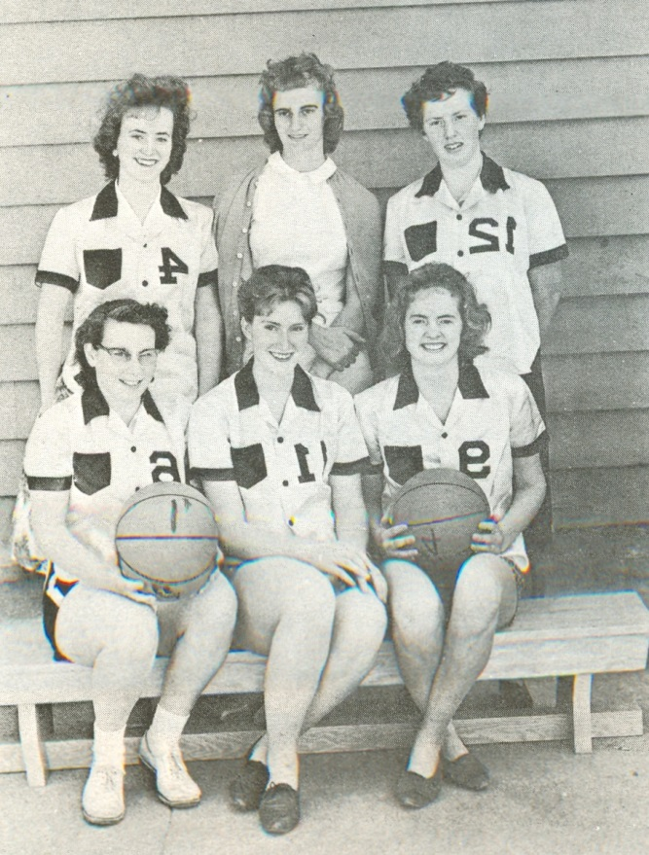
Carol is sitting on the far left in the front row in this photo of the 1961 senior girls’ basketball team.

