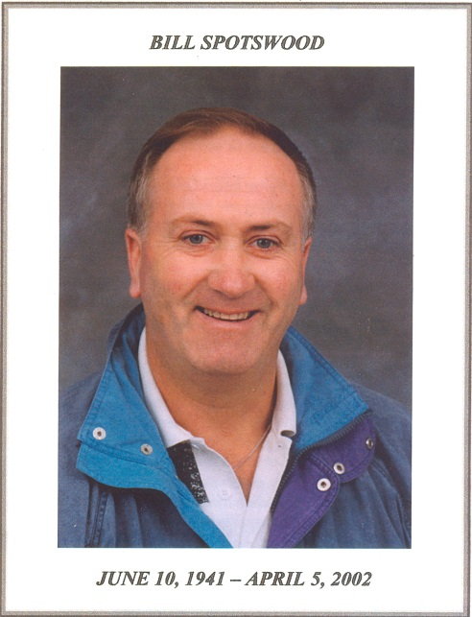
Bill Spotswood: 1967 – 2002
“ Busiest guy of all was Bill Spotswood, the athletic director and coach of Belmont. The Brave mentor not only was in charge of the gym, the ticket takers, the programs, the clock and timers and press and visiting team billet arrangements, but he also refereed a few games.”
The preceding excerpt from the December 12th, 1977 Port Angeles Daily News submitted by veteran high school broadcaster Scooter Chapman clearly captures the dedication, organizational abilities and versatility of former Belmont coach Bill Spotswood. Bill spent thousands of hours in the gym that now bears his name, first as a talented high school athlete and later as a long-term respected coach.
After graduating from Belmont in 1960, Bill earned his BA in history and geography at Uvic, and then headed off to explore Europe. While he was away travelling, his mother received a call from the Sooke School District superintendent who hoped to recruit Bill to teach PE at Elizabeth Fisher Junior High School in September of 1967. Bill was interviewed as soon as returned to Victoria and was hired on the spot. Besides teaching PE, Bill made it his mission to revitalize the boys’ athletic program, and he coached almost every junior boys’ teams in those early years, including basketball, soccer, track and field, floor hockey and rugby. He coached both the junior and senior Elizabeth Fisher basketball teams in order to build continuity, and his efforts paid off in 1972-73, as the Sun Devils basketball team captured the Vancouver Island junior boys’ title. This win was extra special as the championship tournament took place in the Belmont gym in front of enthusiastic family and student supporters.
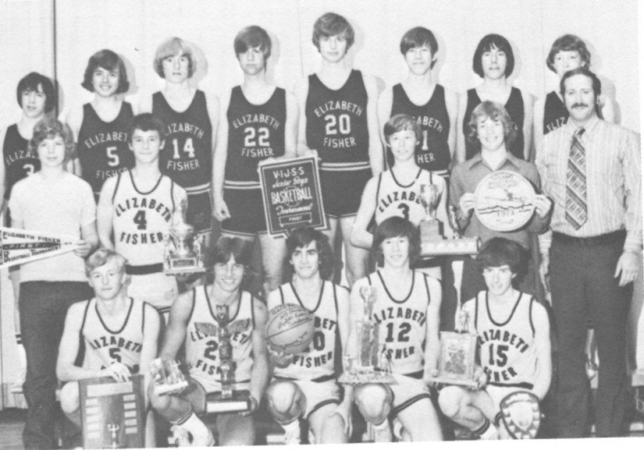
Bill with the Elizabeth Fisher junior boys’ basketball team that captured the Vancouver Island championship in 1972-73
Bill developed strong bonds with his players, some of whom had a reputation for being tough characters. This paid unexpected dividends for Bill’s teaching colleague and future wife, Carol Booth, who laughingly recalls that the basketball boys helped her maintain discipline in her classes, and would quickly come to her defence if they felt someone was being the least bit disrespectful or uncooperative.
When Elizabeth Fisher Junior High and Belmont Senior High merged into a single school in 1974-75 Bill took over the senior boys’ basketball program. Although basketball was a high demand sport, over the years Bill also found time to coach soccer, cross country, golf, rugby, field lacrosse and field hockey. He also coordinated multiple Wescom night league basketball teams each season, some of which included the little sisters of his Belmont players, and held administrative positions in the Vancouver Island and BC School Sports organizations.
Bill first started coaching girls’ basketball when his daughter Kindree joined night league and he helped groom a powerful Dunsmuir group that would go onto win a provincial junior championship in their grade 10 year, under the tutelage of coach and student teacher Kevin Harrington. That same core of players formed part of the Belmont team that finished second in the province two years later. Bill also coached the grade 8 and 9 boys’ teams at Dunsmuir when his son Kyle was on the team.
When Belmont changed from a grade 8-12 to grade 11-12 school, Bill switched his basketball allegiance to the girls’ program and Muzz Bryant retained ownership of the boys. Bill later took over the girls’ field hockey team as well and convinced many of his basketball girls to come out and fill any vacant positions.
Bill was known as a demanding coach who worked extremely hard himself and expected the same high standards from his players. His daily practice plans were always meticulously drawn up, often with different coloured ink for emphasis. He never made excuses for himself and always wanted his players to be accountable for their own actions. He closely monitored his athletes’ school grades and attendance, and on at least a few occasions, temporarily suspended players from the team because they were skipping classes or had received failing marks on a report card, and didn’t allow them to return until their teachers reported positive changes in attitude and results. It didn’t make any difference whether the player was a star or a substitute: he refused to compromise his principles, and as a result most of his players maintained sterling academic records.
Although Bill was incredibly tough (some would even say stubborn) and refused to let illness, injury or other obstacles keep him away from practices or games, family events took precedence over basketball commitments. For example, when his son Kyle earned the starring role of Oliver in the School District 62 musical one year, Bill missed several practices in order to attend the performances. On those occasions he made sure his written practice plans were extra detailed and that the assistant coaches were absolutely clear what needed to be covered in his absence. He would also call one of them later that night for a full report of how the practice transpired.
Although some casual observers might have assumed that Bill’s booming voice that resonated throughout the gym during most basketball games was indicative of a gruff personality, his players knew otherwise and understood how much he cared about them as individuals. They nicknamed him “Bear” and he regularly received a teddy bear at the end of the season, usually dressed in a basketball T shirt that had been autographed by all the team members. Bill took a strong interest in the girls’ lives outside of basketball and relished the opportunity to offer guidance and help them try to reach their potential. Players frequently dropped by his office for fatherly advice, assistance with homework, or just to hang out and chat. Many of his players continued to stay in touch after graduation and kept him updated on their adult lives.
Fundraising was a necessary but time-consuming component of coaching a major sport in those days, and Bill, like his counterpart, Muzz Bryant, devoted countless hours to this pursuit. His wife Carol remembers him sometime arriving home as late as 2:00 am from duty at the casino, getting a few hours sleep, and then heading off to school to teach in the morning. There were garage sales, and car washes, and countless fundraising campaigns including poinsettas, gift wrap and chocolates. Bill was fastidious about his record-keeping and kept a separate account for each girl, based upon her contribution to each event. His goal was to reduce the financial burden for families and to ensure that no one was ever left out of an activity, particularly their bi-annual spring break trips to locations such as Hawaii, Disneyland or Arizona.
Bill’s driving idiosyncrasies became a source of amusement (not to mention aggravation) amongst the basketball girls. Whenever he transported teams in the minivan or small school bus, he always left his driver’s side window wide open as he drove in order to ensure a constant supply of cold air to keep him alert. For the same reason, he rarely consented to turn on the heater. Some girls recall bundling up in jackets and blankets to try to say warm in the back of the van during December or January road trips and pleading unsuccessfully for some warmth to be pumped back. Bill would cheerfully deny their requests and tell them it was for their own safety. Others remember Bill’s reluctance to stop for washroom breaks and how the girls learned not to consume many fluids before heading off on long road trips because the only way Bill was going to make an unscheduled pit stop was if he was convinced it was an absolute necessity. Players often waited to hydrate until they got close to their destination.
Bill suffered a devastating personal loss with the tragic death of his 20 year old daughter Kindree in a car accident and was diagnosed with cancer on month later, but he remained committed to his basketball players and program. Bill demonstrated his indomitable fighting spirit while battling cancer, as he downplayed his personal discomfort and showed up to all the practices and games. Many colleagues were amazed to learn that he scheduled his chemotherapy treatments for the first appointment of the morning so that he could get to school in time for his first class. There were times on road trips when the side effects of his treatment left him violently ill all night and unable hold any food down the next day, but he would somehow will himself to make it to the games and to perform his usual duties. There were only a couple of instances when he warned assistant coaches Troy Harris and Cindy Cullen that he was “feeling a little rough” and might need to lean on them a little more than usual.
That last coaching season of Bill’s was very emotional for everyone and although co-coach Steve Frizzell assumed much of the day-to-day duties, Bill continued to attend practices and games whenever possible. Although he knew his days were numbered, he was determined to hang on until the end of basketball season and defied his doctor’s expectations by being able to attend the traditional year-end celebration dinner at the Macaroni Grill restaurant in early March, one month before he passed away. His current players rallied around him those final months and many former players and coaching colleagues also offered their support. Several ex-players travelled from out-of-town to visit him one last time and many wrote heart-felt letters to let him know the influence he’d had on their lives. Bill very much treasured those interactions and often sent those individuals away with words of wisdom and / or small personal gifts. Carol recalls one such occasion when one young woman dropped by their house brought him a special pair of socks because he’d said his feet were always cold. Despite being so weak, he insisted on going all over town to find a particular poster to give to her in return.
Bill was truly honoured a few weeks before he passed away to learn that the old gym in which he had spent so many hours was to be renamed the “Spotswood Gym” in his honour and would undoubtedly be delighted to know the new Belmont gym will retain his namesake.

