Bill Spotswood: 1954 -1960
Bill Spotswood is probably best known as a long-time coach and educator who taught at the school for 35 years. However, his Belmont roots go back even deeper, as he attended Belmont as a student and was a prominent athlete during the late 1950’s.
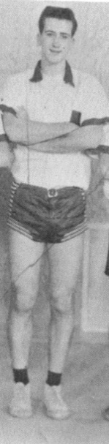
After attending Colwood Elementary until grade 6, Bill moved to Belmont and made an immediate impact upon the school’s athletic program. His tall, powerful build made him well suited to basketball, and he became a key member of the Braves for several years. He was a fierce competitor and tenacious defender, which may help explain his high school nickname “Moose.” He was the top scorer on the 1959-60 basketball team that finished fourth on the Island, Belmont’s best basketball result to that point in time. Basketball was not the only sport in which Bill excelled at Belmont: he was also a top-notch high jumper and a significant contributor to the soccer, cross country and volleyball teams. He also played lacrosse for the Victoria Junior Shamrocks while in high school and was a member of the team that won the Minto Cup in 1962.
After high school graduation, Bill stayed active in Victoria’s sporting community. He continued with lacrosse and played a few season with the senior Shamrocks. According to his brother Mel, who also played on the team, Bill was not a prolific goal scorer but was a defensive stalwart. There was no 30 second clock in those days and the games were often extremely physical. Bill loved to throw his weight around and deliver crushing body-checks into the boards, and he never hesitated to drop his gloves and fight in order to protect his smaller team-mates. It wasn’t only his physical presence that could be intimidating. He was very witty and came up with quick verbal barbs and amusing comments on a regular basis. Although his regular commentary entertained his team-mates and spectators, it sometimes got under the skin of his opponents. In lacrosse’s off season, Bill played Senior A men’s basketball for the “Coffee Macs” team.
After earning his university degree, Bill returned to Elizabeth Fisher and Belmont, where he would teach and coach for another 34 years.
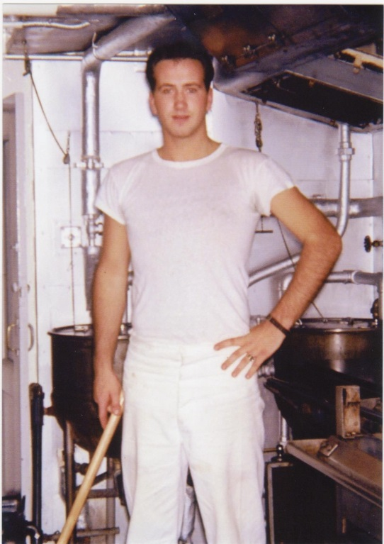
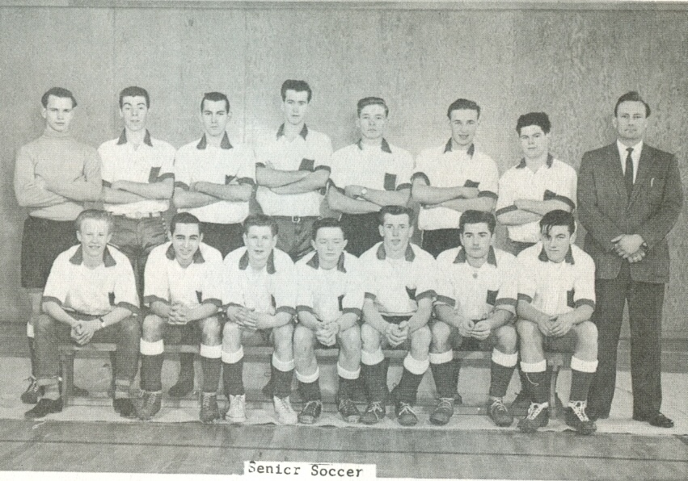
Picture of Belmont’s 1959-60 boys’ soccer team scanned from the Kee-Yu yearbook. Bill is the tallest boy in the
back row.

Bill the year after high school graduation: working on a ship to earn money for university

