Barbara Gilbert: Hall of Fame – Supporter/Contributor
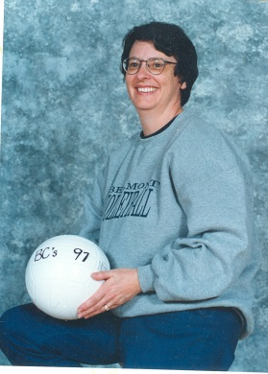
Manager of Senior Boys Volleyball Teams – 1994 – 2005

Barbara Gilbert began her teaching career in the Sooke School District in 1974 at Dunsmuir Secondary School, as a Home Economics teacher. She was at Dunsmuir until 1985 and it was there she gained her earliest extracurricular experience - a two year stint coaching the midget girls’ basketball team. Barb then moved to Spencer Junior for two years, where she became involved with the PACE Theatre musical productions. In 1988 Barb took a Home Economics position at Belmont. It was then she was approached by the school’s Athletic Director, Muzz Bryant, who asked if she would volunteer to be a teacher sponsor of the Senior Boys Volleyball Team while they were in the process of finding a coach from the community. Barb agreed, and when a coach was found, one of the players (Angus Stewart) convinced her to stay on as manager. It was a decision that two decades of senior boys volleyball players would benefit from.

Barb had an immediate impact – she saw both a need to deal with the team’s growing travel costs and to eat healthier when they were on the road. She became very skilled at trimming the costs associated with transportation and used her home economics skills to get the boys making their own meals, assembly line style. This would lead to team breakfasts that usually featured pancakes or French toast, and team dinners that often included her famous “taco salad in a bag”. Barb’s other specialty was her banana bread, which she baked, not just for on the road, but also for the end of practices. She was making about 6 loaves of banana bread each week of the season. Soon other teams, both those at Belmont and others they met at tournaments, were very envious! All the while Barb was also arranging hotel accommodations, phoning scores into the local papers, driving her van (loaded with the necessary cooking items), providing the “permission to travel letter” that went home to parents, providing budgeting/accounting, and overseeing fund-raising efforts - selling flower bulbs, Krispy Kreme Donuts, and representing the team at the Bingo Hall.

What Barb most enjoyed about her experience over the years with the Senior Boys Volleyball teams was the sense of camaraderie, almost family, that developed and how it was like “having sons for 3 months of the year and then giving them back to their parents” at the end of volleyball season. Some of the moments she remembers most fondly are learning to play laser tag with one team, bowling in Courtenay with another, and being a part of Belmont’s first ever team provincial championship in ’97 (after having come so close the previous year when they finished 3rd).

Here’s what a pair of former player/coaches had to say about “Mrs. G”:
Matt Hennessy:
“Mrs. Gilbert was the backbone to the senior boys volleyball team for many years. I remember going to her house for spaghetti dinners before big tournaments and, of course, her banana bread. She was a huge reason why many young/unorganized coaches like myself could put all of our thoughts on the kids and not on the logistical things. She is very deserving of the Belmont hall of fame and we couldn't have done it without her!”

Cam Burton
“As a coach working with Mrs. G you were spoiled. It was simple. You showed up and coached. EVERYTHING ELSE had already been taken care of for you. Smiling, she would routinely check-in during practices, let the boys know if she needed anything administratively from them, confirm any scheduling or travel arrangements that had been made, and count heads to make sure she was baking enough Banana Bread for everyone after practice. There are no downsides to having a Home Economics Teacher as your Teacher Sponsor. Ever.

Travelling to tournaments with Mrs G was always a team highlight. On overnight trips, Mrs G would have a room to herself and it would always have a kitchenette. “What do you mean we are cooking our own dinner?" and “Will the Grade 11’s be doing all the dishes” were two questions I often found myself answering that most coaches never have to. Once reality sunk in and the boys realized that they would actually have to cook and clean up after themselves, it quickly became part of the routine.

Mrs G's teams ate well. While other teams pulled into Subway, McDonalds and Boston Pizza, we were unloading a fully stocked, pre-packed Dodge Caravan into a hotel fridge and setting the table. Sloppy G's, Lasagna, Spaghetti, Taco Salad, Oatmeal Coconut Cookies and Ritz Cracker Apple Pies were consistent favorites.

These days it only takes a glance at one of the cross-stitched pictures Mrs. G made, or to flip through one of the photo albums she would create each year for everyone on the team (complete with recipes!) to bring back a flood of emotions and memories. Mrs. G's firm and fair nature and her genuine interest in all the boys’ successes earned her respect from the players, coaches, officials and parents. Because of her and all she did behind the scenes and in the gym, the players could play, coaches coach, we all had a great time doing it and we will never forget her. That is Mrs. G’s legacy.”

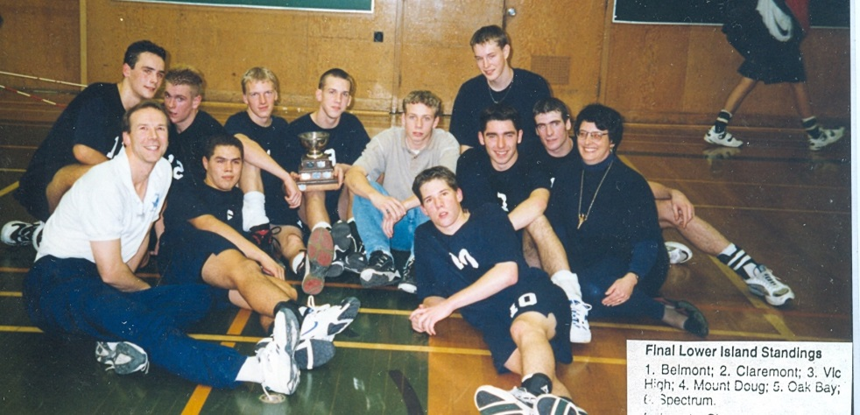
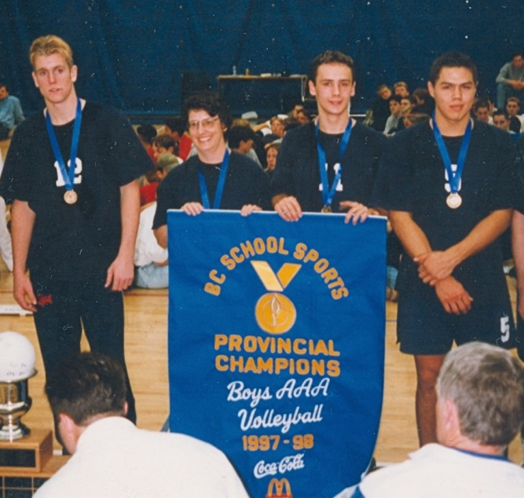
Barb holding the 1997-98 provincial championship banner in Kelowna
KEl

