Adam Cracknell: 2002
Adam Cracknell, known as “Cracks” to his team-mates, was a multi-sport athlete who returned to graduate from Belmont after playing WHL hockey in Cranbrook for the Kootenay Ice for much of his grade 12 year.
Adam was an all round athlete who didn’t start playing competitive hockey until the age of 14 with his bantam team. He was an excellent roller hockey player and also golfed recreationally.
At Belmont, despite his busy hockey schedule, Adam still played on two school teams: golf and roller hockey. His 2002 golf team, which also included Dan Roberts, Dustin Pewarchuk, Cody Pewarchuk and Julianne Kim, won the Vancouver Island championship and then capped their outstanding season by winning the BC title at the Cordova Bay course with a record combined score of 588. At the time, this was only the second Belmont in any sport to earn gold medals at a provincial championship.
Adam’s best Belmont memories are playing sports with his friends and having a good time doing it. He remembers coaches Ken Lowe and Muzz Bryant as being positive influences on him as a high school athlete.
After graduation, Adam climbed the hockey ranks all the way to the NHL level. He was drafted by the Calgary Flames in 2004 and spent several seasons playing in the AHL and ECHL before signing as a free agent with the St. Louis Blues. He currently is a member of the Columbus Blue Jackets.
Adam’s advice for current Belmont athletes is “if you have a dream, believe in yourself and work your hardest to give yourself the best chance. If you don't try you will never know what your potential is.”
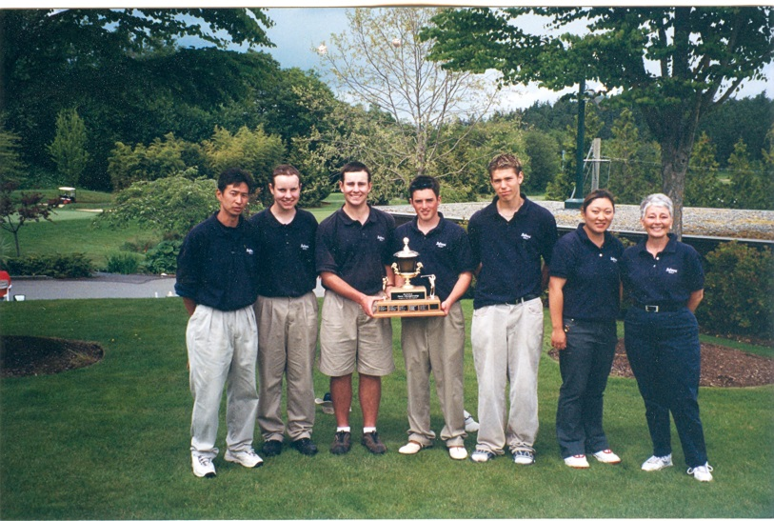
Adam (3rd from the right) with the other members of Belmont’s 2002 BC Championship golf team

