2004-05 Tennis Team
The 2004-05 tennis team was Belmont’s most unexpected Vancouver Island championship winner of the decade. The program had previously been operated more as a recreational club, with an emphasis on participation and fun. The school occasionally had strong individual players, but there had never been a group strong enough to contend with the perennial powerful teams from Oak Bay, Claremont, or Mount Douglas. In the spring of 2005, a strong contingent of international students showed up for the first practice and demonstrated some impressive skills. Belmont had two key returning local players: Claire Hoffman and Nathaniel Guenter, both of whom were provincially ranked juniors, and these two athletes took on a leadership role by welcoming the newcomers and helping to foster team unity. Practices took on a new level of intensity and some of the athletes met at Juan de Fuca or Royal Roads on the weekends for some extra hits.
The Belmont squad, led by their dominant girls’ trio of Claire Hoffman, Stephanie Winkler and Anna-Lena Fertmann, and the powerful Nathaniel Guenter on the boys’ side, emerged as one of the stronger teams in the city that year and qualified for the Vancouver Island tournament. Oak Bay had won this tournament for many consecutive years and was heavily favoured to capture top honours once again. As expected, Oak Bay easily won its semi-final match, while Belmont upset Claremont to advance to the final. One of the interesting aspects of these tennis tournaments was that each player could play only two matches out of the seven, so there was considerable strategy involved for the coaches trying to figure out the most favourable combinations. To add to the intrigue, both coaches had to submit their written lineups at the same time, so they had to anticipate the combinations of the opposing coach. Ms. Baker made some crafty decisions that worked in Belmont’s favour against Oak Bay, and all the players turned in terrific performances. The two teams were tied 3-3 with the deciding match of the day being the mixed doubles. Both teams lined the court, encouraging their team-mates, and Lena Fertmann and Hannes came through with an exciting victory to clinch the Island title for Belmont. This was the first time in the school’s history that a tennis team had won an Island tournament and qualified for provincials.
The BC’s were an impressive event held in Vancouver that featured 24 teams. It was also quite a social occasion, as all the out-of-town teams stayed at the same hotel and were treated to a barbecue and Hawaiian-themed dance on the Friday night. The Belmont team performed admirably in the scorching heat and finished in 6th place overall, with all team members making valuable contributions. Strong friendships were formed and Coach Baker was extremely proud of the excellent effort and sportsmanship displayed by all of the team members.
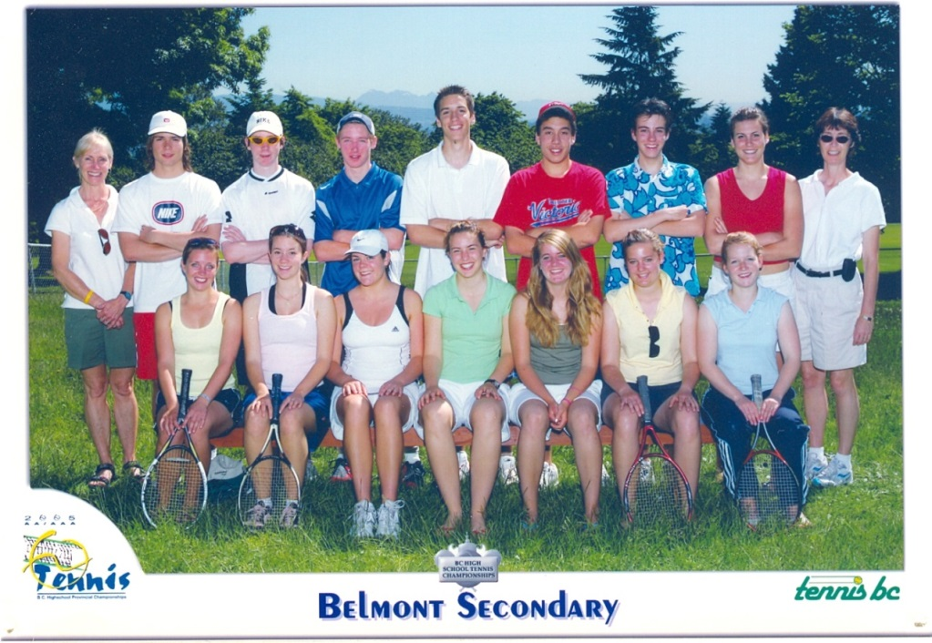
We have done our best to identify the players in this photo, but it is possible that there are a couple of errors in the front row.
Back Row from Left to Right: Val Baker (coach), Max Sogst, Matt Fulcher, Nate Guenter (boys’ captain), Hannes, Bobby Lavis, Felix, Stefanie Winkler, Cindy Cullen (assistant coach)
Front Row from Left to Right: Valerie Von Hodenberg, Caroline, Claire Hoffman (girls’ captain), Alessia Leischik, Elisa Von Wallis, Anna-Lena Fertmann, Sophie Koch

