2001-2002 Girls’ Volleyball Team
The 2001-02 volleyball team, skillfully coached by Mike Toakley and Lee Phillips, capped off an amazing season by capturing the gold medals at the B.C. Championship tournament, becoming the first Belmont girls’ team to ever win a provincial title. This was a very special group right from the start, as 13 girls bonded quickly and devoted their energies to pursue the #1 ranking. The 2002 Belmont yearbook describes the team’s victorious experience:
“It came on Saturday, Dec. 1 at approx. 6:00 pm on Capilano College’s center court. It completed four wet, windy days in North Vancouver, beginning with pool play over Mt. Baker, Penticton, and Argyle, then play-off victories over Churchill, Burnaby Central, and sweet revenge over Vanier in the semi-finals. The final, played before a packed crowd that included parents, relatives and staff, was a dominating performance against a North Peace team that was tall and skilled. Kathy Anderson’s final blast down the line sent us all into a screaming euphoria and finally, after coming so close last year, that big, beautiful blue banner was ours!
The season had many, many highlights, including beating Vanier in the BC semi-finals, having “the Gorilla” play our request for “Goodbye Earl”by the Dixie Chicks, the quality of the rooms (especially the bedding) in the Kelowna hotel, driving the RCMP’s P.T. Cruiser at Capilano, the assembly back at Belmont (complete with the Langford fire trucks and free lunch at John’s Other Place), and being named both “VI” team of the week and the Q’s hometown Heroes.”
Several of the Bulldogs earned individual provincial honours. Darla Myhre, who would later star at the University of Washington, was named MVP of the entire tournament, while Andrea Gollmer and Kathy Anderson were named first team all stars. This was the second provincial title for coach Toakley, who had also accomplished the feat in 1997098 with the Belmont boys’ squad.
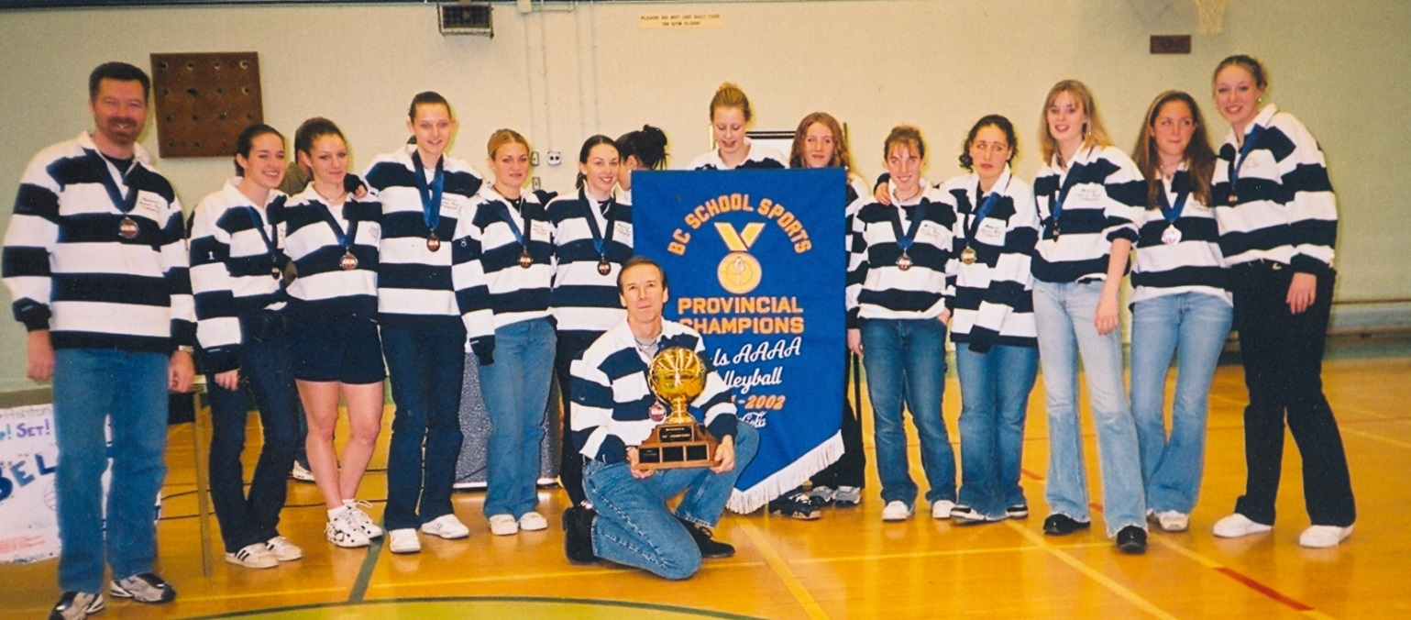
From left to right: Lee Phillips, Lauren Gallop, Elaine Anderson, Kathy Anderson, Gillian Carter, Shelly Walushka, Mike Toakley (kneeling with trophy), Darla Myre, Aston McFarland, Natasha Berry, Andrea Gollmer, Jenny Johns, Janna Prsala, and Carly Petillion
Kneeling in the front holding the trophy: Coach Mike Toakley

