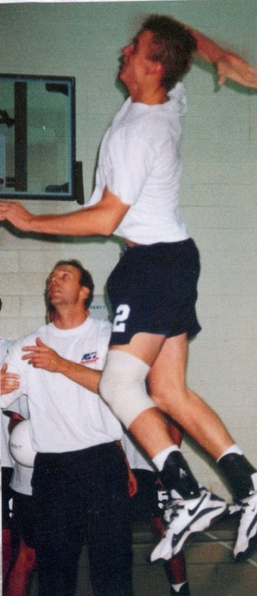
1996-1997 Boys Volleyball
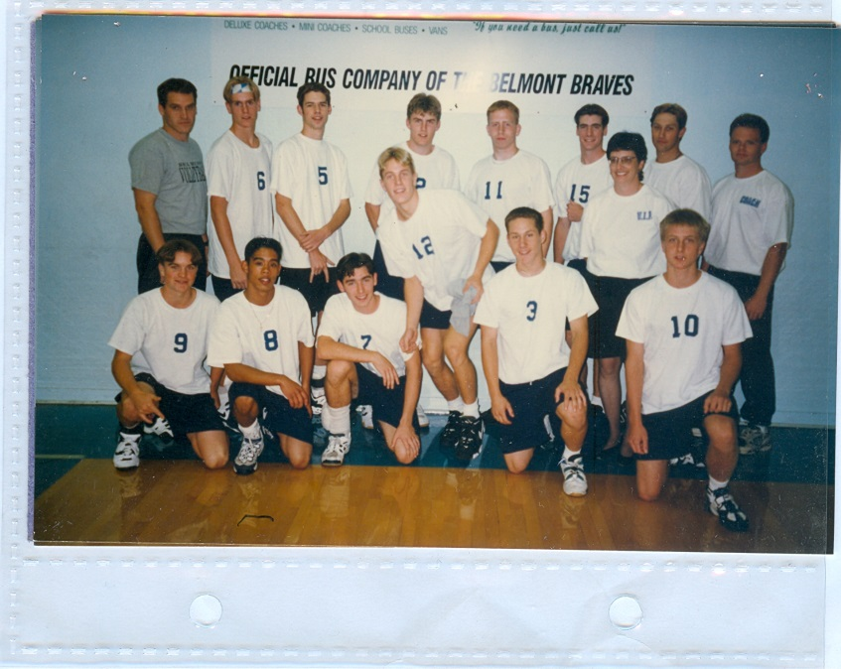
The 1997 boys’ volleyball team, coached by Uvic students Brian McAskill and assisted by Dave Weiss, had a very successful season, winning medals in each tournament they attended including a first place finish at the Malaspina and Gulf Island tournaments. They also won the league, Lower Island and Island titles. This qualified the boys for the Provincial Championship Tournament at Okanagan University Gym in Kelowna. The boys advanced to the semi-finals against Kelly Road Secondary, but came up a little short. They rebounded to beat KLO and capture the bronze medals. Matt Hennessy and Darren Goss were named as first team all stars, while Eric Stewart earned an honorable mention.

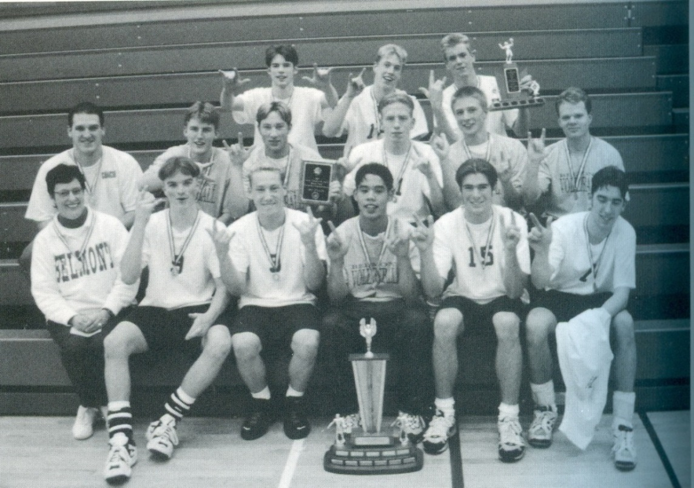
Back Row Left to Right: Matt Hennessey, Mike Maxwell, Darren Goss
Middle Row Left to Right: Brian McAskill (coach), Eric Stewart, Cory Moore, Dean Mikkelson, Paul Mick, Dave Weiss (assistant coach)
Front Row Left to Right: Mrs. Gilbert, Ash Cronk, Brad Prettie, Rommel Agbay, Gary Venn, Derik Lucik

