1970-1971 Senior Boys Braves Basketball

The 1970-1971 Braves Basketball team broke every record ever set by a team at Belmont. Team manager and yearbook writer Cliff LeQuense stated that there simply wouldn’t be enough room in the annual to mention the many team and individual efforts. However there were three particular highlight for the Braves, all first time accomplishments for Belmont. The boys won the league title, placed second at the Island tournament and competed in the B.C. tournament. This group would form the nucleus of the Belmont team that would finish 3rd in the province one year later.

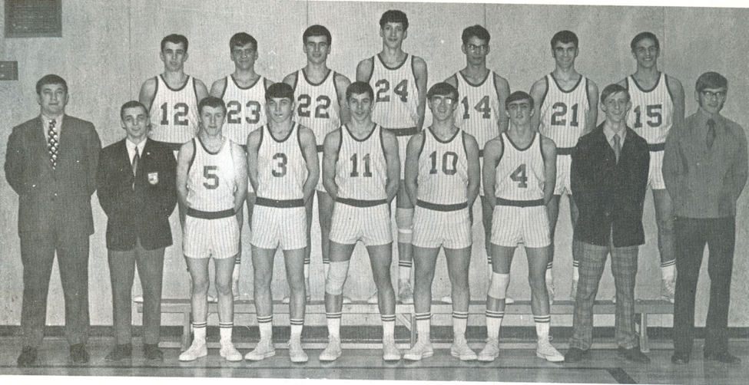
Back row (from left to right): John Bodman, Gerry Dicker, Richard Denman, Lee Edmondson, Ron Mills, Jim Merz, Jack Munch
Front Row(from left to right): Coach Wally Russell, Larry Park (statistics), Willy Murray, Don Salmons, John Hunter, Rick Sylvester, Jim Kupiak, Bard Woolven, Cliff LeQuense

