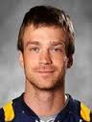
Tyler Hass: 2000-2003

Tyler Hass was a gifted natural athlete who excelled at basketball during his three year stint at Belmont. He became involved in sports very young; he first started lacrosse at the age of three, and picked up basketball and golf shortly after on local club teams. He explains: “Really, I played anything with a ball as soon as I was walking.”
By high school, he had developed into one of the top basketball players in the city, someone who could bring the crowd to their feet with his explosive drives to the hoop and his tenacious defence. His senior year he led the Bulldogs to an undefeated regular season and first place in the Lower Island. Unfortunately the team lost a heartbreaking game to Dover Bay in the Island Championship to come up two points short of a berth in the B.C.’s. Belmont coaches Muzz Bryant and Tom Holmes both consider this one of the most disappointing losses of their long coaching careers, as they felt this talented and hard working group of boys really deserved the chance to play on the large stage. In recognition of his terrific 2003 season, Tyler was named Belmont’s top senior male athlete at the year-end awards ceremony.

After high school graduation, athletics continued to play a central role in Tyler’s life, first providing him with an education and later with a career. He earned a basketball scholarship to the University of Victoria and became one of most outstanding defensive players in the country, helping the Vikes make it to the national championship game. He currently plays professional lacrosse with the Vancouver Stealth in the NLL and also is a member of the Victoria Shamrocks in the WLA. Although the Shamrocks have lost two Mann Cups (national championship final series) in a row, he still considers them highlights of his lacrosse career. An individual highlight was being selected the 2014 WLA playoff MVP. He still hopes to win both NLL and WLA championships before he retires from the sport. Tyler points out: “There is nothing better than playing the sport you love, except when you get paid to do it.”

Tyler credits his family for helping him achieve his high level of athletic success. “My father Alfred Hass introduced and taught me sports from a young age. He also pushed me to become an elite athlete by making everything a competition and showing me how handle pressure. My mother Heather Speed has always supported me in any decision I have made growing up. She made pursuing sports an easy and fun choice. Also my wife Jacqueline McMorran, her unconditional love and support allows me to continue pursuing my career in athletics.”
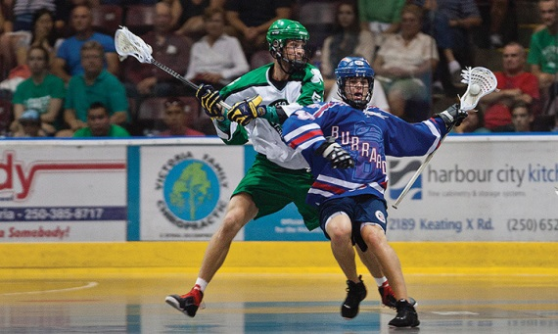
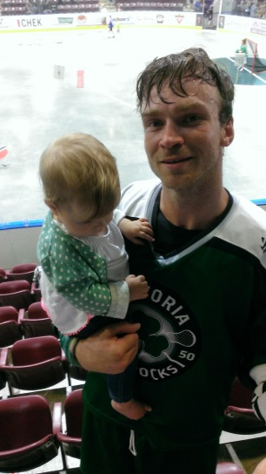
When asked if he had any advice for current Belmont athletes, Tyler responded: “Putting extra work in during my Belmont athletics career turned out to be the best decision I ever made. When I look back, it is such a small sacrifice for such a huge reward.”
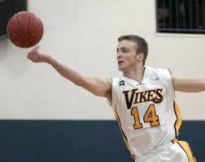
Tyler works for a shot during a Shamrocks lacrosse game (Goldstream Gazette photo)
Tyler and his daughter
Tyler with the Uvic Vikes basketball team (Uvic Vikes photo)

