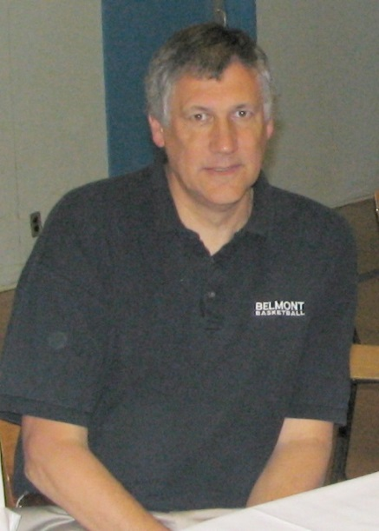
Tom Holmes: 1979-1981 and 1998- 2014
Tom Holmes retired in 2014 after a long and successful teaching career, eighteen of which were spent at Belmont as PE / Social Studies teacher and a well-respected basketball coach.
As a youngster, Tom was a talented multi-sport athlete who excelled at soccer, basketball and track and field at Oak Bay Secondary School, as well as baseball in the community. It was in basketball, where Tom emerged as a true standout, and he was a key member of Gary Taylor’s powerhouse teams in the late 1960’s. During his grade 11 year, the Bays captured both the Vancouver Island and BC championship titles, and Tom was named as a first team Island all-star. One year later, the Oak Bay boys won the Island tournament again and advanced all the way to the provincial championship game, where they lost a thriller in overtime to crosstown rival, Vic High. Tom capped off his outstanding high school career by winning MVP honours at both the Island and BC tournaments in 1969.
Tom’s impressive athletic accomplishments earned him a scholarship to Spokane College to play basketball and baseball. Although he enjoyed the experience, he decided to return to Canada and enrolled at Uvic in 1970 in order to pursue his goal of becoming a high school PE teacher. Of course, the UVic basketball coach Robert Bell, was delighted to welcome Tom to the team and he became a valuable contributor for the next four years, and his 10.4 rebounds per game in 1970-71 still ranks in the Vikes record books as the fourth highest of all time. In a twist of fate, when Coach Bell retired the following year, Gary Taylor took over the position, reuniting Tom with his high school mentor.
When Tom graduated from Uvic in 1975, teaching jobs were hard to come by in Victoria, so he accepted a posting in Campbell River and taught PE there for two years. In September 1977, he returned to his hometown and taught for 3 months at Lansdowne, followed by a 6 month stint at Spencer. Oak Bay hired him the following year, where he coached the senior girls’ basketball team, and the following September, he landed a permanent position in School District #62, where he would remain for the next 34 years. He started out at Belmont from 1979-81 and coached the senior girls’ basketball and cross country teams. In 1982, Tom was transferred to Dunsmuir and coached the senior boys’ basketball team for four years. After the school switched to a grade 8-10 junior high, he continued to coach a variety of teams, including junior boys’ basketball, soccer and volleyball. It was during this time that Tom also became interested in basketball officiating and worked his way up the refereeing ranks, starting with night league and junior games and later progressing to the high school and collegiate level.
In 1998, School District #62 once again reconfigured its high schools, and grade 10 students were added to Belmont while Dunsmuir and Spencer became grade 7-9 middle schools. This resulted in an influx of teachers transferring to Belmont, and Tom decided to return to the high school. He immediately joined forces with long-term Belmont senior boys’ basketball coach, Muzz Bryant, and the two of them formed a successful coaching tandem and strong friendship for the next decade. They consistently fielded competitive teams that challenged for city and Island titles, but it wasn’t until the 2007-2008 season that the Belmont boys were able to upset higher ranked teams from Dover Bay, Oak Bay and Mt Douglas to win the Island championship and qualify for provincials. Tom felt that the 2003 team, led by Tyler Haas and Kyle Swenson, were a very talented group that also deserved to make it to the BC’s, but they suffered a heart-breaking 2 point loss to a strong Dover Bay squad in the elimination game for the final provincial berth.
After Muzz Bryant’s retirement, Tom teamed up with former junior boys’ coach Kevin Brown, his former student teacher, and continued to coach for another five years. The two enjoyed considerable success and took the Bulldogs to the BC’s in two consecutive years: 2012 and 2013, both times exceeding most people’s pre-season expectations for the teams.
Tom had many positive coaching attributes, and his players appreciated his impressive basketball knowledge, laid-back personality (except for rare outbursts when he thought there was a particularly bad call) and terrific sense of humour. The boys affectionately called him “Holmesy” and found his quick wit highly entertaining. Tom liked to keep a low profile for himself and never sought personal recognition. He loved to share his knowledge in practice and was able to inspire his players to work hard and steadily improve, but he usually downplayed his own role in the team’s success and instead passed on all the credit to the guys themselves.
Besides forming positive connections with the players, Tom formed strong bonds with his co-coaches, teaching colleagues and others in the basketball community. He was instrumental in helping to build upon the strong tradition of boys’ basketball at Belmont and he will definitely be missed.

