Belmont Sports History from the 1990’s
The early 1990’s saw the re-emergence of Belmont basketball teams as provincial power-houses. Both the Braves and Tomahawks were helped immensely by a core of talented coaches and players from the Spencer and Dunsmuir junior programs. The Dunsmuir girls’ team, coached by Belmont alumnus Kevin Harrington, captured the BC junior title in 1989-90, the same year that Peter Songhurst and Gary Mols guided the Spencer Knights to the boys’ junior championship. The following season, under the guidance of Bill Spotswood and Cindy Cullen, Belmont’s girls’ team placed 4th at provincials in 1990-9, led by dynamic point guard Lisa Koop, 6’3” defensive stalwart Denise Rehman, and a strong supporting cast that included Sherri Griffiths, Kindree Spotswood, Kirsten Lane and Amber Thompson. The Tomahawks followed up their results the next year and finished 2nd place in the province, with Lisa and Denise earning All Star honours.
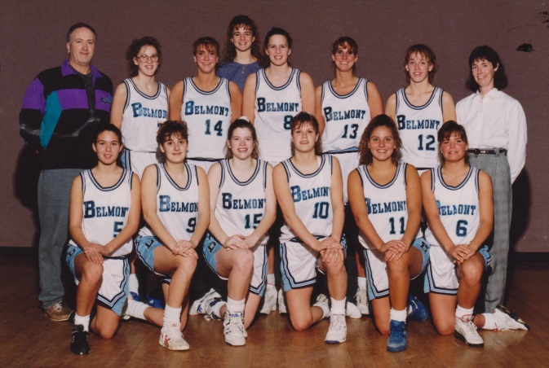
The 1991-92 Belmont senior girls’ basketball team that finished 2nd in BC
The 1990-91 Braves edition, coached by Muzz Bryant and Gary Mols, also had a very strong season and earned the bronze medals at the BC Championship Tournament, with Curt Spaven and Amrit Lalli being singled out for All Star recognition. Donovan Walters, Chris Olson, Keith Gibson, and Cory Boyd were also key contributors to the team’s success.
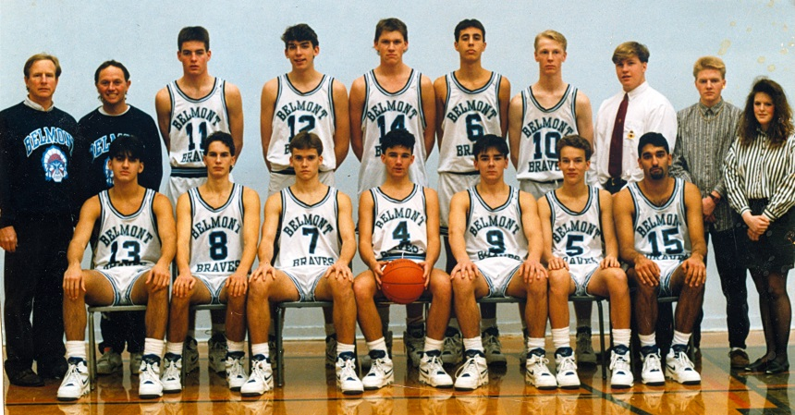
The 1991-92 Belmont senior boys’ basketball team that finished 3rd in BC
The boys’ volleyball program also developed into one of the strongest in the province, and the 1997-98 group would be the first Belmont team in the school’s history to bring home a provincial banner. The stage was set the previous season, when Darren Goss and Matt Hennessey powered the boys to a bronze medal performance at the BC championship tournament. The team benefitted greatly from the expertise of Brian McAskill and Dave Weiss, two Uvic students who volunteered to coach the team, and also from the contributions of manager and Belmont home economics teacher Barbara Gilbert, who kept the boys well fed all season. One year later, Mike Toakley and Lee Phillips assumed coaching duties, and the boys capped off an outstanding season by defeating arch rival Claremont in a thrilling five set match in the provincial final. Darren Goss earned MVP honours, and Ben Gollmer, Mike Strandlund and Dustin Price all received All Star recognition.
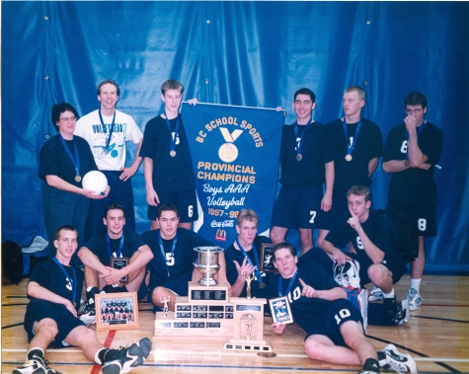
The 1997-98 senior boys’ provincial championship volleyball team
Belmont was well represented in a variety of sports during this decade, and many athletes went on to achieve tremendous success, both at the high school and national level. The 1995-96 boys’ 4 by 100 meter swim team of Cliff Smirl, Scott Shea, Carlos Cohelio and Jon Smirl captured gold medals at the BC’s, and Jon competed at a high level in swimming, rugby, judo and triathlon for many years after graduation. Scott Kral was a BC junior golfer of the year and competed for Team Canada while still in high school. Shane Prieur won the Vancouver Island wrestling competition and finished 2nd at the BC championship meet.
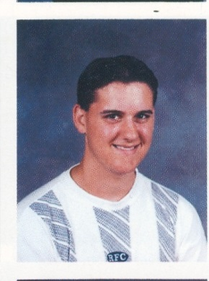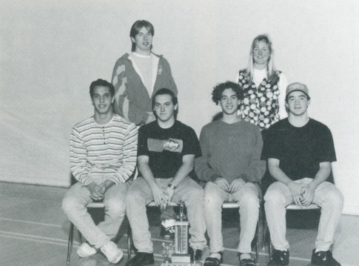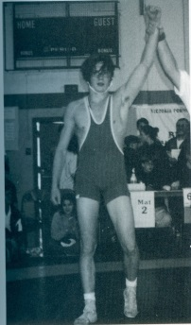
From left to right: Scott Kral, the 1995-96 4x100 meter relay team, Shane Prieur
Jacqueline Harrison was a strong soccer player for the Uvic Vikes for five seasons, and Lindsay Strickland was captain of the Fraser Valley College women’s basketball team that finished 2nd in the country. Kristen Wall, a member of Belmont’s fledgling rowing team, was a star performer at Uvic and competed for Canada at the 2000 Olympics. And Ryder Hesjedal rose to international stardom in cycling, becoming one of the top racers in the world. In 2012, he became the first Canadian ever to win the prestigious Giro d’Italia. That same year, he was named as Canada’s top male athlete and took home the Lionel Conacher award.
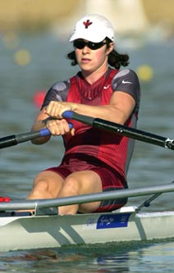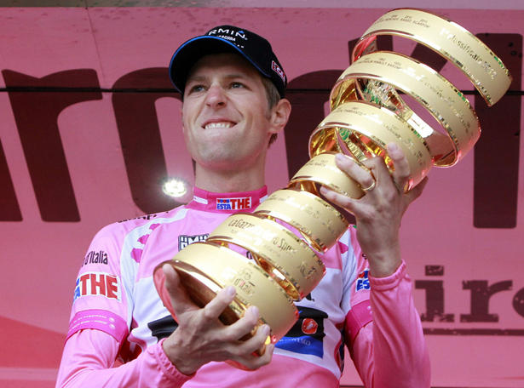
Ryder Hesjedal with the Giro d’Italia trophy
Kristen Wall at the 2000 Olympics
The 1990’s confirmed the fact that Belmont athletics could compete with the top programs in the province and paved the way for many future impressive accomplishments in the 2000’s.

