The Early Years: 1946-1949: (History of Belmont Athletics)
Prior to 1947, no designated high school existed for students from Langford, Colwood, Metchosin or the Highlands. Teenagers from these municipalities had to either travel into town to Vic High or make the trek out to Milne’s Landing in Sooke, the only secondary school in the district. In 1946, as Victoria’s post-war population grew, Victoria School District #61 declared that they would no longer accept new out-of-district students due to overcrowding in their schools. Children from the western communities who were already enrolled at Victoria high schools would be permitted to continue, but the rest would have to find alternative arrangements.
School District 62 trustees realized that it would be necessary to create a new high school to service students who attended Langford (Ruth King), Colwood, Happy Valley, Metchosin and Rocky Point elementary schools. They purchased a ten acre tract of land from Mr. E. Peatt along Jacklin Road (which was still known at that time as Station Road) and preparations began for construction of the new facility. They also negotiated the sale of a number of old army huts from the former anti-aircraft camp in Colwood that would be used as building materials. The trustees selected the name Belmont to honour Vancouver Island chief justice David Cameron, whose property around Fort Rodd Hill was also called Belmont. (Josephson n.d.)
It took a year for the Belmont site to become operational, so as an interim measure, a temporary one room school house, “Milne’s Landing High School, Albert Head Annex”, more commonly known simply as “The Annex” was established in 1946-47. Mrs. Kay Maughan was the teacher of 30 grade 9 students, many of whom would form Belmont’s first graduating class of 1950. (Mansfield 1994) There were no proper athletic facilities, but the army gave permission for the Annex students to use their playing fields and even donated a few softball bats. Mrs. Maughan recalled that occasionally the students resorted to more creative forms of exercise: “Once in awhile, when the urge became too strong, a game of run sheep helped to work off a little energy – and incidentally caused the odd noon-hour to be lengthened while some erring sheep were found.” (Maughan, History of Belmont 1950)
Belmont Secondary opened in September of 1947 for students in grades 7-10. There were four fulltime teachers: Mr. Greg Cook, Ms. Ann Davidowski, Mr. Harold Parrott, and Mrs. Maughan, who accompanied her Annex group to the new facility. (Maughan, History of Belmont 1951) Mr.Wilkinson, principal of Milne’s Landing, was assigned administrative responsibility for both high schools in the district. As the building was not fully completed, classes had to co-exist with extensive construction activity. Five army huts, transported in nine sections, were creatively assembled into a series of classrooms that encompassed 9,000 square feet in total. The 1950 Pioneer Edition of the Belmont yearbook described some of the obstacles faced by staff and students during the construction process: “No one will forget that year – no furnace until late in the fall; carpenters in and around the building hammering, sawing, pulling nails, and running electric sanders. The classes were moved here and there while rooms were painted. The halls were cluttered with saw horses and wall board.” Besides the commotion created by the carpenters and other tradespeople, the school lacked a telephone which created considerable communication challenges.
By the spring of 1948, the finishing touches had been completed, and the Minister of Education, W.T. Straith, attended an official ceremony at the school.
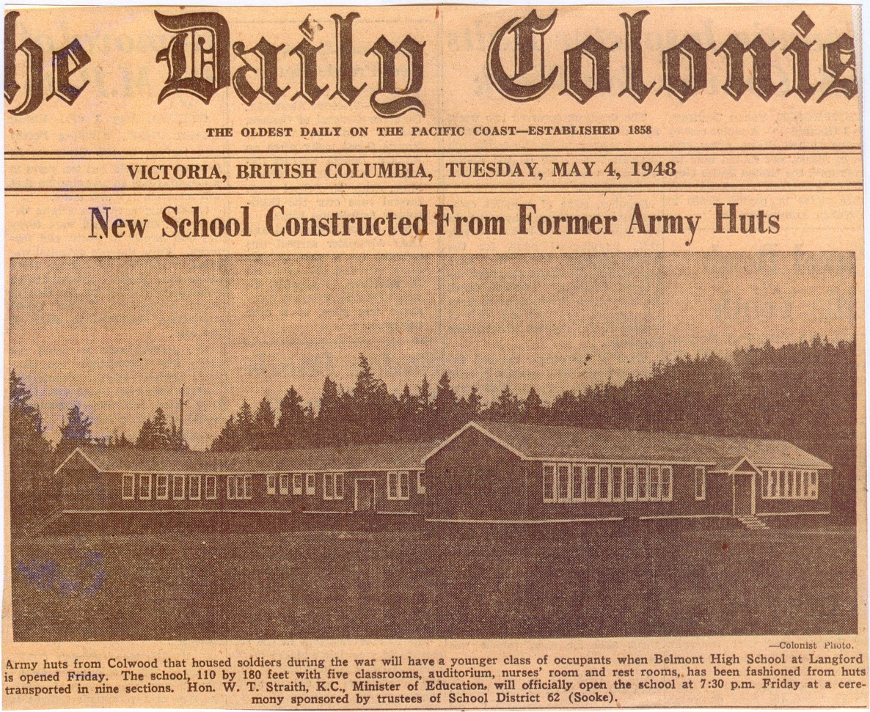
Construction was not only occurring on the Belmont army hut building; there was also the herculean task of clearing and preparing the fields. The ground was rough and rocky, and forest lined the property. A crew of adults, supplemented with student labour, took on the daunting mission of trying to convert this region into a field that would be suitable for softball, soccer, and other outdoor sports. It would take over a decade for the process to be fully completed, but Belmont teams were operational that very first year. The staff and students simply had to accept the fact that their home turf was not up to the same standard as the fields at some of the other high schools in town at that point in time.
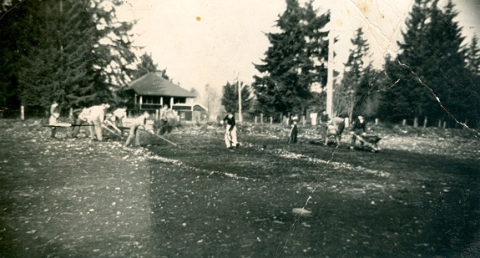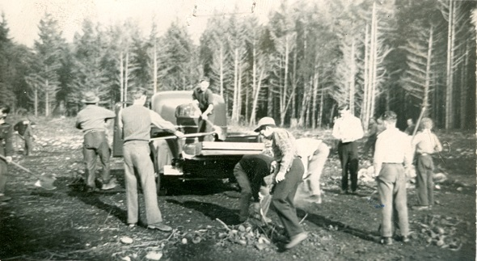
These two 1947 photos show the Belmont field under construction.

Due to the lack of a proper gymnasium in the army-hut building, it was a challenge to establish a full extracurricular athletic program, although one of the huts was fashioned into an auditorium that could be used for limited physical activity. During that chaotic 1947-48 year, Belmont staff founded the school’s first official sports teams: boys’ and girls’ softball. The girls were called the “Wolves” and the boys were known as the “Sluggers.” The two teams are pictured below.
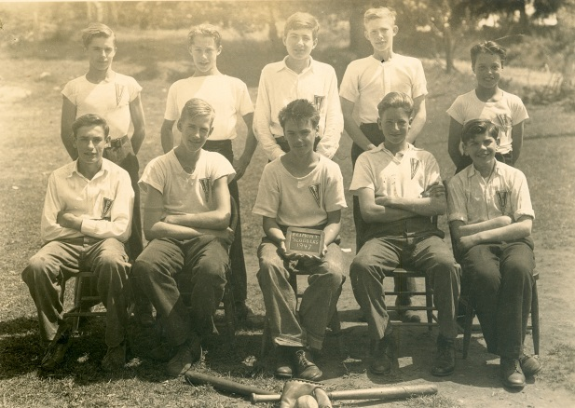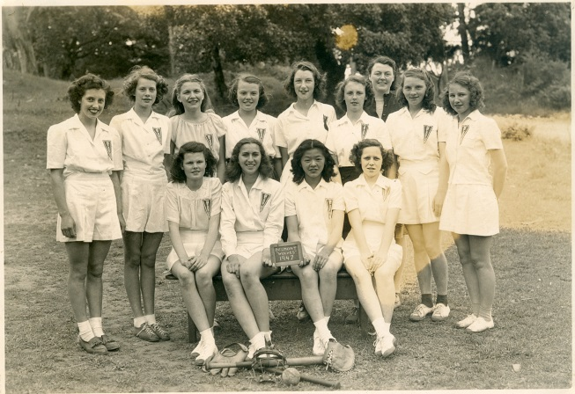
The dirt playing field was still not properly levelled or fully cleared of rocks at that time, so team members regularly raked the diamond before every practice. Former Belmont student Allen Le Quesne recalls that the laborious task of field maintenance was not restricted to willing volunteers; it was also assigned as a consequence for truancy or other disciplinary infractions. Offending boys and girls would be sent outside with rakes and wheelbarrows to gather rocks and other debris under the close watch of a supervising teacher. Mr. Le Quesne lamented the fact that there seemed to be a never-ending supply of rocks, as each heavy rainfall lifted a new batch to the surface. Vivid images of rocks seemed to be seared into the memories of many Belmont students from the early 1950’s; the grad class of 1953 even used rocks for table centre-pieces at their 30 year reunion.
In the spring of 1948, Belmont and Milne’s Landing held their inaugural Inter-High Sports Day, which would become an annual tradition and create significant rivalry between the two schools. This event consisted of four softball games (for junior and senior teams of both genders) as well as a series of track and field events. Points were awarded for each victory and the “Legion Cup” was presented to the winning school, with Milne’s Landing coming out victorious.
That second year of 1948-49 “marked very definite athletic progress for Belmont” (Maughan, History of Belmont 1951) as additional sporting activities were offered and home and away games were arranged with Esquimalt, as well as matches against Milne’s Landing. Mr. Archie Stephenson was appointed as Belmont’s first principal and he was a firm believer in the value of sport for young people. All the students were divided into houses (A, B, C or D) and a tabloid sports competition was held in the spring to allow students to earn points for their respective houses. Events included ball throwing, sprints, broad jump, high jump and relays. These activities were not just intended for the strong athletes: mass participation was strongly encouraged.
In June of 1949, it was Belmont’s turn to host the district’s Inter-High Sports Day and the host school recorded some excellent results. Clarence Creasser raced to victory in the 75 yard dash and Ray Helgesen tied for first in the boys’ high jump. The girls’ softball team, captained by Helen Cuche, defeated Milne’s Landing, while the boys’ softball team also emerged triumphant in their match against their Sooke opponents. In what was likely an emotional moment, Mrs. Maughan presented the “Maughan Cup,” named in honour of her late husband Herbert who died in World War 2, to Belmont team captain Alan Robertson. Despite the excellent efforts of these Belmont athletes, Milne’s Landing retained the Legion Cup by an aggregate score of 115-90. (Times 1949) 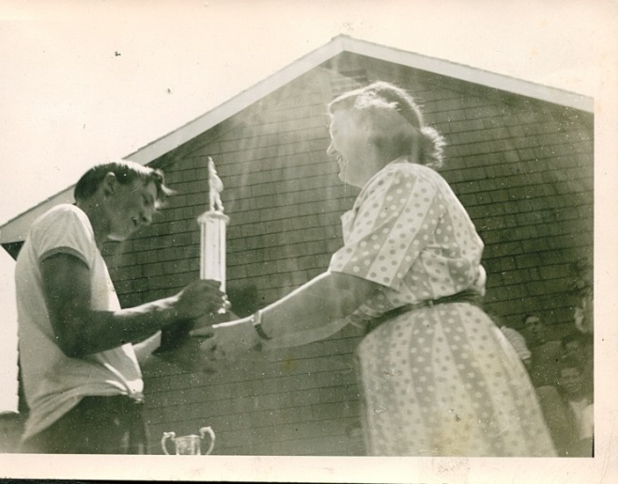 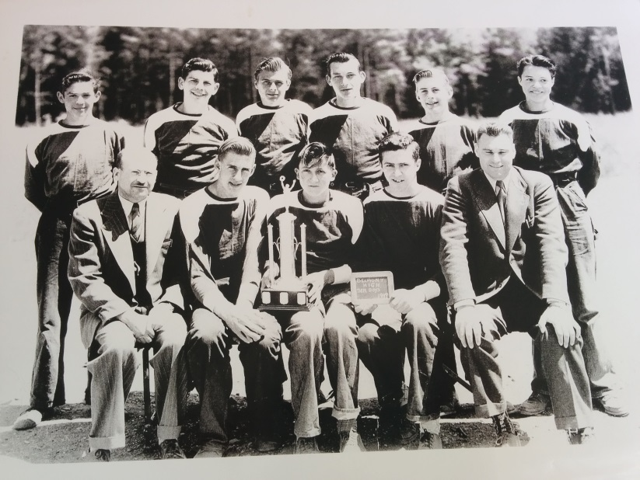
The victorious 1949 Belmont senior boys’ softball team
Alan Robertson accepting the Maughan Cup

Along with the spirited house competitions, extracurricular opportunities continued to grow throughout the 1950’s, made possible by a number of dedicated teacher-coaches. Two of the longest-serving and most influential were Mr. Harold Parrott and Mr. Doc Palsson, both of whom volunteered their coaching services for over a decade. In those early years, softball was the most popular team sport for both genders, and Belmont consistently fielded competitive teams. Allen Le Quesne believes that least some of the credit for the high skill level of the incoming students can be attributed to Langford Elementary School principal Ms. Ruth King, as she got many of the kids involved in the sport at a young age. Boys’ soccer was also popular but was not an option for the girls. In fact, it would be another quarter century before girls’ high school soccer became officially sanctioned by BC School Sports.
1949-50 marked the first graduating class of the new Langford high school, and 16 students walked across the stage to receive their diplomas. In three short years, these young men and women had helped Belmont establish the foundation for a strong sporting tradition.
Compiled by Cindy Cullen - 2015

Bibliography
"500 Attend Belmont Reunion ." 30 1970, January.
Administration, Belmont. "Program for Opening Ceremony." Victoria, January 1955.
"Belmont High School Statement of Cost As At December 31st." List of financial costs, Victoria, 1947.
Daily Colonist. "Army Buildings are Acquired As Schools For Sooke Area." July 9, 1946.
Daily Colonist. "Belmont School Opens Monday." September 7, 1947.
Daily Colonist. "Colwood Camp School Costs Pose Problem." December 16, 1947.
Daily Colonist. "New School Constructed From Former Army Huts." May 4, 1948.
Jacobson, Gaye. "Valedictory, 1950." Pioneer Edition Belmont Annual, 1950.
Josephson, Bonnie. "History of Belmont High School." Written Summary for SD 62, Victoria, n.d.
Kerley, Don. "Letter to the Editor." Goldstream Gazette, August 25, 2009.
Le Quesne, Allen, interview by Cindy Cullen. Recollections of Belmont School in the early 1950's (July 22, 2014).
Mansfield, Earl. A Brief History of Belmont Senior Secondary School. Victoria: Belmont School, 1994.
Maughan, K.E. "History of Belmont." Blue and White Belmont Yearbook (Belmont School), 1951.
—. "History of Belmont." Pioneer Edition, 1950.
"New Belmont High Off to Busy Start." 1954.
"New Principals Named for District Schools." 1966.
Pollack, Muriel, and Robin Price. "PTA Sponsors a New Field in Conjunction with the School Board." In 1953-54 Yearbook. Belmont Secondary School, 1954.
"Resolution." Town council resolution, Victoria, 1947.
Robertson, Alan, interview by Cindy Cullen. Recollections of Belmont Athletics in the Early 1050's (July 24, 2014).
Smith, Shirley, interview by Cindy Cullen. Recollections of Belmont Athletics in the Early 1950's (August 5th, 2014).
Times. "Milne's Landing Wins Inter-High Sports Day at Belmont School." Victoria Daily Times, June 4, 1949.
Varcoe, Carol (Booth / Spotswood), interview by Cindy Cullen. Belmont memories (August 19, 2014).

