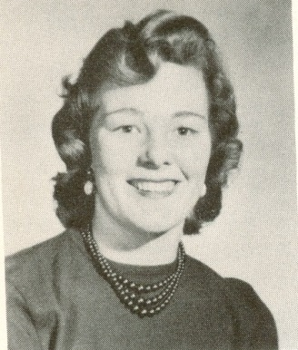
Sheilla Arden: 1950-1956
Sheilla Arden attended Belmont Secondary school from 1950-1956. Described in her grade 11 yearbook as a “quick silver” girl, Sheilla fully embraced her high school experience, participating in numerous clubs and activities such as the Journalism club, the Future Teacher’s club, Student Council and Student Court. Somehow Sheilla still found time to be heavily involved in sports, and like everything else she did, she excelled in that pursuit as well.
Throughout Sheilla’s years at Belmont, she was a mainstay of the girls’ athletic program and participated in softball, volleyball, track and field and basketball. While she was in grade nine, Sheilla was even able to play up a year in basketball and played on the senior team instead of the junior team with the rest of her peers. However, softball was her number one sport, and she also played on a strong community team with some of her Belmont classmates, including the Moseley sisters, Marilyn and Shirley. Marilyn described her friend Sheilla as “a delightful gal to be around...in my class as well...always happy. She was a good athlete and a good student. She loved my mom’s homeade bread sandwiches at lunchtime. I could always find her around noonish.”
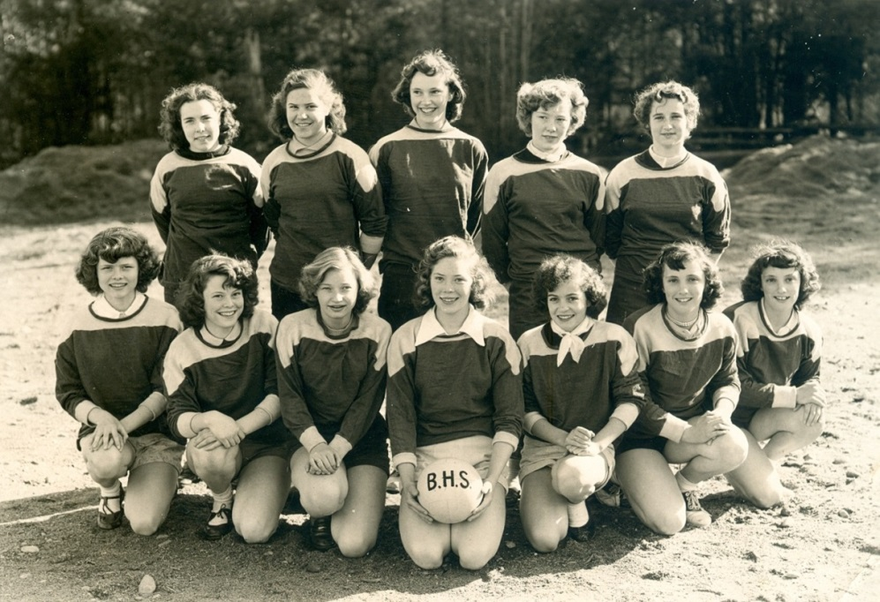
Belmont’s 1952-53 girls’ volleyball team poses for a team photo on the school field. Sheilla is standing in the back row, 4th from the left.

