Shane Prieur – 1997
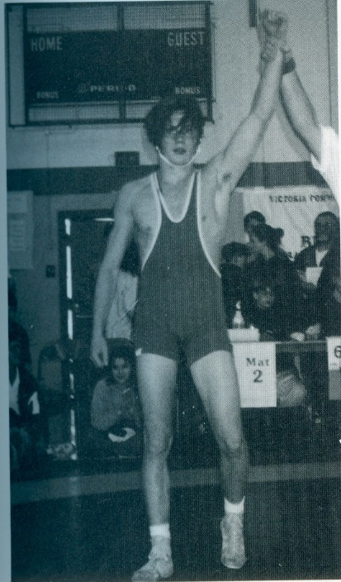
Shane was a wrestling standout for Belmont who won the Vancouver Island championship in 1996-97 and was named the outstanding wrestler of the tournament. That same year he earned a silver medal at the BC high school championship event.

We have been unable to contact Shane. If anyone has a current email address or phone number for him, we would appreciate it if you could ask him to contact us.
