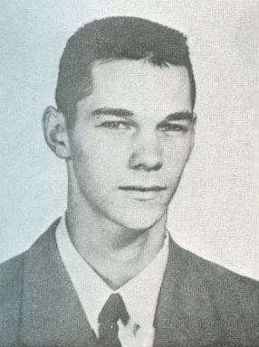
Rod Kilduff: 1956-1961
Rod Kilduff attended Belmont from grade seven all the way to grade twelve, graduating in 1961. He was a well-rounded athlete, partaking in multiple sports and extracurricular activities while excelling in academics throughout his time at Belmont.
As a junior, Rod played on the Belmont soccer team, as well as the basketball team. He was also in band, the Brains of Business and a member of Belmont’s Sports Committee. As a senior, Rod was a prefect and a House captain. He was a valuable member of the Braves Senior Basketball team, and also did track and field. In the year of 1957-58, he and the rest of his teammates won the track and field city championship.
Outside of school, Rod was a very skilled lacrosse player and played for the Junior Shamrocks team that won the Minto Cup in the 1960’s. He later played in the Western Lacrosse Association with the Coquitlam Adanacs. Today, Rod is no longer with us, but his athleticism and love of sports continue to live on in his three sons, who played hockey, basketball, and fastball/ softball while growing up.
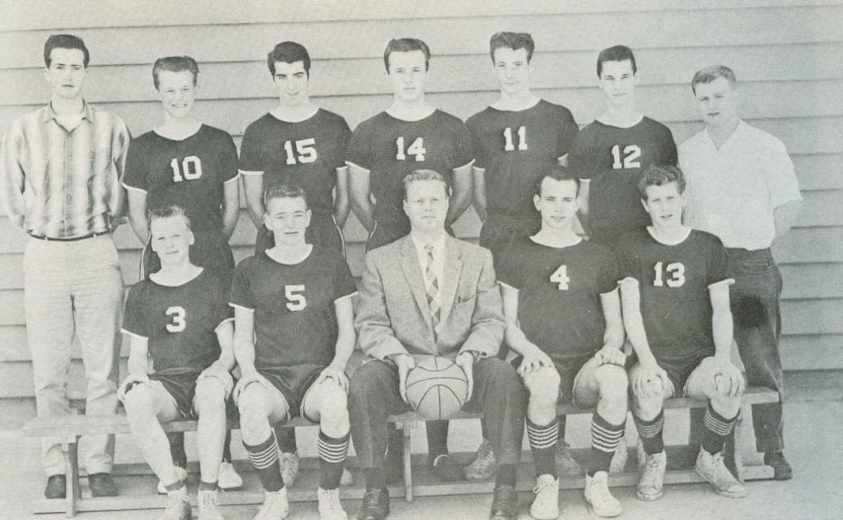
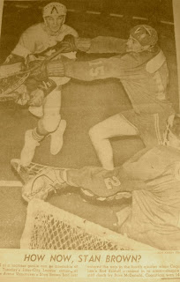
Rod Kilduff – Coquitlam Adanacs photo
1961 Belmont Braves Basketball Team: Rod is #12 in the back row.

