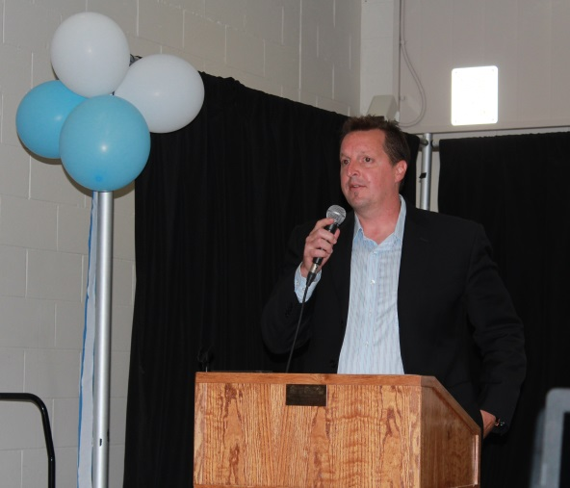
Rob Dyke
Rob was the keynote speaker at the 2015 Belmont sports banquet, the final such event in the old building. He gave an inspirational speech about his journey as an athlete and encouraged the students to try new activities they are not already good at, and to not be afraid to fail. He explained that the most gratifying accomplishments in life often come from humble beginnings, and that there is tremendous satisfaction to be gained by conquering goals that might have seemed unattainable at first.
Rob was a Belmont student in the late 1980’s and was a strong swimmer who went on to compete for the University of Victoria swim team after high school graduation. Many former collegiate athletes are content to move on to more recreational activities, but Rob continued to challenge himself in extremely demanding ways. In 1996, he became the first man to swim from Tsawwassen to Swartz Bay, tackling the strong Straight of Georgia currents. Impressive as that accomplishment was, it was only the warmup for his next long distance challenge: to become the first person to swim around Vancouver Island! This was an extremely tough physical test, but an exhausted Rob successfully completed the feat.
Given Rob’s desire to push his body and mind to their absolute limits, it’s not surprising that he decided to give the sport of triathlon a try, and he completed a number of competitions: both Olympic distance and Ironman. He also took up mountain climbing and on one expedition, made it close to the peak of Mount Everest!
It is no wonder that Rob is in demand as an inspirational speaker, and Belmont’s athletic class of 2015 was fortunate to be able to share his story.

