Paul Vandenboomen
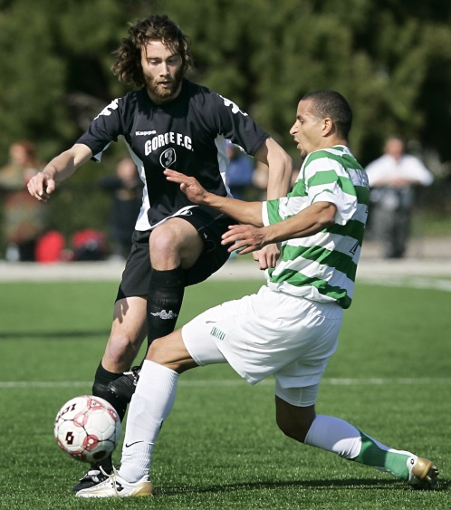
Paul Vandenboomen attended Belmont in the early 2000’s and was a key member of Belmont’s soccer team. He considers the #1 highlight of his high school soccer career to be playing in the Colonist Shield final game. He feels that sports really enriched his entire school experience and made his years at Belmont much more rewarding.

After high school graduation, Paul received a full soccer scholarship to Niagra University in upstate New York. He made an immediate impact on their soccer program and earned team MVP honours his very first season. He says it was a great experience and is grateful for the chance to go to school abroad and come out with a degree in Recreational Management and Tourism.

Paul played three seasons for the Victoria Highlanders soccer team of the Professional Development League. His high skill level and great work ethic helped him win the team’s MVP award in their inaugural season of play. He saw limited action the second season due to injury, but came back strong the third year. Since getting married and starting a family, his soccer priorities have changed, and he is looking forward to sharing his love of the sport with his two children. He plans to coach and mentor them one day and hopes that they will have great experiences with the game, just like he did.

There were several people who contributed to Paul’s soccer accomplishments, He credits his Belmont coach Troy Harris as being a great role model, and says that Dunsmuir and Belmont P.E. teacher Patti O’Neill also was a positive influence. And of course his parents were always there to fully support him with all his activities.

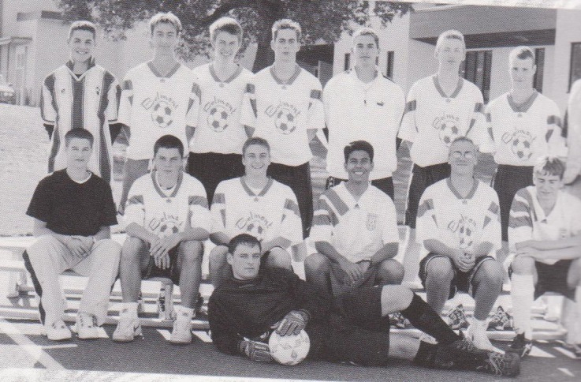
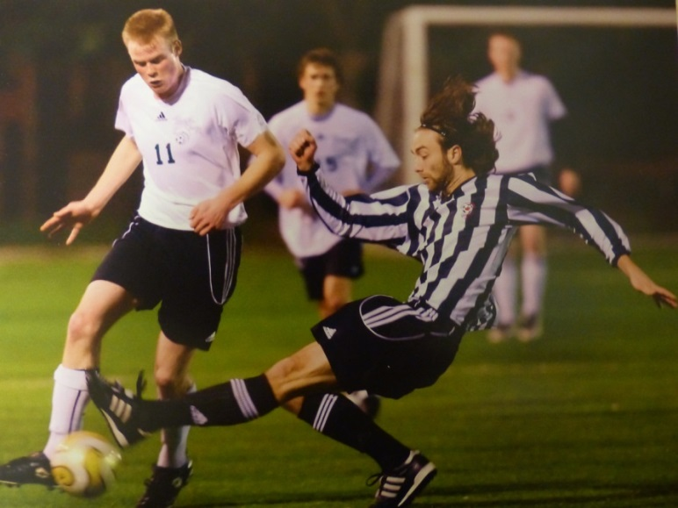
Paul is in the back row 2nd from the left in this 2001 Belmont soccer photo.
Paul (in his black and white Gorge jersey goes in for a hard tackle

