Patti O’Neill: 1974-1985 and 1998-2007
June, 2004: Almost 300 grade 10-12 student-athletes, along with about 20 of their coaches filed into the North Gym which had been transformed into a restaurant format. Round tables had been arranged throughout the gym, each covered with a blue tablecloth and formal place settings. A vase of freshly cut flowers sat in the centre of each table and hundreds of random action photos of Belmont athletes were scattered around for the students to examine and claim as keepsakes. Blue and gold balloons and streamers were strategically placed around the room, adding to the festive atmosphere. In one corner, a few student musicians provided quiet background music as people mingled and waited for dinner. Most of the students and athletes were dressed up in semi-formal attire which added to the classiness of the occasion. The students were treated to a delicious meal which was followed by the athletic awards ceremony and presentation of the various trophies. The culminating event of the evening was the showing of “The Year of the Dog,” a lively 15 minute video produced by Patti O’Neill that showcased every Belmont team of the entire school year.
Belmont’s 2004 athletic banquet was a huge success and would never have come to fruition were it not for the efforts of Patti, along with her co-chairperson Troy Harris. These two individuals came up with the idea for a more formal celebratory evening and started a new tradition that has been continued ever since. Patti had been the prime organizer of the previous athletic awards evenings, where trophies were presented in the gym and to be followed by desserts and tea or coffee for the students and their parents in the cafeteria, and she continued to be the driving force for the more elaborate banquets in subsequent years. She coordinated and delegated the various tasks (taking on many of the duties herself), created and printed the program and tickets, encouraged and cajoled coaches to get their players to attend, and spent countless hours on the final video. She made a point of personally watching at least one practice or game of every Belmont junior and senior sports team to take video footage and photographs that could be incorporated into her year-end video. Patti would appear with her camcorder at Elk Lake for a rowing regatta, Beaver Lake for a cross country race, Uvic for a track meet, Juan de Fuca Rec Centre for a tennis match, the gym for basketball, volleyball or badminton games, or the field for soccer, rugby or softball competitions. No team was ever left out. Then Patti would perform the laborious task of viewing all of her video clips to select the best segments and organize them into one 15-20 minute video. This took hours and hours of time at home and each year there was a different theme and different songs to accompany the visuals.
As a young woman, Patti certainly never envisioned a career as a Belmont PE teacher and coach. She grew up in San Francisco in the 1960’s when girls’ high school and collegiate athletic opportunities were very limited in the United States. Patti’s main sport was gymnastics and her expertise in that activity helped her earn a physical education teaching position in San Francisco in 1970. She recalls the segregated system of PE in those days, not only with separate classes for boys and girls, but even separate gyms and other facilities. There was one field, but that was reserved for the boys’ football team and the girls were not permitted to use it. The male and female PE teachers had their own offices and rarely associated with one another, although Patti was given one co-ed class to teach, composed of alternative students who had experienced difficulty in the regular system. Her teaching area was a cement courtyard surrounded by the school buildings, but Patti frequently took her class off campus for hiking or biking excursions. The historic Title IX legislation that called for an end to gender bias in education radically changed the American sporting scene and led to a dramatic rise in high school and university athletic teams and scholarships. Patti remembers policies just starting to change during her teaching time in San Francisco, with gymnastics and volleyball being two of the first sports promoted for girls.
After a trip to visit in friends in Victoria captivated Patti and husband Kevin, the couple decided to relocate to Vancouver Island in 1974 and Patti immediately landed a teaching job at Belmont, while Kevin was hired at Edward Milne School two years later. Belmont had a large PE department and Patti found the system much more progressive than her previous San Francisco school, as the males and females worked closely together and the students had many more choices of activities. Her first coaching experience was the cheerleading team, which Patti described as a lot of fun, but she soon took over the senior girls’ volleyball program and coached that sport for ten years. She also volunteered several seasons with girls’ soccer and helped out with track. In 1985, Patti transferred to Dunsmuir and continued to be a catalyst with various extracurricular sporting activities. She switched over to junior boys’ volleyball, which was a similar skill level to the senior girls, so was an easy transition. In 1998, with the restructuring of the school grade configuration in School District 62, Patti returned to Belmont and continued to coach junior boys’ volleyball every year until her retirement and also helped out with junior girls’ basketball and track and field for several seasons. With the addition of grade 10’s to high school and the increased size of Belmont’s population, Patti noticed that many students seemed uninformed about the different athletic opportunities and missed tryouts or practices because they didn’t know how to access the necessary information. She decided to improve communication by starting the “Belmont Sports Page”, a weekly publication designed to list all the practices and games and to recap the previous week’s athletic results. This became a valuable source of information for students, teachers and parents, and has been continued to this day.
Patti thoroughly enjoyed her 20 year coaching tenure at Belmont and says she appreciated the many wonderful kids, great parents, and supportive administration. There were many highlights, including some large trips, such as a Christmas Break excursion to San Diego with the junior girls, senior boys and senior girls’ basketball teams, made extra special because her daughter Erin (herself a Belmont grad) accompanied the team as the second female chaperone. Her colleagues remember her tremendous energy, organizational skills, attention to detail and great sense of humour. Her players appreciated her positive nature, competitive drive and dedication. She formed strong positive relationships with her players and often hosted windup pizza parties for the teams at her house in Metchosin.
It was fitting that Patti’s final retirement tribute occurred at the sports banquet in June, 2007 (which as usual, she had spent long hours organizing). After Patti’s traditional year-end video concluded, Troy Harris surprised her with a moving video of his own that recognized her many contributions over the years and included commentary from past and present Belmont athletes. When the video ended, every student, parent and coach in the gym rose to give Patti a well-deserved standing ovation.
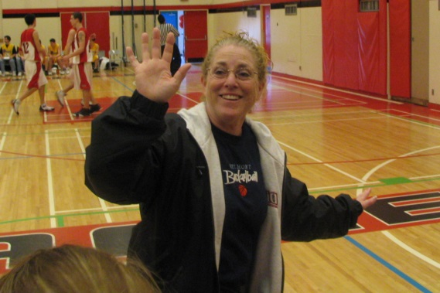
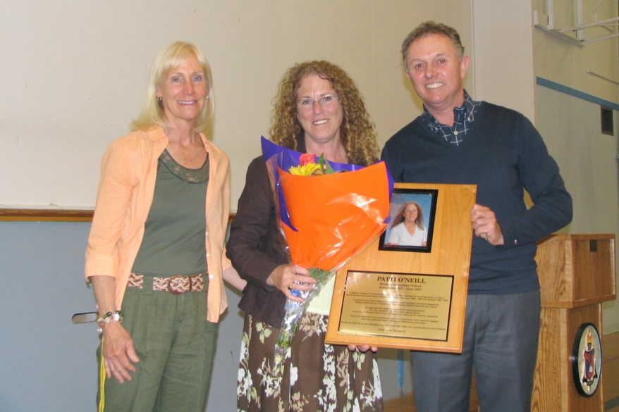
Belmont coaches Valerie Baker and Muzz Bryant presenting Patti with a plaque in her honour that would be placed at the entrance to the Spotswood Gym

