Nicole Weldam-Dickson
Nicole is a multi-sport athlete who has been a key contributor to many of Belmont’s sports teams the past three years. As a youngster she participated in basketball, soccer, cross country, track and field (long jump and 400 meters) but by the time she reached high school, she had narrowed her focus to basketball, volleyball and rugby.

In volleyball, Nicole’s best memories come from grade 10, when the Bulldogs junior squad upset Oak Bay to win the Lower Island title with an exciting three set victory. The team went on to qualify for the B.C’s, despite the fact that many of the girls were quite inexperienced compared to many of their opponents.

Nicole was a starter on the junior girls’ basketball team that finished 4th on the Island and just missed out on a provincial berth. At the senior level, she continued to be a key contributor and had a number of standout games, including a 32 point performance against Edward Milne School in grade 11. She took up the new sport of rugby in grade 11 and found she really enjoyed the challenge of tackling people and that it was a great way to get out her aggression. The team exceeded expectations by winning the city league and becoming the first Belmont girls’ rugby team to ever make it to the provincial championship tournament.

She has also managed to maintain a high academic standing despite her busy schedule, and for two consecutive years was one of only a small group of students to receive a scholar-athlete certificate for maintaining an “A” average while playing on at least two Belmont teams

Although Nicole relishes the intensity of high school sports and is highly competitive on the court or the field, her best sporting memories revolve around the relationships she has developed over the past three years. As she explains, her best friends are also her team-mates, and she values the many good times they’ve shared.

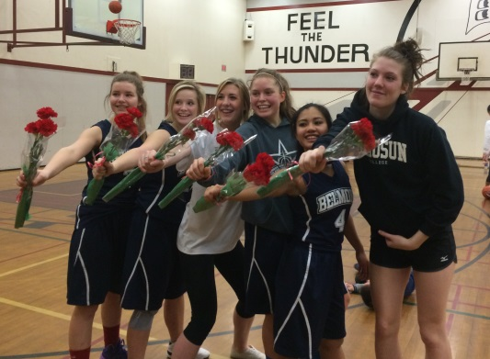
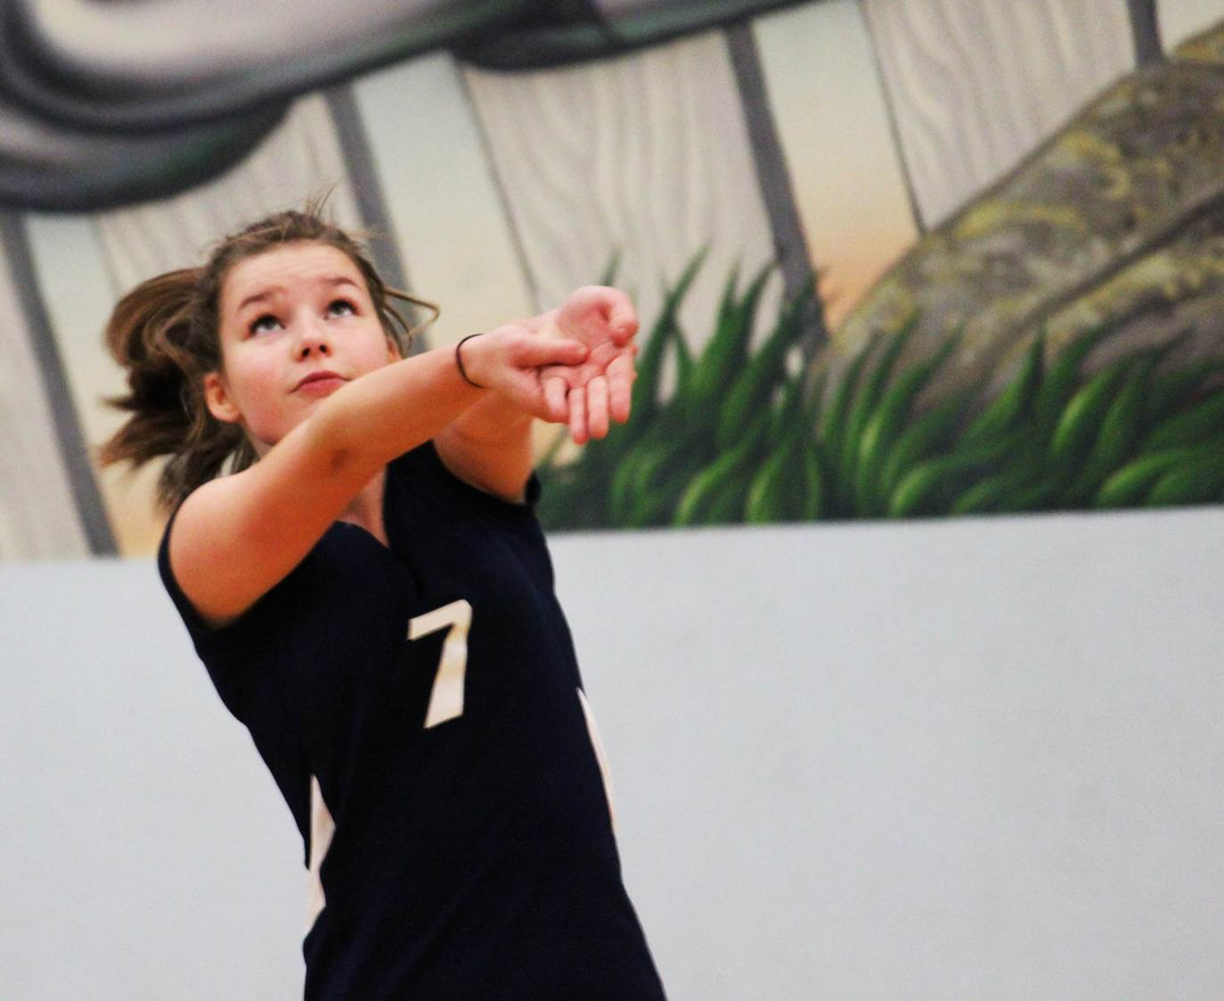
When asked about her experience with the sports history project, Nicole stated: “I have found it really interesting to learn about the older Belmont athletes. For example, Alan Robertson (Belmont grad of 1952) and I went to the same elementary school. He told me some fascinating stories, such as in 1939 when the entire Langford School student body lined Jacklin Road in to welcome the queen as she drove by, and his recollection of being told that World War2 had broken out.”
Nicole is on the far left with her grade 12 basketball team-mates after qualifying for the Island tournament
Nicole focuses on the volleyball as she prepares to receive a serve
Nicole stands on the far left with her basketball team-mates after qualifying for the Island touranment
Nicole focuses as she prepares to receive the volleyball serve

