Nicola Sadowski Priestley: 1998-2001
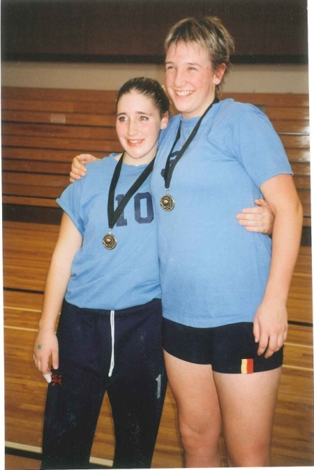
Nicola (Nicki) attended Belmont for grades 10-12 and was an important contributor the school’s volleyball and track & field teams. She started her athletic career as a figure skater at the age of five and continued to skate for the next ten years. She recalls having a competitive nature from an early age, a trait that helped her reach her high level of performance. She first began playing volleyball in grade 6, and, by the age of 15, decided to transition out of figure skating in order to focus solely on volleyball.
Nicki says that playing volleyball at Belmont was a great experience, and that she loved being part of the senior girls’ volleyball team as a grade 10. She also really enjoyed the experience of participating in the first ever girls AAAA provincial championships her grade 12 year, where she captained Belmont to a silver medal finish and was named to the First All-Star Team. Although volleyball was Nicki’s top sport, she also was a valuable member of Belmont’s track and field team and recorded strong results in both the shot put and discus.
Nicki (right)
When asked about her best high school sports-related memory, she replied there were “too many to count,” and that her fondest memories revolve around the girls, now women, that she played with over the years. Many of her former team-mates still keep in touch with one another and always enjoy hearing about one another’s lives. She adds that many of her memories also include her former high school coach, Mike Toakley. She describes Mike as a “consistent support and mentor. An amazing man; he has devoted so much of his life to volleyball and I am grateful to have had him as a coach.” Toakley recalls that “Nicki was a special player and an even more special person. Her leadership qualities were phenomenal.” He still has several motivational mementos that Nicki put together for her team-mates before big tournaments.
After graduating from Belmont, Nicki attended Montana State University on a “full ride” athletic scholarship. She played there for a year and then returned to UVic to play volleyball and complete her math degree and teaching practicum. She also mentions Patti O’Neill as “a wonderful teacher and coach I have fond memories of.”
Nicki hasn’t played much volleyball since her UVic years, as she moved on to focus on her education and career. However, she still stays active and is proud to say she recently ran her first half-marathon!
Nicki’s advice to current Belmont athletes is to “Compete hard, play fair, and have fun!”
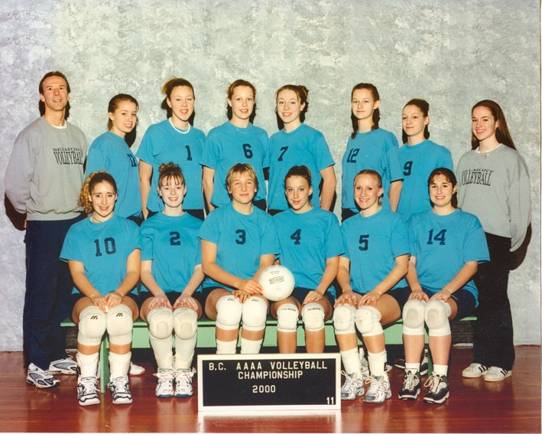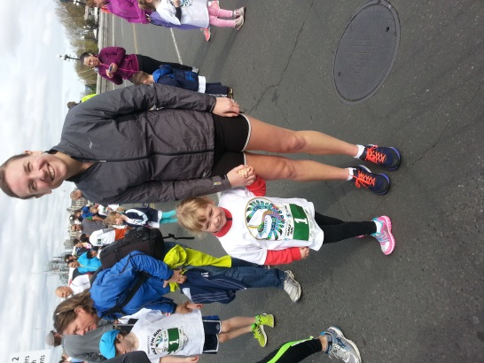
Nicki with her daughter Ella

