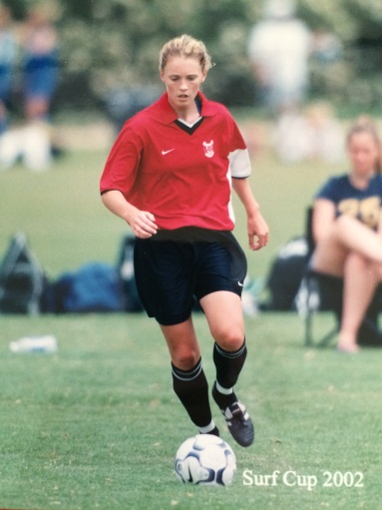
Moira (Mo) Hood: 2001-2004
Moira Hood, a multi-sport (soccer, basketball, volleyball and track) star who attended Belmont from 2001 to 2004, achieved greatness, playing on both the Canadian National Youth Team and BC Provincial soccer teams while still in high school! Moira began her soccer career at the age of six while living in Vancouver, and her parents could barely keep up with her active life style. After moving to Victoria, she played with the Juan De Fuca soccer association, playing on boy’s teams until she was old enough to play on the girl’s Metro soccer team. Mo participated in as many sports as possible, including karate, baseball/softball, and cross-country.
Although Moira was named Belmont’s top female athlete for three consecutive years, she says her best accomplishment at Belmont didn’t consist of any awards or trophies, but instead was being able to play on as many teams as she could. This enriched her high school career, and challenged her to adapt to new physical activities and teams. Moira’s most cherished memories include the lengthy road trips which led to team bonding, and the countless tournaments which her teams attended.
During Moira’s post-secondary journey, she played for the University of Victoria Vikes women’s soccer team from 2004 to 2010. The Vike’s attained their first ever National Championship in 2005, and in Moira’s senior year she was named captain of the team.
She gives thanks to all of her Belmont coaches, especially Troy Harris, Kevin Harrington, Greg Witt, Cindy Cullen, Patti O’Neill, Ken Lowe, Mike Toakley and Lee Phillips. Her future sporting goal is to stay healthy, avoiding injury. Sports continue to be a massive part of her life, as she craves competition and loves to share her passion in sports through teaching and coaching.
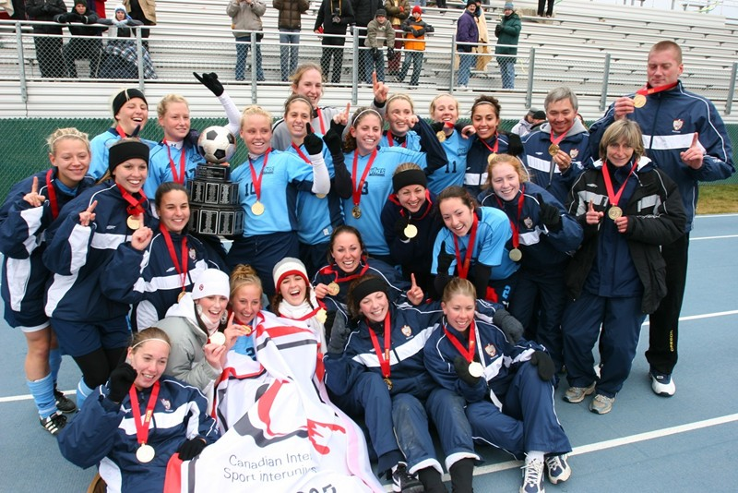
Mo Hood’s words of advice to future aspiring Belmont athletes are, “The skills you learn playing other sports with new team mates and coaches will no doubt make you a smarter and more well-rounded athlete.”
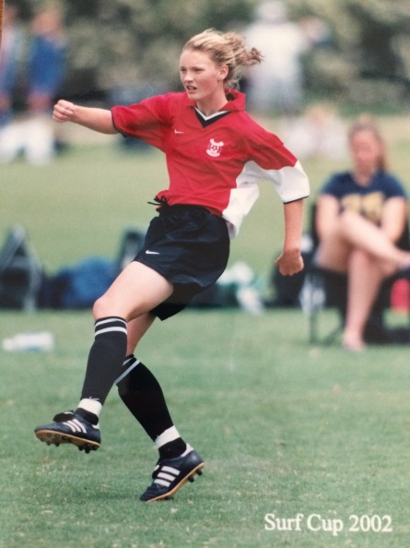
Moira at age 16
Moira (kneeling 2nd from the left) with her Canadian championship Uvic soccer team

